Public Private Infrastructure Advisory Facility

Study of public passenger transport conditions in

Recife, Brazil

K.M.Gwilliam and G Correa
February 2005

Table of Contents
Glossary…………………………………………………………………………
0 Introduction………………………………………………………………1
1 Political context 1
1.1 Geography and demography…………………………………………..1
1.2 Constitutional Structure………………………………………………..2
1.3 Existence of a private sector in other public utility sectors……………2
1.4 History of the bus sector……………………………………….………2
1.5 Central government policy on private sector supply…………...……...2
1.6 Local government policy and willingness to reform…………………..2
2 Economic conditions……………………………………………………..2
2.1 National GDP per capita 2
2.2 Income levels 3
2.3 Public transport fares 3
2.4 Percentage of income spent on public transport 3
3 Current public transport patronage 3
3.1 Passenger numbers by category 3
3.2 Ticket types 3
3.3 Passenger load factors 3
3.4 Social service provisions
4 Structure and organisation of urban public transport 5
4.1 Organisational structure 5
4.2 Legal basis for organisation and jurisdiction 5
4.3 Public sector operators………………………………………………
4.4 The private sector operators 8
4.5 Vehicle purchase, finance and insurance 8
4.6 Staffing and skills analysis 8
4.7 Facilities and equipment 8
4.8 Financial environment 9
4.9 Role of the informal sector 10
5 Service supply characteristics 10
5.1 Operational characteristics 10
5.2 Monitoring and enforcement
5.3 Bus routing and scheduling plan 10
5.4 Income and expenditure statements 10
6 Vehicle related data 13
6.1 Vehicle ownership 13
6.2 Constraints on supply of sector inputs 13
6.3 Financial arrangements for fleet procurement 13
6.4 Fleet inventory 13
6.5 Fleet maintenance 13
6.6 Vehicle operating costs 13
7 Existing regulatory arrangements and institutions 13
7.1 Entry to the market 13
7.2 Fare determination and adjustment 14
7.3 Subsidy mechanisms
7.4 Effects of unions 15
7.5 Taxation and other incentives / constraints 15
8 Perceived problems and attributed causes 16
8.1 Advantages of the existing system 16
8.2 Congestion 17
8.3 Decreasing demand and fincial viability Error!.
8.4 Integration Error! Bookmark not defined.
8.5 Jurisdictional fragmentation 17
8.6 Financing and mangement of rail services 17
9 Options for reform Error! Bookmark not defined.
9.1 The general reform strategy Error! Bookmark not defined.
9.2 The committed reforms 22
9.3 Required next steps 22
9.4 Drivers of reform
9.5 Obstacles to reform

Figures and Tables
Figures

1. The location of Recife

2. The municipalities of the Recife Metropolitan Region

3. Spatial extent of medium sized Brazilian conurbations

4. Relative population densities of middle sized Brazilian conurbations

5. Distribution of population by social class
6 Evolution of passengers carried, fleet and vehile kilometrage (1989-2002)
7. Modal split in 1997

8. The inter-municipal pattern of trips.
9. The institutional structure of the RMR with respect to urban transport

Tables

- Population of RMR in 2000
2. Basic fares in the Brazilian conurbations, October, 2004
3. Performance of the bus system, 1998-2004
4 The performance of the two elements in the STPP/RMR.
5. Change in operating performance 2003-4
6. Changes in prices, salaries and costs 2003-4

7. Fleet by vehicle type and company at end 2004

8. Distribution of fleet by age, Dec 2004
9. Cost structure of EMTU operations, 2004

Glossary of Abbreviations

ARPE Agencia de Servicos Estaduais Delegados do Estado de Pernambuco (Delegated Services Regulatory Agency)
AVL Automatic Vehicle Location
BNDES ………….(Brazil National Development Bank)
CBTU Companhia Brasileira de Trens Urbanos (Brazilian Urban Train Company)
CCT Camara do Compensacao Tarifaria (Tariff Compensation Chamber)
CMTU Conselho Metropolitano de Transportes Urbanos (Metropolitan Urban Transport Council)
CONDERM Conselho de Desenvolvimento da Regiao Metropolitana do Recife
CRT Cidade do Recife Transportes (Recife City Transport)
DETRAN-PE Departamento de Trânsito de Pernambuco (Pernambuco State Department of Transport)
EMTU Empresa Metropolitana de Transportes Urbanos (Metropolitan Urban Transport Agency)
FIDEM Fundacao de Desenvolvimento da Regiao Metropolitana do Recife (Regional development agency)
FUNDERM Fundo de Desenvolvimento da Regiao Metropolitana do Recife (Regional development fund)
GDP Gross Domestic Product
IMF International Monetary Fund
PPIAF Public Private Infrastructure Advisory Facility
RMR Recife Metropolitan Region
SABE Sistema Automático de Bilhetagem Eletrônica (Electronic Ticketing System)
SEI Sistema Estrutural Integrado
STTP Sistema De Transportes Público De Passageiros
STU/REC Superintendência de Trens Urbanos do Recife
VPP Vehiculos do Pequeno Porte (small vans)
VT Vale Transporte (Transport token)

0 Introduction
The World Bank, financed through the PPIAF, is preparing a practical toolkit to support national and city policy makers to develop procedures to implement contracting, regulating, institutional and financing options to secure a more market based approach for engaging the private sector in providing urban bus transport services. As part of the program it has commissioned studies to describe and analyze urban public transport arrangements in a number of cities which have already recognized a need or desire for reform. The purpose of such analyses is to identify the specific causes of the deficiencies of urban public transport in different locations and circumstances so that the toolkit can suggest proper and appropriate regulatory and institutional solutions. This study of the public passenger transport sector in Sri Lanka is one of those basis studies.
This report is based on missions to Recife, undertaken by the consultant, firstly in connection with a concessioning of the urban rail system and an associated proposed reform of the institutions for urban transport and, secondly, specific to this project. The numerous persons to whom the authors are indebted are listed in Annex 1.

Political context

Geography and demography
The Metropolitan region of Recife (RMR) is located on the north Eastern costs of Brazil. (see Figure 1).
Figure 1. The location of Recife
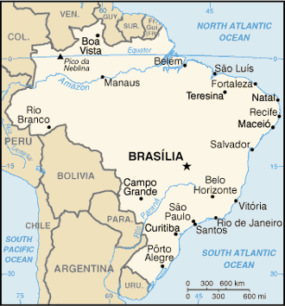
Brazil has an estimated population of 184 million, growing at 1.1% per annum, with a median age of only 27 years. The total population of the RMR in 2000 was approximately 3.4 million, of which 2.5 million live in the four completely urban municipalities of Recife, Jaboatao do Guarapes,Olinda and Camaragibe. The area of the region is 2708 km² with an average population density of 1232 persons per km² (See Table 1). It consists of 14 municipalities with a spatial configuration and characteristics described below (see Figure 2).

Figure 2. The municipalities of the Recife Metropolitan Region

MUNICÍPIO
POPULAÇÃO - hab
ÁREA - km2
Municípios: 14
População:3.337.565 hab
Área: 2.208 km²
Densidade: 1.232 hab/Km²
Região Metropolitana do Recife

Only 3% of the population of the region lives in areas designated as rural, and three of the municipalities, Recife, Camaragibe e Olinda, have a totally urban population. Compared with other Brazilian metropolitan areas of comparable size (hence excluding Sao Paulo and Rio de Janeiro) Recife is relatively small (see Figure 2) and dense (see Figure 3).

Table 1. Population of RMR in 2000.
Source: Metrodata – Basic Information of metropolitan regions and household surveys – EMTU/Recife 1997
Municipality | Population | Área | Pop/km2
Municipality | 2000
Abreu e Lima | 89.039 | 144 | 618
Araçoiaba | 15.108 | 90 | 168
Cabo de Sto.Agostinho | 152.977 | 451 | 339
Camaragibe | 128.702 | 53 | 2428
Igarassu | 82.277 | 323 | 255
I Ipojuca | 59.281 | 507 | 117
Itamaracá | 15.858 | 65 | 244
I Itapissuma | 20.116 | 74 | 272
Jaboatão dos Guararapes | 581.556 | 234 | 2485
Moreno | 49.205 | 189 | 260
Olinda | 367.902 | 29 | 12686
Paulista | 262.237 | 63 | 4162
Recife | 1.422.905 | 209 | 6808
São Lourenço da Mata | 90.402 | 277 | 326
TOTAL | 3.337.565 | 2708 | 1232

The Recife Metropolitan region is one of the smallest of the metropolitan regions of Brazil (see Figure 3)
Figure 3. Spatial extent of medium sized Brazilian conurbations

However, as a consequence of its relatively small spatial extent it is one of the most densely inhabited of the metropolitan regions (see Figure 4)
Figure 4. Relative population densities of middle sized Brazilian conurbations

Constitutional structure
Brazil is a federation of states, with the attribution of responsibilities between the jurisdictions contained in the formal constitution. The most recent amendment to the constitution, in 1988, was aimed at increasing the responsibility of the states through the transfer of powers over the provision of certain public services to state and municipal levels.
Each level of government has a democratically elected government to implement the powers attributed to that jurisdiction by the constitution.

Existence of a private sector in other public utility sectors
The role of the private sector in provision of public utility services is not an issue in Brazil. Gas, electricity and telecommunication services have already been privatized, subject to the general supervision of a regulatory body, ARPE. The only remaining public sector enterprise is the urban rail network. This remains in the ownership of the Federal government, administered through the Recife subsidiary of the national CBTU. However, it is government policy to transfer responsibility for, and ownership of, urban rail systems to the states. This has already been achieved in several states (Sao Paulo, Rio de Janeiro), but is delayed in Recife because of the poor financial condition of the rail enterprise. The need to find acceptable ways of achieving this transfer, as well as the state taking over the extension to the system now under construction, is one of the sources of the reforms that are presently being considered.

History of the bus sector in Recife
Bus services in Recife have long been provided by the private sector on the basis of permissions to operate granted by the relevant local authorities. Initially the permissions were issued in response to requests by the individual operators. Since the creation of the integrated system, SEI, in 1985 the permissions have been developed within a more controlled structure, with each operator working in a pre-defined area (zoning). The permissions have not been competitively tendered, but a system of compensation between routes, and hence between operators, has been developed to allow the continued operation of some unremunerative routes.

Central government policy on private supply in public transport
Central government, as part of its constitutional policy of decentralization of responsibility for public transport, takes no formal position with respect to the role of public and private sectors in urban bus supply. In fact, urban bus services are almost exclusively provided by the sector throughout the country.
Also as a consequence of the constitutional position on decentralization the central government has taken steps to transfer ownership and responsibility of urban rail systems from the central government owned CBTU to the states. Central government has contributed to the refurbishment of the rail systems before transfer to the states. Where this has happened, as both Flumentrens and the Metro in Rio de Janeiro, the urban rail systems have been concessioned to the private sector. There is therefore no impediment to reform stemming from central government policies.

Local government policy and willingness to reform
As described above, responsibility for urban public transport in RMR is divided between the state of Pernambuco (generally responsible for inter-municipal transport) and the constituent municipalities (generally responsible for intra-municipal transport). The governments of the state and the largest of the municipalities, Recife, have already committed themselves to work together in a consortium to address the problems of urban transport, and it is hoped and expected that the other municipalities will join the consortium as it develops. That willingness to reform includes the creation of an integrated multimodal transport system, concessioning of the existing publicly owned metro system to the private sector, and supporting strategies on the treatment of the informal sector.

Economic conditions

The national economy

Brazil possesses large and well-developed agricultural, mining, manufacturing, and service sectors, and is expanding its presence in world markets. However, its development has been very uneven. In real terms GDP grew by 2.8% in 1995 and again by 3% in 2000. But the performance of the economy has been very uneven, with declines in real terms in three years in the decade and an average growth of only about 0.5% per annum over the whole decade. From 2001-03 real wages fell and Brazil's economy grew, on average, only 1.1% per year, with a real GDP decline of 0.2% in 2003 as the country absorbed a series of domestic and international economic shocks. In face of these shocks the government adopted a program combining a floating exchange rate, an inflation-targeting regime, and tight fiscal policy, reinforced by a series of IMF programs. The currency depreciated sharply in 2001 and 2002, which contributed to a dramatic current account adjustment: in 2003, Brazil ran a record trade surplus and recorded the first current account surplus since 1992. While economic management has been good, there remain important economic vulnerabilities. The most significant are debt-related: the government's largely domestic debt increased steadily from 1994 to 2003, straining government finances, while Brazil's foreign debt (a mix of private and public debt) is large in relation to Brazil's modest (but growing) export base.

Income levels
The national GDP at purchasing power parity in 2003 was estimated to be $1.375 trillion, with a GDP per capita of $7,600. Despite the relatively high average income, the distribution is very uneven so that poverty is a serious problem. The lowest 10% of households by income consume only 0.7% of the national income while the highest 10% consumed 48% in 1998. The Gini coefficient was 60.7 and 22% 0f the population was estimated to live below the poverty line. The inflation rate in 2003 was 14.7% and the unemployment rate 12.3%. This context underlines the need for transport sector policies which protect the poor whilst avoiding a high fiscal burden. 48% of the total have household incomes less than 4 minimum salaries.
60% of the population of the region falls into the two lower social classes D and E and 87% in the lowest three classes (see Figure 5). These classes are still largely dependent on public transport.
Figure 5. Distribution of population by social class.

Public transport fares
The tariff structure of the public transport in the RMR is zonal, based on a set of semi circular rings around the center of the metropolis. The number of zones, originally 5, has been progressively reduced to 2, with the last simplification being the merging of all trips above 32 kilometers into a single zone, which occurred in 2004. There are also special tariffs for the trunk lines of the SEI and for some lines operated by microbuses. The metro system has its own tariff, but is also included in the SEI so that passengers can use the metro lines for trunk movements in multi-modal trips at the integrated tariff rate.
The current fare for the first ring, the basic fare, which accounts for 75% of total trips, was Rs 1.3 until October 2004. This was one of the lowest basic fares for the Brazilian conurbations, and 10% below the average for all the conurbations (see Table 2). It was increased to 1.5 Rs in November 2004, bringing it close to the average level.
Table 2. Basic fares in the Brazilian conurbations, October, 2004
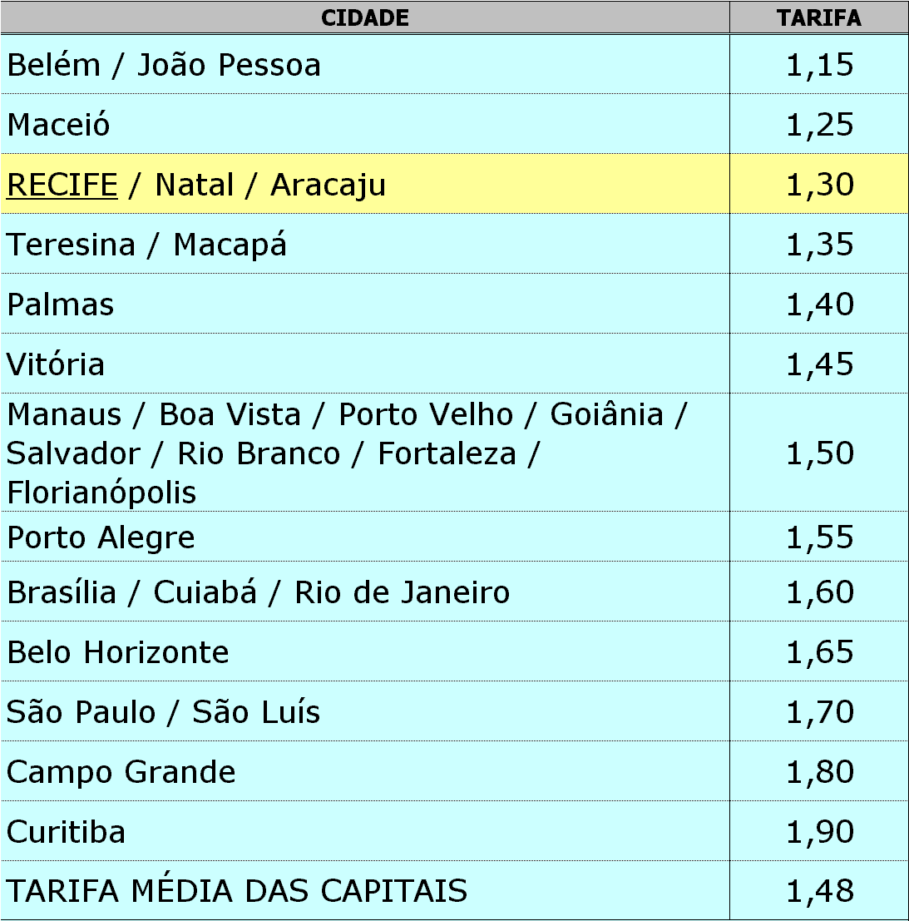

Source: EMTU. Resultados operacionais e financeiros no período abril/03 a novembro/04

Despite this apparently reasonable comparative fare level, the social survey undertaken on behalf of EMTU in April 2004 showed that 73% of passengers considered fares to be high or very high and 51% said that they could not pay more for an improved quality of service.

Percentage of income spent on public transport
The social survey of April 2004 indicated that 53% of the public transport users interviewed had family incomes less than 2 minimum salaries, and 89% had less than 5 minimum salaries. Public transport is clearly the transport of the relatively poor. No direct statistics have been collected on the proportion of income spent by households on public transport. However, the issue of the affordability of essential transport to the poor is dealt with directly by the “vale transporte” system (see more detail below) which effectively ensures that poorer employees in formal employment pay no more than 6% of their income for travel on journeys to work. As mentioned later, however, this does not apply to informal sector workers who are not in receipt of the vale transporte, and for whom equivalent data is not available
The vale transporte (VT) is a distinctive Brazilian system of income support to the poor. If requested to do so by an employee any employer is obliged to provide a ticket for the journey to work, for which he can deduct a maximum of 6% of the workers salary. As it will not normally be in the interests of more highly paid workers to take advantage of this scheme it is a benefit primarily to lower paid workers who are in any case captive to public transport. As they are only sold for use on the formal public transport system the VT should in principle tie employees to the formal public transport operators who should thus also benefit from a higher demand than they might otherwise be able to achieve.
The VT is issued in the RMR by EMTU, which sells them to employers. Employers give them to their employees, who in turn are supposed to give them to the public transport operator as a ticket. The operator can then cash in the returned VTs with EMTU.
Over many years there developed a secondary market for VTs so that workers who would prefer cash could sell them at a discount to other potential passengers or to third party agents dealing in VTs. The dealers made a living from the margin between the price at which they bought them from the original beneficiary and that (still discounted on face value) at which they sold them on to other passengers (or it is suspected to formal operators who could cash them in). Because of the existence of this secondary market it became possible for VTs to be used in lieu of fare payment on kombis as well as on buses. The Cavalcanti study in RMR indicated that over 25% of kombi passengers were paying with VT.
The welfare effects of the VT have been much discussed. It is clear that they did not help the very poorest of the poor – those without formal employment – who did not receive VTs. But it is also clear that above this lowest threshold those benefiting were definitely among the very poor groups. So, while a direct income supplement to the poor would have been better, the VT definitely yielded a welfare benefit.
For some years the formal sector operators complained about the “leakage” of the VT through the secondary market. To remedy this they have now moved to an electronic smart card version which can be recharged by the employer, and is much less easily traded and used except strictly for transport by formal sector operators. It is reported that since the change employers have saved up to 20% through the reduced take up of the VT (which now has no secondary market value). The formal sector bus operators have also benefited. The losers from the change are the informal sector operators (for whom the loss of the VT is yet another element driving them from the market in RMR) and the poor employees who were formerly able to supplement their income by something more valuable to them than a free journey to work through selling the VT into the secondary market. The effect on the poor is therefore likely to be negative, and the instrument becomes a less well focused aid to the poor employee than formerly.

Public transport patronage

Passenger numbers
Over a long period the number of trips carried by the formal public transport system has been declining, despite fleet size and bus kilometers having increased as Figure 6 shows. The decline in patronage can be attributed to the growth in car ownership, as well as the growth of the informal sector, while the perverse growth in service can be largely attributed to the pressure of local politicians – supported by the operators – to increase service as the region expands physically.
Figure 6 Evolution of passengers carried, fleet and vehile kilometrage (1989-2002)
Source: Annual Statistics of EMTU/Recife
The decline of public transport patronage results from increasing private vehicle ownership. According to a household survey undertaken by EMTU Recife in 1997 60% of the daily motorized trips were by public transport.(see Figure 7). More recently, a study by DETRAN-PE showed that in 2002 there was a total fleet of 426,781 private cars and 10,548 public transport vehicles.
Figure 7. Modal split in 1997
The individual municipalities have the formal right to manage their own transport systems for intra-municipal services, though Recife has already delegated this function to EMTU in the interests of co-ordination of services. In practice, however, all municipalities are very dependent on the state regulated services because with the exception of Recife the majority of trips generated in all the municipalities are inter-municipal, as shown in Figure 8.
Figure 8. The inter-municipal pattern of trips

Service network
The formal public transport system of the Recife Metropolitan Region (STPP/RMR) has two elements.
The first, called the Estrutural Integrado Sistema - SEI was conceived in 1985 and revised in 1992. It consists of a network of services, integrated both physically and in terms of a through ticketing system, which allows interchange in closed terminals without payment of a second fare. By this device it was possible to offer longer distance trips at a relatively lower fare cost than could be achieved through transfers in the Complementary System. The Metro is included in some of the interchange points so that the system is also a multi-modal system.
SEI was designed as a trunk and feeder system with six radial trunks and four transversal services which allow movements across the conurbation without the need to go through the center. In this way SEI also helps to reduce central area congestion. The system is capable of extension as the new metro line is included and as further radials and interchange terminals are developed.
The Sistema Complementar is composed of conventional lines operated by conventional buses and (to a decreasing extent since the blocking of the VPPs in Recife Municipality) by VPPs.

Ticket types
The tariff structure of the STPP/RMR is characterized by three rings, defined in terms of their distance from the center. The first ring covers a return trip up to 32 km, the second a return trip of 32 to 45 kms, and the third covers return trips in excess of 45 kms. There is a special tariff below the first ring tariff for the trunk lines of the SEI and another tariff, falling between the first and second ring tariffs applying mainly to trips carried by microbuses. Whenever service from the complementary system is replaced by an extension of the SEI the affected areas benefit by an effective reduction in the tariffs applicable. Tickets purchased through the vale transporte system are also based on this ring system. In addition to the basic rates there are also student season tickets carrying a discount of 50% on the normal ticket price.

Passenger load factors
Recent development of operations of bus services is shown in Table 3. The most notable feature of this table is the great stability of output and performance until the changes introduced in association with the driving out of the kombis in 2003/4. By international standards, the fleet is young, and is operating a reasonable average number of kilometers per day. However, in 2004, with 280 kilometers per bus operated and just under 1.5 passengers per kilometre the passengers per day only averaged 420 – which is relatively low by international standards for large vehicles.
Table 3. Performance of the bus system, 1998-2004
 | 1998 | 1999 | 2000 | 2001 | 2002 | 2003 | 2004
Number of lines | 346 | 347 | 360 | 362 | 363 | 385 | 392
Total fleet | 2344 | 2298 | 2341 | 2388 | 2380 | 2329 | 2569
Ave veh trips per day | 20900 | 20943 | 20982 | 19013 | 21096 | 22419 | 24952
Average vehicle age | 4.15 | 3.15 | 3.99 | 4.20 | 4.24 | 4.75 | 3.03
Passengers per km | 1.58 | 1.59 | 1.47 | 1.40 | 1.45 | 1.55 | 1.48
Kms per bus per day | 265 | 264 | 262 | 260 | 265 | 292 | 280

Social Service provisions
The maintenance of some less unremunerative services (and operators) by internal cross subsidy within the system is facilitated through a clearing house known as the Camara do Compensacao Tarifaria (CCT). The allocation of routes to operators has historical roots which do not result in all operators having an equal share of profitable and less profitable activities. CCT is an account kept by the EMTU through which the revenues of the operators are in principle redistributed to reflect the inherent unequal profitability of the route allocations.
The system works as follows. Individual operators retain directly the direct fares that they collect, and the revenues obtained through cashing in of VTs with EMTU. Payments for student concessions go directly to CCT and form a buffer which is then distributed to balance the interests of different operators. The entitlement of each individual operator is calculated by a cost based formula including fixed costs (vehicle depreciation) and variable cost components. The payment is in the form of a price per vehicle kilometer planned, related to the particular fleet operated. If the operator supplies more than the scheduled amount he gets no direct compensation for those extra miles. However, if he gets more passengers than planned for the period he is able to keep 50% of the revenue above plan. The costs on which the allocations are determined are those estimated individually on the basis of the actual mode of operation of each company.
This system has generated a very special type of behavior by the operators. Some of them, generally the most remunerative ones who were net contributors to the CCT, began deliberately to inflate their services in the form of increasing their calculated costs in order not to pay their excess of revenues over costs into the system. They did this by early renewal of fleet and purchase of more expensive vehicles, as well as by encouraging the communities that they served to demand increased levels of service or creation of new lines from EMTU. Later, even the unremunerative operators began to follow the same behavior in order to protect the share of the revenues which they could obtain from the system.
As mentioned above, the origin of the CCT was as an internal cross subsidy mechanism, not as a direct subsidy mechanism. Consequently no provision was made for the CCT to run a deficit. But the allocation mechanism relates to calculated costs, not to any revenue constraint, with the effect that the claims based on the cost calculation may in practice exceed the total revenues accruing. In those circumstances the operators are paid a proportion of their cost based entitlements equal to the proportion of total revenues to total costs estimated. Underpayment demands can only be carried forward one period and EMTU, which operates the account, has never acknowledged any accumulated indebtedness of the system. This remains a point of contention between the operators and the state government.
In the longer term, the reconciliation of revenues with costs is supposed to be resolved through an annual (and sometimes more frequent) fare adjustment. A typical cost structure has been constructed as the basis of the fare adjustment calculation, with all the constituent items of the typical cost structure indexed. The annual fare adjustment is derived automatically from this. However, this assumes an initial balance, a constant cost structure and constant passenger load factors. Where these change (and the latter fell steadily through the 90s) even the annual fare adjustment does not necessarily keep the CCT in balance.

Structure and organisation of urban public transport

Legal basis for organisation and jurisdiction
The region was established by the Lei Complementar nº 14, of 08/06/73. Subsequently, according to the Constitution of 1988 (Art 23), and the complementary state law No. 10 of 8.1.94 it was given the function of organization, planning and execution of the major functions of public interest at the state level.
The formal allocation of responsibilities for urban transport, contained in the 1988 Constitution, is divided between three jurisdictional levels, namely

- The federal government which is responsible for national strategy on urban development (through the Ministry of Cities) and also in some states (including Pernambuco) for the operation of urban railways, under its management agency CBTU
- The state government which is responsible for regional development policy (through the “Plan Diretor”) and for the management and regulation of all inter-municipal bus transport
- The municipalities, which have their own “Plan Diretor”, and are responsible for the management and regulation of all iontre-municipal bus services as well as for the granting of permissions for the operation of minibuses and vans (vehiculos do pequeno porte – VPP).
The constitutional powers of municipal authorities, - reinforced recently by the “Lei do Estatuto da Cidade” permit a revision of their own “Planos Directores”. In the case of Recife and Olinda, the new plans confirm that the planning of municipal transport, including priority actions to expand the SEI will be integrated with the metropolitan plan.

Organisational structure
The metropolitan management system, established by “Lei Complementar no 10/94”consists of three main bodies (see Figure 8)

- CONDERM (Conselho de Desenvolvimento da Regiao Metropolitana do Recife) is a deliberative and consultative Council composed of representatives of the state and the constituent municipalities, supervising the administrative structure of the Secretary of Planning for the State
- FIDEM (Fundacao de Desenvolvimento da Regiao Metropolitana do Recife) is the executive secretarial body for regional development, established in 1975
- FUNDERM (Fundo de Desenvolvimento da Regiao Metropolitana do Recife) is the financial instrument for the support of regional development, also established in 1975.
In respect of transport policy, the supreme body on transport policy is a Metropolitan Urban Transport Council (CMTU). This council is composed of 3 representatives of the State of Pernambuco, 1 representative of each municipality administration (14 in all), 4 representatives of the “Camara de Vereadores” of the munipalities (2 from Recife with the others rotating among the municipalities), representatives of the employers and labor unions and one representative of the federally owned rail organization CBTU. The council is responsible for all strategic decisions, and particularly for tariff decisions.
Figure 9. The institutional structure of the RMR with respect to urban transport
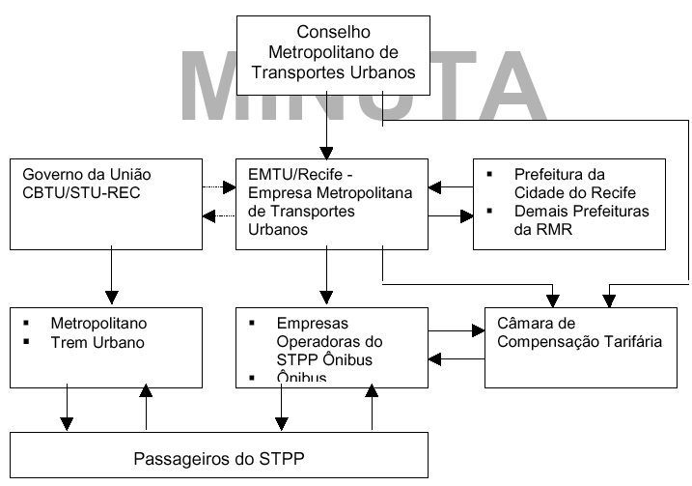

The executive authority for implementation of policy is the “Empresa Metropolitana do Transport Urbanos (EMTU). This body establishes the lines, schedules, frequencies, types of vehicle and all other matters pertaining to the control of inter-municipal bus transport in the RMR. The responsibility for control of intra-municipal bus services rests with the individual municipalities, though Recife and Jaboatao have delegated this responsibility to EMTU. In practice, therefore the bulk of the bus services in RMR are controlled by EMTU, which makes all the effective decisions of a policy nature.
In addition to the institutions already mentioned there exists a regulatory body, Agencia de Servicos Estaduais Delegados do Estado de Pernambuco (ARPE), which was established in January 2000, primarily to exercise economic regulation of the public utilities which had been franchised to the private sector. Although in principal this body might be interpreted as having the powers to regulate public transport services, to date that has not been the case and this function has been performed by EMTU. However, as the state moves towards a systematic competitive tendering of public transport services, ARPE may attempt to assert its role as the regulator in that area as well. It has recently set up an urban transport team.

4.3 Public sector operators
The urban rail system is still owned and operated by the regional unit of the federal urban rail organization (CBTU). Although it is federal government policy to transfer ownership of and responsibility for all urban rail systems to the states this has still not happened in RMR because of the continuing large operation deficit of the CBTU-Recife. The terms for the relationship between the state and the federal government are a matter of continuing discussion.(see below).
Despite the wish of the federal government to dispose of all of the urban rail systems to the states, the Recife metro is still owned and operated by the federal government CBTU. Metro fares have been consistently lower than bus fares. Large losses are incurred and subsidies paid, ostensibly on the grounds that the metro serves poor people. Certainly it would appear that the metro extension under construction, which will increase the metro deficit, will benefit relatively poor people. The restructuring of bus services to feed the metro will increase the number of poorer people able to benefit, though at the cost of paying the integrated fare which will be higher than the metro only fare., Integration of the system is to some extent inhibited by the separation of control. However, the metro is included in the SEI system, and part of the metro subsidy is accounted for by the fact that it is not adequately remunerated for passengers who use the metro for the trunk movement but are distributed local by the buses (to whom they pay the fare). There is now an agreement between the federal government and the local authorities for both the municipality of Recife and the State of Pernambuco to have a representative on the Board of the Metro.
It would also appear, however, that the metro is overstaffed and more costly than it might be under different organizational arrangements. In advising on the possible concessioning of the Metro to the private sector Procenge have estimated the amount that might be saved through a concession
Until 2001 there existed also a municipal trolleybus operation. However, the trolleybus operations were discontinued and the enterprise was sold off to the private sector on competitive tender. The new owner replaced the trolley fleet with buses and entered into a management agreement with another operator, Metropolitana, to maintain and operate the fleet. There is now no public sector operator of buses in the RMR.

Private sector operators
In RMR, bus services are entirely operated by the private sector, with the last public sector activity in public road passenger transport having disappeared with the transfer of the former public sector trolleybus enterprise to the private sector through a competitive tend The private enterprise has subsequently replaced its trolleybus system with diesel buses, and operates in the same way, within the same institutions as the other private sector bus companies.
The bus services are provided under permissions granted by EMTU. Their routes, frequencies and fares are determined by EMTU, and they exercise no formal strategic control over the system. In principal their services are self financing in total, though because not all routes or segments of the region are equally profitable the revenues are redistributed to a certain extent through a clearing house (Camara de Compensacao Tarifaqria – CCT)
There are at present 17 separate private operators of bus services under the auspices of EMTU, with fleet sizes ranging from 33 to 413 in September 2004. Most of these are family owned businesses based in Pernambuco, often associated with other non –transport businesses. One of the smaller operations, CRT, is the former metropolitan trolleybus enterprise purchased by an investor from Rio de Janeiro. The operations, however are concessioned to another existing local operator, Metropolitana.
The bus operators are generally well organized companies practicing modern maintenance policies comparable to those in industrialized countries. There are two syndicates of operators, one generally representing smaller enterprises and one larger ones. They do not always agree, particularly recently over proposals to reform the remuneration system within the CCT, which have been accepted by smaller operators but resisted by some of the larger ones. The two syndicates also have differing political alignments.

Vehicle purchase, finance and insurance
Vehicles are generally purchased directly by the bus companies under the incentives offered by the CCT system. In addition, special lines of credit are available from the national development bank BNDES, with lower interest rates and longer terms than would be available commercially. The warrant for the issue of special terms is given to BNDES by the Ministry of Cities according to federal government policies, with favored terms for special circumstances (integrated systems) or special vehicle types (gas vehicles, articulated buses). A similar special line of credit was established after negotiation between EMTU and BNDES for the replacement of kombis by minibuses, as part of the recent policy for reform of the VPP sector.

Staffing and skills analysis
The general quality of operational staffing within the formal system is good. Public Service Vehicle licences are required by all bus drivers: these are issued by the State Department of Transport. Conductors formally require an intermediate level of education, but there is no check on this. Bus companies undertake their own staff training, and, in the better companies this is done very well. In addition EMTU provide some training for companies. Metro staff have more formal training requirements (for example including first aid training.
In contrast, the informal sector is highly fragmented and staff have little if any formal training.
System planning is undertaken by the responsible authorities – mainly the EMTU. There is no strong land use and transport database, or pool of planning skills, for public transport planning in Recife, equivalent to the PITU in Sao Paulo.

Facilities and equipment
Garaging and maintenance facilities are provided exclusively by the private sector for their own company operations. In one case, that of the concession of the RCT services by Metropolitana, the vehicle maintenance is performed under contract be another operator.
The interchange terminals in the SEI system are separately provided. In most cases they are owned and managed by EMTU. However, in the case of some interchanges with the metro system the terminal facilities are owned by the metro company and operated by EMTU. Also, in one case where there is only one bus operator in the terminal (Metropolitana) the interchange terminal is managed by the bus company. Some consideration has been given to the concessioning of terminal operations to the private sector in future.

Financial environment
Although the bus system is in principal self financing, in practice the CCT has been in serious deficit for some years, with the deficit reaching about Rs 2.5 million per month in the year 2002 ($1 million). This arises from the fact that while the revenues of the CCT are determined by the level of fares and vale transport and student compensations, the basis for allocation of these revenues is the calculated costs of the various operators in providing the services allocated to them. While there is no doubt that the bus sector has been in some difficulty, the real size of the deficit is not entirely clear as there is substantial incentive to, and scope for, the “padding out” of costs in the procedure, as might be expected with cost based allocations.
Given that the rail system also has a deficit of about Rs 2 million, expected to rise substantially with the completion of the extension currently under construction, the total deficit was estimated by Procenge consultants in 2002 to be likely to be between Rs 4.5 amd 5.5 million on completion of the metro.
Three strategies have been considered to limit this deficit. First, the decision to ban the operation of Kombis within the inner areas of the RMR has already yielded a significant improvement in the finances of the CCT, which is in balanced for the first time for a decade. Second, it is proposed (under the terms of a World Bank loan which financed the urban rail extension) to concession the rail system to the private sector. This is expected to result in significant reductions in rail operating costs. Third, it is proposed (but not yet agreed) to introduce a system of competitively tendered franchising of bus services which should be able to further reduce the costs of bus operations. These issues are dealt with in more detail below.

Role of the informal sector
The role of small vehicle transport by the informal sector has been a matter of great controversy and often public unrest in many Brazilian conurbations. While it is recognized that kombis may undermine traditional public transport service, it is also often asserted that the kombis not only provide a very valuable social service in areas where formal public transport is absent or insufficient, but are a significant source of income and employment and income for the poor. Taken together these characteristics may suggest that suppressing them would be a very regressive policy in terms of welfare distribution, and would explain the history of unrest associated with the sector in cities such as Sao Paulo and Rio. Often this has been accentuated by inconsistent or conflicting policies taken by the state and the municipalities in these regions.
The issue has also arisen in RMR. What appears to be special in RMR is that the governments of the state and the major municipality have adopted a joint policy involving vigorous suppression of the sector apparently without the creation of significant political or social problems. That experience requires careful examination and explanation.
The background to that analysis should be an understanding of the actual characteristics of the sector. For RMR the best available source is a report by Cavalcanti, published in 2000. This report brings together data on the number of plates issued together with surveys of operations, operators and users to identify both the objective characteristics of the sector and subjective attitudes to it.
Some of the major findings and conclusions of that report cast light on the outcome of the reforms already undertaken, and the suitability of the RMR approach to other conurbations. The most germane of these conclusions appear to include the following.

- The study suggested a total number of VPP vehicles (kombis) operating in RMR to be about 6,000, over 60% of which operated under permissions granting them the right to carry passengers for payment, but 40% of which had no such legal permission.
- The volumes both of supply and patronage had increased by a factor of 3 between 1994 and 1999 (and probably increased by a further factor of 2 up to the time olf their suppression)
- Of the 105 routes within RMR 87 were totally covered by formal bus services and a further 14 partly covered. Most routes and most VPP vehicle kilometers were directly duplicating existing formal sector routes. Only 1% of the VPP total service was on routes not covered by the formal bus network
- Over 75% of passengers interviewed claimed that they paid less to travel using VPP than on the formal network, a proportion which had increased from only 3% in 1994.
- The VPP did not offer student discounts, but over 25% paid with vale transporte, even though these were not legally valid for use other than on formal sector services. This emphasizes the importance of the secondary market in allowing the VT to have a wider currency than formally provided for.
- 50% of users said that they used VPP because it was quicker than formal buses and nearly 20% because it was cheaper.
- 66% of vehicles were owned by individuals who only had one vehicle; and a similar proportion was owner operated. Nearly half had been in the business for 2 years or less. Over a quarter were in the business because they saw it as the only way to make a living.
During 2003, on the basis of an agreement between EMTU and the Municipality of Recife, the kombis were denied access first within the inner ring road of the city and later from a much wider area. In some areas where kombis remain, they are prevented form using the major roads, and subject to heavy fines (Rs2,0000) and impounding of the vehicle where the infringe. Three unmarked control patrol vehicles are in operation throughout the day. This measure also followed the introduction of electronic ticketing for the VT which eliminated about 25% of their income. Despite the vigorousness of the suppression, there was relatively little unrest from the operators many of whom are thought to have moved to outer municipalities where the constraints are not yet in operation.
Consumer response to the change can be elicited from the results of a survey undertaken in April 2004 by the Institute of Social, Political and Economic Surveys, on behalf of EMTU. 1000 public transport users were interviewed, with a wide range of income, age and residential location. 77% used public transport for work or business, most being bus and metro users. 36% considered public transport to have improved in the previous six months, compared with only 22% considering that it had deteriorated. However, when directly questioned on the effects of the “regularization” of the kombis 32% considered that public transport had worsened, compared with only 30% considering it to have improved. The improvements were seen to have come from improved vehicle flow, together with an increase in the number of buses and bus lines, while the main objections were to the increase in waiting times, inadequacy of total supply and loss of options. EMTU claim that a later survey, after 6 months indicated that about 65% of people approved of the change. However, EMTU admits that it is in the more prosperous inner areas where the response is most favorable. It is therefore possible that there is a substantial minority of losers who have not been compensated for the change, which could have a regressive effect both relatively and possibly absolutely.
Part of the acceptance of the changes appears to have occurred because they were accompanied by a set of measures to facilitate the change. These included:
- Increasing the bus fleet by about 500 vehicles (now down to 400) to increase service, particularly at the peak.
- The franchising of a number of plates for continued operation (but not on the main routes). This eliminated some existing operators who had not got driving licences, etc. It is estimated by EMTU that about 3000 VPP were taken out of the system by the change.
- The provision of a line of credit for the financing of larger vehicles (minibuses instead of kombis)
- Retraining for re-employment as formal bus sector employees (affecting 700 persons) or elsewhere (number unknown)
In the initial round of tendering for the new permissions there was some resistance from the operators and the first tranche was undersubscribed with only 90 bids for 270 places. However, for a second round there have been over 600 bids for 162 places.

Service supply characteristics

Operational characteristics
As described earlier, the bus system has two main components. The first element – the integrated system SEI -accounts for 26% of trips and 33% of passengers carried, while the second, called the Sistema Complementar accounts for 74% of bus trips and 67% of passengers. In November, 2004, on an average working day the system carried 1.412 million passengers per day, of which 723 thousand used the vale transporte and a further 259 thousand had student fare concessions.
The operational details of the two systems for the mo nth of May, 2003 are shown in Table 4. Note that the SEI, despite giving fare advantage to the customer in avoiding double ticketing appears to be the more financially viable part of the system because of the higher load factors that it is able to achieve.
Table 4 The performance of the two elements in the STPP/RMR

SYSTEM | LINES | DEMAND | FLEET | TRIPS | COST COVERAGE
SEI | 64 | 496.330 | 469 | 5.561 | 1,03
COMPLEMENTAR | 300 | 1.000.259 | 1.776 | 16.239 | 0,98
TOTAL | 364 | 1.496.589 | 2.245 | 21.800 | 0,99
Source : EMTU/Recife
By November, 2004 there were 9 interchange terminals and 72 SEI lines in operation using a fleet of 600 buses and 12 train units to carry about 500,000 passengers per day. When completed this is planned to be extended to 23 interchange terminals and 171 lines within the integrated system.
In addition the metro, operated by Companhia Brasileira de Trens Urbanos - Superintendência de Trens Urbanos do Recife-CBTU-STU/REC consists presently of two lines with 10 trains and carries about 140 thousand passengers per day.

Monitoring and enforcement
Because of the system of remuneration, operators have strong incentives both to provide as much service as they can and to use high quality (and high cost) vehicles to supply that service. While neither quantitative nor qualitative inadequacies of service supply are a serious problem in Recife, the nature of the remuneration system within the CCT requires control data both on mileage run and on passengers carried. Services within the STPP/RMR are thus monitored by EMTU on the basis of a Transport Regulation and Manual of Operations. For the most part this is based on returns from the companies, subject to random checks by EMTU. The use of Automatic Vehicle Location (AVL) is envisaged for the future, but not yet implemented.
Another important instrument of control and monitoring of STPP/RMR is the electronic ticketing system SABE (Sistema Automático de Bilhetagem Eletrônica). This automatically records the number of passengers going through the system, as well as the origin and destination of each trip. This system has important advantages for the passenger. It is easy to carry, and in the case of loss can be blocked from use by the finder. It can be used on any line, independent of the fare and allows unpenalised transfers without the need for either paper tickets or closed transfer stations. For the operators the system has also reduced the illegitimate use of the student discount and the vale transporte.

Bus routing and scheduling
Bus routing and scheduling is undertaken by the responsible authorities (mainly the EMTU), both for the SEI and the System Complementar. The authorities also issue permissions for the operation of kombis on a route by route basis. Until recently, as shown by the Cavalcante report (see above), most of the kombi services duplicated the route structure of the formal sector. However, since 2003, the kombis have been reorganized to operate as a complementary system providing feeder services to the formal system, particularly where travel volumes are relatively low.

Income and expenditure statements
The banning of the kombis in 2003 has had some clearly discernible effects on the finances of the bus sector. 18 new bus lines were created and patronage of the bus system rose by 20% (250,000 passengers per day). Peak travel speeds in the inner areas have reportedly increased by up to 30% and bus operating speeds by between 10% and 20%. Fares have been kept constant since April, 2003 and the CCT is in surplus for the first time for several years. New buses have been brought on to the road to arrest the increase in average age of vehicles which had been occurring. (See Table 5)
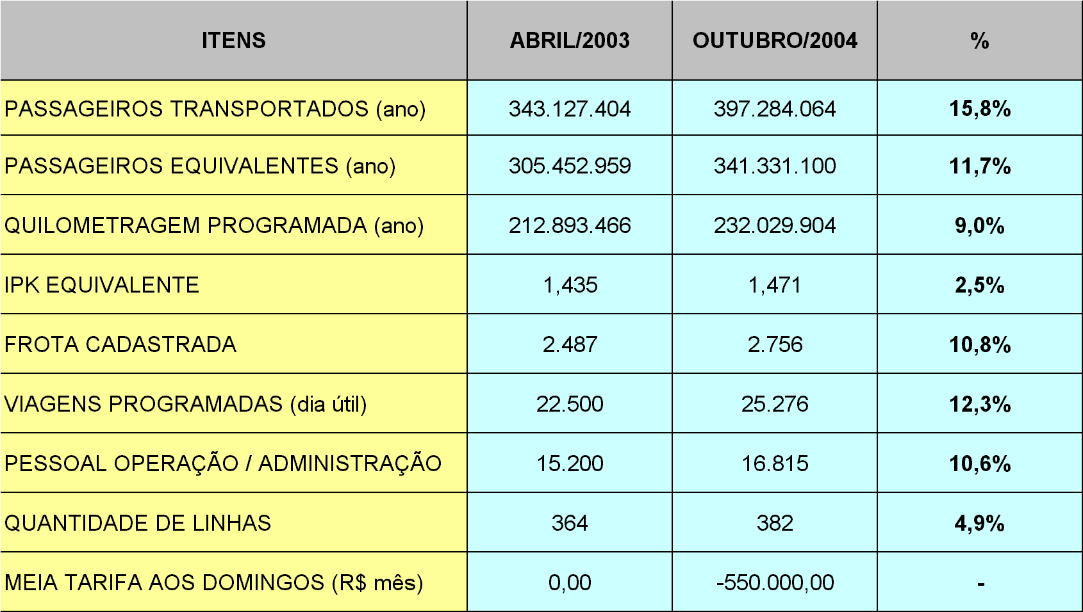
Table 5 Changes in operating performance 2003-4
However, as might have been predicted, costs have risen significantly following the change. (see Table 6)
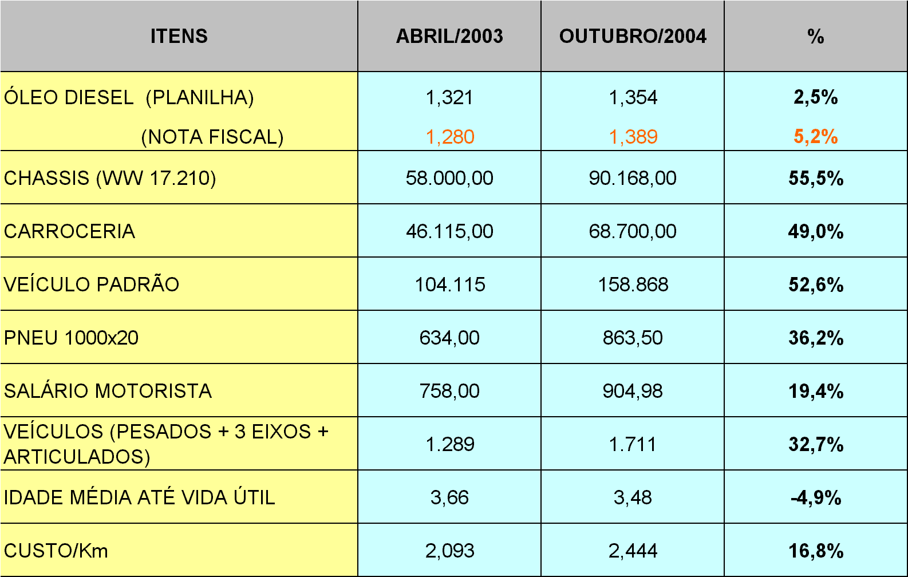
Table 6. Changes in prices, salaries and costs 2003-4

6. Vehicle related data

6.1 Fleet inventory
The total fleet operational on services falling within the CCT at the end of 2004 is shown in Table &. Of a total fleet of 2650 vehicles, 754 were medium sized, 1698 heavy (included heavy with air conditioning) and 60 articulated. The average age of the fleet was 4.92 years, with only 664 vehicles, about 25% of the fleet aged more than 7 years.
Table 7. Fleet by vehicle type and company at end 2004
TYPE | Light | Med. | Heavy | Artic | Heavy  With A/C | Micro/ Mini | Total CCT | Ave Age | No > 7 years
BOA | 27 | 142 | 190 | 18 | 36 | 31 | 413 | 5.28 | 127
CAX | 27 | 77 | 58 |  | 9 |  | 171 | 3.64 | 0
CDA |  | 59 | 112 |  | 33 |  | 204 | 4.63 | 48
CRT | 2 | 34 | 73 |  | 50 |  | 159 | 2.64 | 0
EME |  | 57 | 180 | 12 | 32 |  | 281 | 4.48 | 40
GLO | 34 | 11 | 62 |  | 8 | 7 | 115 | 6.15 | 51
ITA |  | 22 | 181 | 20 |  |  | 223 | 3.40 | 12
MLT | 1 | 36 | 64 |  | 13 |  | 114 | 4.88 | 37
PED | 3 | 36 | 67 |  | 7 | 7 | 113 | 4.90 | 34
RME | 7 | 66 | 90 | 10 | 15 |  | 188 | 5.10 | 72
ROD |  | 30 | 26 |  |  |  | 56 | 5.79 | 28
SJT | 13 | 30 | 36 |  |  |  | 79 | 7.69 | 48
SPA | 18 | 44 | 53 |  |  | 3 | 115 | 6.45 | 53
STA | 6 | 26 | 40 |  |  |  | 72 | 7.15 | 32
TRC |  | 2 | 73 |  | 7 | 8 | 82 | 2.83 | 5
VML |  | 6 | 24 |  | 3 |  | 33 | 4.28 | 1
VRC |  | 76 | 156 |  |  |  | 232 | 5.39 | 76
TOTAL STPP | 138 | 754 | 1485 | 60 | 213 | 42 | 2650 | 4.82 | 664

6.2 Fleet maintenance
The average age of the fleet has remained about 4 years, with steady renewal. (see Table 8.) All companies have well organized maintenance arrangements and the fleet is in very good condition.
Table 8 Distribution of fleet by age, Dec 2004
Year of Purchase | Quantity
1992 | 8
1993 | 7
1994 | 64
1995 | 203
1996 | 299
1997 | 160
1998 | 395
1999 | 271
2000 | 288
2001 | 261
2002 | 220
2003 | 358
2004 | 222
Total | 2,756

Operating costs
Vehicle operating costs are calculated annually by EMTU for the whole fleet operating within the CCT on the basis of information returned. Capital costs are taken as the sum of the linear depreciation on the book value of the vehicles at 12% per annum over a 7 year life with a residual value of 10%, plus a remuneration of 12% per annum on the residual value of the fleet at any time. Fixed costs include the full cost of labor, nearly 90% of which are operational staff costs and the remainder administrative staff. The total complement of staff recorded in the EMTU planning statistics amounted to 4.66 platform staff, 0.40 despatch and control staff per, 0.75 maintenance staff and 0.09 management staff per vehicle operated. The total of 5.90 per is slightly high by industrialized country standards because of the extensive use of conductors, but reasonable by developing country standards where that form of operation is common. The variable costs include fuel, lubricants, tyres and other variable charges. The estimated current costs for 2004 are shown in Table 9.
Table 9 Cost structure of EMTU operations, 2004
Cost item . | Total cost per vehicle | Cost per vehicle km
CAPITAL | 22,216 | 0.220
Depreciation | 13,836
Return | 8,380
FIXED | 109,280 | 1.082
Operating staff | 90,213
Administrative staff | 12,990
Other | 6,277
VARIABLE |  | 0.849
Fuel |  | 0.519
Lubricants |  | 0.037
Tyres |  | 0.144
Other |  | 0.149
TOTAL |  | 2.151

This calculation is used as the basis for imputing the estimated cost increase for the following year, based on data from suppliers. The imputed increases are added to the estimated current costs to obtain an estimate of future costs to which the fare levels are adjusted, in principle to secure full cost coverage.

Regulatory arrangements and institutions

Entry to the market
The award of permissions to operate public transport services is the prerogative of the state for inter-municipal services and the municipalities for intra-municipal services. The set of suppliers is very stable and the existing bus service suppliers mostly obtained their initial permissions many years ago, though there have been some bankruptcies and mergers which have changed the set slightly. The supply is currently structured in overlapping segments of the region – with the segments overlapping mostly in the center.
The present arrangement for the provision of services by private companies is somewhat precarious. Firstly, because they consist of permissions without contracts they threaten an instability and fragility in the business. Second, because the terms of the permissions were constructed in 1980 and renewed since 1991 under the “Avaliações de Desempenho Operacional das Empresas”, they need bringing up to date. Third, the terms of remuneration also have no formal contractual basis, and have been a subject of continuing dispute. It is therefore proposed that in future all services should be provided on contract to the Consortium, and procured by a system of competitive tendering. To date that reform has not yet been implemented.
The VPPs also require permissions which have been issued mostly by the various municipalities. Until very recently there has been little constraint on the issue of permissions, and no competition for them. However, in the recent reform undertaken by Recife municipality the permissions have been limited in number and scope and their award subject to competitive tendering. The VPPs are henceforth to be used as feeder services to the main network.

Fare determination and adjustment
Fares are determined by EMTU, usually on an annual basis, though occasionally, in periods of high inflation, they are adjusted more regularly. The basis of the annual adjustment is a cost calculation undertaken by EMTU, using a standard cost structure and evidence on changes in specific input costs collected from the major suppliers. The costs allowed include costs of capital, including depreciation, based on the actual fleet structure. In principle, the fares adjustment should reflect the high quality of the fleet employed and fully meet any changes in costs.
In practice this has not been the case. The difficulty about this arrangement is that it may not fully catch elements which affect the real cost per passenger kilometre, including the extent to which operators obtain their inputs at a discount from the officially published prices, or the extent to which load factors change in unforeseen ways.

Subsidy mechanisms
There are two main subsidy mechanisms in operation in the RMR.
The “vale transporte” system, which operates in most large Brazilian cities gives travel to work on buses and metro to employees in the formal sector at a cost not exceeding 6% of their earnings. It is funded directly by employers, though the fact that the costs are chargeable as a business expense reduces the liability of the employer to profit taxation and hence effectively passes about one third of the cost to the Federal budget.
Students are also eligible to subsidy of approximately half the ticket cost. This is funded directly from municipal and state budgets.

Effects of unions
Labor unions exist in the sector, and are explicitly provided for in some of the more modern companies, but they do not appear to be particularly strong, or to have very significant effects on the economics of the industry.
There are two syndicates of operators, one generally representing smaller enterprises and one larger ones. They do not always agree, particularly recently over proposals to reform the remuneration system within the CCT, which have been accepted by smaller operators but resisted by some of the larger ones. The two syndicates also have differing political alignments.

Taxation and other incentives
The formal bus companies pay taxation on inputs, and particularly on labor in the same way as other employers.
The main special arrangement applying to bus operators are the preferential loan arrangements afforded to them by BNDES for the purchase of approved types of bus. The effect of this incentive has been to maintain vehicle replacement and a low average vehicle age even in the very difficult circumstances where the revenues available through the CCT fell substantially below the formula calculated payment levels.

Perceived problems and their causes

- The advantages of the existing system
Many issues which have appeared important elsewhere are clearly not problems in Recife. These include:
- Technical competence in the public transport operating sector
- Public transport vehicle age, condition and maintenance
- On the road operational behavior of the formal public transport enterprises
- Responsiveness of the formal public transport network to new demands.
Five major problems which have arisen in the development of public transport in RMR, and which have generated the desire for reform.
- Congestion
Congestion in the central areas has been increasing, and has appeared to require increased efficiency in the use of space by public transport vehicles. EMTU reported that the elimination of the kombis from the central area of Recife had reduced travel times by 10%. That conclusion appears to be supported by the results of the passenger survey

- Decreasing demand and financial viability
Decreasing demand for formal public transport has adversely affected their financial viability, and threatened the continuation of the high quality of service which had traditionally been offered by the sector. Again, however, the elimination of the kombis, with the associated increase of 18 bus lines and around 400 buses operated has been claimed to generate an increase of 250,000 passengers per working day.

- Integration
Integration between services has been viewed as still inadequate, in two respects. First, the SEI system is seen as incomplete. There are plans to engage in a program of investment in new interchange facilities which will permit an extension of the number of lines in the SEI system. Second, there are substantial problems to be addressed in the integration of the Metro within the SEI. Rail fares are below bus fares, and the allocation of revenues between the bus operators and CBTU appear to favour the bus operators. This arises because there are a large number of trips within the integrated system which use a metro leg, but for which the metro does not receive any revenue. So long as the rail system remains in the ownership of the federal government, through CBTU, and receives federal subsidy, this has not been a matter of concern for EMTU or the operators. But, in the event of the transfer of the metro to state ownership, and even more so in the event of its concessioning to the private sector as proposed, the arrangements for integration of the metro will need to be thoroughly revised. The terms of that revision remain unresolved.

- Jurisdictional fragmentation
While good relationships between the central municipality, Recife, and the State have been exemplified by the delegation of the public transport management responsibilities of the municipality to the state EMTU, fragmentation of responsibility between jurisdictions has sometimes led to inconsistent or “beggar my neighbor” policies (for example the ejection of kombis by Recife has accentuated the pressure of kombis in the outer municipalities). The creation of a transport consortium, jointly owned by the state and all the municipalities, is intended to overcome this problem. At the moment it appears that all of the municipalities will join the consortium.

- Financing and management of rail services

As mentioned above, transfer of the CBTU rail undertaking to states, and the commitment to concession it to the private sector, has seemed to require a revision of the arrangements so that a viable concession could be offered within an increasingly integrated system.

Options for reform
9.1 The general reform strategy
The strategy being adopted in the RMR is to further develop the existing SEI by integrating an extended rail network within the system and by creating a strong metropolitan transport agency to act as the public customer, procuring transport services from private suppliers. The intention is that this agency shall manage the system to maintain it in financial equilibrium as far as the state and municipal finances are concerned, by using competitive tendering of service both to improve the efficiency of supply and to ensure that the imbalances which have appeared in the CCT in recent years shall not reappear. Given the intention of integrating the currently highly unremunerative rail services within the system this is bound to be a difficult task.
9.2 The committed reforms
Among the major changes which have already been introduced or which are in the process of introduction are:
- The state and the municipalities will establish a “Consortium” and will transfer the integrated management and development of all public transport modes to this consortium (IFC have been involved in the development of the consortium) 50% plus one of the shares of the consortium will be held be the State, 30% by the municipality of Recife and the rest by the other municiplaities in proportion to the magnitude of their participation in the sector;
- The small vehicles (kombis, VPP) which have operated in a very irregular and uncontrolled way have been driven out of the central municipal area of Recife:
- Some of the kombis are being integrated into the existing system through regulation and issuing of licences through a tendering process.

9.3 Required next steps

The further steps which are required to complete the reform include:

- Joint action by the state and the municipalities to seek investment funds primarily for the development of the road based system.
- Completion of the rail network and tendering of the completed system to the private sector. In order to be able to privately concession the rail services it will be necessary to identify a much more attractive net revenue flow than presently exists. Several elements can contributed to this, including;
  - Reductions in operating costs achievable by private management
  - Guaranteed revenues from a service contract with the EMTU
- Design and implementation of a tendering system for the bus lines. This will require decisions to be made about the form of contracts (gross or net cost); the size of packages (routes or areas); and the duration of contracts. It will be necessary to pay close attention to preventing collusion amongst the existing operators in the introduction of tendered contracts.

Drivers of reform
The reform process has so far been pursued through a close collaboration between the State EMTU and the Municipality of Recife, with support from the bus operators. The State interest was partly driven by the need to find a solution to the problem of concessioning the rail system to the private sector agreed as one of the terms of the World Bank loan which supported the investment in the extension of the rail system. The Municipality also has an interest in the extension of the rail system, and hence the solution of the rail management and finance problems, but has also been concerned about the impact of the kombis on urban road congestion within the municipality. The bus operators were driven by increasing financial pressure as the combination of the kombis and increasing car ownership undermined the financial viability of the CCT arrangement. The creation of the consortium as a strong management and procurement agency able to integrate a privately concessioned rail system within an extended SEI, promised some solution to the public transport problems perceived by EMTU and the Municipality. The driving out of the Kombis helped to meet the road traffic objectives of the Municipality as well as offering very substantial relief to the bus operators.

Obstacles to reform

Some potential obstacles to reform can be foreseen in further analysis of the nature of the drivers of reform hitherto. The driving out of the kombis, and the conversion of the VT into electronic form has put the operators in a much more favourable financial position which some of them at least may not wish to jeopardise by the introduction of competitive tendering of services. By taking these steps in advance of the rest of the reform package, EMTU may find that it has lost its leverage over the operators who may now resist further changes.

The effects of recent changes (most notably the conversion of the VT into electronic form and the driving out of the Kombis) have hitherto given rise to surprisingly little resistance. This appears to be partly the result of the package of supporting measures offered to the kombi operators. However, possible future increases in fares associated with the need to maintain the financial balance of the whole SEI, together with the absence of the alternative which the Kombis offered, may cause future problems. Even if the lack of voice of those adversely affected prevents this from becoming a major politicvical issue there should still be some concern about the potentially adverse effects of the changes on some of the very poor.

Annex 1 Persons consulted

Many people assisted in the preparation of this report. We are particularly grateful to:
Regilma de Sousa
Cristina
for the generously large amount of time and effort that they put into providing data and explaining the intricacies of the existing system. We are also most grateful to the following for spending time to discuss various aspects of the system with us.
Dilson

ANNEX 2 Source Documents

The main documentary and statistical sources used for this report included:

Portarias da Camara de Compensacao Tarifaria. No 109/2004
Governo do Estado de Pernamnbuco. Secretaria de Transportes, Energia e Communicaciones. Resolucao 016/92 Politica e Estrutura Tarifaria
Prefeitura do Recife. Contrato de Adesao de Permissao. 2003
Regiao Metropolitana do Recife. Pesquisa de Opinao Publica. Abril, 2004
EMTU Estudo da Tarifa. Novembro, 2004
GET “Modernizacao do Sistema de Transporte Publico de Passageiros da Regiao Metrolitana do Recife” Outubro, 2003
Procenge. Avaliação Estratégica do Sistema de Transporte Público de Passageiros da Região Metropolitana do Recife. Report for the IFC January. 2003

