Public Private Infrastructure Advisory Facility

Public Transport Reform in Santiago, Chile
1990-2005

(Final Version)

Germán Correa-Díaz
Consultant

Santiago, May 2005
Glossary

ACHIMU, Asociación Chilena de Municipalidades (Chilean Association of Municipalities)
CGTS, Coordinación General de Transporte de Santiago (General Coordination of Santiago Transport)
CORFO, Corporación de Fomento de la Producción (State Corporation for Promoting Production)
3CV, Centro de Control de Calidad de Vehiculos (Center for Vehicle Quality Control), Ministry of Transport and Telecommunications
ETCE, Empresa de Transportes Colectivos del Estado (State Public Transport Company)
INE, Instituto Nacional de Estadísticas (National Institute of Statistics)
MIDEPLAN, Ministerio de Planificación y Cooperación (Ministry of Planning and Cooperation)
MINSEGPRES, Ministerio Secretaría General de la Presidencia (Ministry General Secretary of the Presidency)
MINHAC, Ministerio de Hacienda (Finance Ministry)
MOPTT, Ministerio de Obras Públicas, Transportes y Telecomunicaciones (Ministry of Public Works, Transport and Telecommunications)
SECTRA, Seretaría Ejecutiva de Transporte (Transport Executive Secretary)
SEREMITT, Secretaria Regional del Ministerio de Transportes y Telecomunicaciones (Transport Regional Metropolitan Secretariat of the Ministry of Transport and Telecommunications)
UOCT, Unidad Operativa de Control de Tránsito (Operative Unit of Traffic Control)

Table of Contents

Graphs and Tables 5

Introduction 6

1. Geography and demography 6

2. Political context 10

2.1 Constitutional structure 10
2.2 The party system 10

3. Economic conditions 11

3.1 National economy 11
3.2 Income levels 11
3.3 Percentage of income spent on public transport 14
3.4 Existence of private sector in other public utility sector 14
3.5 Central government policy on private supply in public transport 15
3.6 Local government policy and willingness to reform 15

4. Brief history of public transport 16

5. Public transport characteristics 18

5.1 Public transport patronage: evolution of transport demand 18
5.2 Bus and metro service network 23
5.2.1 Bus network 23
5.2.2 Metro network 24
5.3 Public transport fares 27
5.3.1 Bus fares 27
5.3.2 Metro fares 28
5.4 Ticket types 29
5.5 Passenger load factors and revenues 29
5.5.1 Bus services 29
5.5.2 Metro services 31
5.6 Structure and organization of urban public transport 31
5.6.1 Legal basis for organization and jurisdiction 31
5.6.2 Organizational structure 32
5.6.3 Public sector operators 33
5.6.4 Private sector operators. 34
5.7 Vehicle purchase, finance and insurance 34
5.8 Operational staffing and skills 35
5.9 Bus system facilities and equipment 37
5.10 Financial environment 38
5.11 Role of the informal sector. 38
5. 12 Service supply characteristics 38
5.12.1 A public transport “system”? 39
5.12.2 Some structural characteristics of bus services 39
5.13 The apparent advantages of the existing bus services 44
5.14 Operational characteristics 45

6. Other characteristics of the bus services 47

6.1 Monitoring and enforcement 47
6.2 Bus routing and scheduling 47
6.3 Fleet maintenance 48
6.4 Vehicle operating costs 48

7. Options for reform 53

7.1 Regulation of public transport between 1990-1993 53
7.2 Regulation of public transport between 1994-1999 57
7.3 Reform of public transport 2000-2005 58
7.3.1 Main elements of Santiago Urban Transport Plan 2000-2010 58
7.3.2 The implementation of Transantiago 61

Annexes

- Sources consulted 62
- Total annual number of passengers, revenues, bus/kilometers
and service length of each one of the 326 bus lines of Metropolitan
Santiago in 2004. 63
- Methodology for tariff adjustment for Metropolitan Santiago
tendered bus lines 70

Graphs and Tables

Graphs

Graph 1: The shape and main avenues of Metropolitan Santiago
Graph 2: Modal split of motorized trips in a working day
Graph 3: Modal split of motorized trips in a working day, by income groups. 2001
Graph 4: Travel pattern among/inside zones of Metropolitan Santiago
Graph 5: Existing and new metro lines and Intermodal Transfer Stations under construction

Tables

Table 1: Population by districts in Metropolitan Santiago
Table 2: Evolution of monetary income distribution by deciles of autonomous income
Table 3: Distribution of households income national total. 1990-2000
Table 4: Distribution of the poor in Metropolitan Santiago districts. 2000
Table 5: Percentage of family income spent in public transport by level of income
Table 6: Motorized trips by purpose. 2001
Table 7: Metro passengers transported 1990-2004
Table 8: Evolution of travel demand in a working day. 2002
Table 9: Car rate by household in selected Santiago districts 1991 and 2001
Table 10: Intensity of car use by income groups in 1991 and 2001
Table 11: Metro and metro-bus fares up to december 2004.
Table 12: Annual number of passengers, revenues, bus/kilometers and service length. 2004
Table 13: Metro distribution of trips in a working day by type of passengers and by lines
Table 14: Santiago public transport drivers by level of education.
Table 15: Drivers by age groups in public transport in Metropolitan Santiago
Table 16: Structure of property of the Metropolitan Santiago tendered bus fleet
Table 17: Buses in Metropolitan Santiago by year of fabrication and modality
Table 18: Number of operators by type of bus company
Table 19: Average monthly private cost per passenger ($ passenger) by type of bus company
Table 20: Summary average monthly private cost (Ch$/month-bus) by type of bus company.
Table 21: Average monthly private cost by item and type of bus company
Table 22: Average monthly private costs by type of bus company

Public Transport Reform in Santiago, Chile
1990-2005

Germán Correa-Díaz
Consultant

Introduction

The World Bank, with the financial support of PPIAF, is working in the development of a tool kit to support national and urban policy makers to implement policies addressed at public transport reform, covering the wide spectrum of aspects involved in such a policy. Particularly important in this endeavor is the consideration of the participation of the private sector in the provision of these services as well as in related aspects that make operationally possible to implement such a reform.

In pursuing this objective the World Bank has commissioned a number of studies related to public transport in differents cities of the world. These studies are addressed at describing and analyzing the existing systems, how they have evolved through time, the problems they present, the likely causes and influencing factors of those problems and the way in which governments, whether at the national or at the city level, have tried to cope with such problems through different reform strategies.

The driving idea in the elaboration of this tool kit is that the analysis of the different experiences of public transport reform that can be found in some cities of the world may help to identify not only the causes of the specific public transport problems that a certain city may be encountering. They may help to know concrete strategies, instruments, mechanisms of regulation and institutional arrangements successfully used in those cities, so that policy makers might then carry out informed options as to the specific componentes they might consider in their own policies and solutions for the concrete public transport problems they face.

Such is the case of the selected city of Santiago, the capital of Chile, where some interesting experiences of public tansport reform have been undergoing since 1990, with two particularly important strategic moments of such a process, in 1990-1992 and 2000-2005.

The report has been elaborated on the basis of the existing studies and data on public transport reform in Santiago as well as on the direct personal experience of the author, as the conductor of the two big reform processes of public transport carried out in Santiago, in the periods 1990-1992 and 2000-2003. The first one as Minister of Transport and Telecommunications. The second as chief of the technical team that designed and General Coordinator of the execution (2002-2003) of the Urban Transport Plan for Santiago 2000-2010, known today as Transantiago.

1. Geography and demography

Located in the west coast facing the Pacific Ocean in the southern part of Latin America, and extending for around 4.500 kms., Chile has a population of 15 million inhabitants, according to the 2002 National Census. Annual growth rate was at 1.2% between 1992-2002. The population living in urban areas of the country is 87%.

Metropolitan Santiago is a city located at the feet of the Los Andes Mountains in a flat plain between the Los Andes Cordillera and a string of minor mountains, the Coast Cordillera.

Graph 1
Shape and main avenues of Metropolitan Santiago

Because of its secluded geographical location in a low basin entraped between two importan chains of mountains, Santiago suffers particularly in winter from a phenomenon of thermic inversion. Lack of air streams and low air temperatures at a few meters from the soil place a kind of “cap” over the entire city basin, making very difficult for gases and pollutants to disperse into the atmosphere.This is why Santiago shares with Mexico City the rare “privilege” of being the two cities that show the highest atmospheric contamination in Latin America. Being public transport one of the important contributors to air pollution (the bus fleet in Santiago is completly diesel driven and with defficient maintenance practices), the solution of the public transport problem has a direct significance for the quality of life in the city.

Santiago is criss-crossed from north to south and east to west by a number (55) of two-lanes (both senses) avenues. (See Graph 1). It is also circumvented by a circular ringroad, Avenue Americo Vespucio, at present being re-constructed under a private concession-toll electronic payment scheme which is just beginning to operate, very successfully indeed.

Metropolitan Santiago is composed of 37 districts (comunas) or municipalities. Ten of these districts account for 50% of the population of the city, and two, Maipú and Puente Alto, which are among the fastest growing districts, account for around 20% of the total population of the city. (See Table 1)

The strongest population growth in the last ten years has been in three districts: one in the northern part of the city, Quilicura (126.000 inhabs, 207.7% variation, mostly high middle class), one district located to the southeast, Puente Alto (493.000 inhabs., 93.5% variation, mostly middle class), and one district located in the southwest, Maipú (468.000 inhabs., 82.6% variation, mostly middle/middle-low class).

One-level houses is the predominant type of construction all over the extension of the city, although multiple-story buildings are abundant in the old dowtown and are strongly and extensively springing up in those zones of the city showing high demographic growth in the last ten years This is the case of Maipú, Puente Alto, La Florida, as well as those districts where the main commercial and business activities have been moving from the old center of the city, as Providencia and Las Condes (located in the higher parts of the city, in the east). This trend has been obviously having an impact on a re-distribution of transport demand, both public and private.

In the last twenty years metropolitan Santiago has been showing significant changes in terms of demographic growth and of the territorial distribution of activities. The classical Spanish pattern, where most of the productive, services and entertainment activities were concentrated in a small downtown area, has given place to a pattern of increasing dispersion of activities throughout the whole metropolitan area, and even beyond. As some zones of the metropolitan area have shown an impresive population growth in the last ten years and continue to grow, new huge malls, supermarkets, public services buildings, cinemas and sports centers have erupted elsewhere. People have changed their pattern of movements around the city accordingly.

The upper class sectors moved out of dowtown by the beginning of the 50´s to the upper parts of the city and this process of moving each time farther away from downtown has increased in the last twenty years. This pattern also characterizes the development of many of the cities of Latin America (but not only) today. Middle-class sectors have also followed a similar pattern of moving farther away from the historical center of the city, living in far away extensive and protected “condos” (some may be 2.500 houses big). In this situation, the more intensive use of the car and the multiplication of cars by family have been the ensuing trends.
Table 1
Population by districts in Metropolitan Santiago

District | Population | % Variation | Urban | Rural
Quilicura | 126.518 | 207.7 | 125.999 | 519
Huechuraba | 74.070 | 19.9 | 74.070 | 0
Recoleta | 148.220 | -10.0 | 148.220 | 0
Conchali | 133.256 | -12.9 | 133.256 | 0
Independencia | 65.479 | -15.8 | 65.479 | 0
Vitacura | 81.499 | 2.7 | 81.499 | 0
Las Condes | 249.893 | 20.1 | 249.893 | 0
Lo Barnechea | 74.749 | 49.3 | 72.496 | 2.253
Providencia | 120.874 | 8.7 | 120.874 | 0
Pudahuel | 195.653 | 41.8 | 192.258 | 3.395
Renca | 133.518 | 3.5 | 133.518 | 0
Cerro Navia | 148.312 | - 4.8 | 148.312 | 0
Santiago | 200.792 | -13.1 | 200.792 | 0
Quinta Normal | 104.012 | -10.6 | 104.012 | 0
Lo Prado | 104.316 | - 6.0 | 104.316 | 0
Estación Central | 130.394 | -7.5 | 130.394 | 0
Cerrillos | 71.906 | -1.0 | 71.906 | 0
P. Aguirre Cerda | 114.560 | -12.2 | 114.560 | 0
Lo Espejo | 112.800 | -6.1 | 112.800 | 0
La Cisterna | 85.118 | -10.1 | 85.118 | 0
El Bosque | 175.594 | 1.6 | 175.594 | 0
La Pintana | 190.085 | 12.1 | 190.085 | 0
San Ramón | 94.906 | -5.9 | 94.906 | 0
La Granja | 132.520 | -0.6 | 132.520 | 0
San Miguel | 78.872 | -4.8 | 78.872 | 0
San Joaquin | 97.625 | -14.4 | 97.625 | 0
Macul | 112.535 | -6.8 | 112.535 | 0
Ñuñoa | 163.511 | -5.3 | 163.511 | 0
La Reina | 96.762 | 4.7 | 96.762 | 0
Peñalolen | 216.060 | 20.2 | 216.060 | 0
La Florida | 365.674 | 11.2 | 365.563 | 111
Maipú | 468.390 | 82.6 | 464.882 | 3.508
Puente Alto | 492.115 | 93.5 | 492.603 | 312
San Bernardo | 246.762 | 29.3 | 241.138 | 5.624
Colina | 77.815 | 47.5 | 62.811 | 15.004
Lampa | 40.228 | 60.7 | 28.229 | 11.999
Til Til | 14.755 | 14.9 | 8.161 | 6.594
TOTAL | 5.540.148 |  | 5.490.829 | 49.319
Source: Instituto Nacional de Estadísticas, INE, Censo 2002

The poor, in turn, have been displaced far away from the historical center and from the areas where middle- and upper-middle class “condos” have developed, concentrating predominantly in the periphery of some of the zones of the metropolitan area (Graph 2, Zones A, C, F, H). For them public transport is an unavoidable necessity. They tend to work in places that are usually many kilometers away, mainly in the upper parts of the city where the well off people tend to live (Graph 2, Zone B, E, I, J) as well as in downtown (Graph 2, Zone D). Walking or bicycling are not very reasonable options for them. (Nevertheless during the 1998-2001 drastic slow down of the economy, when unemployment went up significantly, there was a significant increase in the use of those non-motorized modes of transport).

2. Political context

2.1 Constitutional structure

The political organization of the Chilean State is unitary with a strong presidential regime. The President is elected every six years (although a constitutional reform willl be voted soon in Parliament to reduce the period to four years, as it was before 1994). The Parliament has two houses. The Senate, of 38 members whose mandate is of eight years. The Senate is renovated 50% every four years according to the number of the Region the Senators represent, even Regions first and then odd Regions. The House of Representatives, with 120 representatives, is completely renovated through elections every four years. The Parliament is usually very sensitive in relation to public transport issues, because it is a problem of high preoccupation of the citizens and it has a permanent visibility in the media.

Chile has also a decentralized intermediate level of government, the Regional Governments in each one of the 13 Regions of the country. The RG is headed by an Intendente, appointed by the President of the Republic. The Intendente presides over the Regional Council, whose members are elected by the Municipal Councilmen of all the municipalities of the Region. Regional Governments have their own competences, resources and administrative staff. They deal primarily with regional and local development matters and they have no important competences in relation to public transport.

There are 351 municipalities in the country. Mayors are elected democratically every four years together with the election of the Municipal Council members. Mayors have some competences on public tansport matters, but of a limited nature.

2.2 The party system

There are two big party coalitions in the country. The governing coalition since 1990 is the Concertación de Partidos por la Democracia (or Concertación), constituted by an alliance of Center and Left parties. There is also an opposition coalition, Alianza por Chile, constituted by two Rightist parties that strongly supported the Pinochet regime. Besides, there is the Communist Party (with 7% of the national vote) and three or four small leftist parties and neither of these parties have representatives in Congress, because of the existing electoral law (approved in the last days of the Pinochet regime), based on a binomial mechanism that favors big party coalitions.

After recuperating democracy, from 1990 on Chile has experienced a long period of unprecedented stability, growth and social peace, inspite of the difficulties and some strained moments of the transition from dictatorship to democracy. This has allowed the country to look at the problems stemming from growth and modernization with a parsimonious and longer view.

Since 1990 the country has been ruled by the same Center-Left political coalition and this political continuity has given the opportunity to develop long term public policies on a number of issues. Each consecutive Administration building upon the advances made by the previous one. This has also been particularly significant for the public transport area.

Chile has been undergoing deep processes of change since the late 80´s on. If in the 80´s and begining of the 90´s it was the national economy the main object of such changes, since the middle of the 90´s structural changes have extended to other important national areas, as the reform of the Judicial System, the Health Reform, the Education Reform, E-Government Reform and also Public Transport Reform in Santiago. As a result, there is in the country an openness to change and a willingness to reform what is needed, and this positive predisposition to change crosses all along chilean society and institutions.

3. Economic conditions

3.1 National economy

One the basis of the structural reforms started in the 80´s, Chile has become a strong exporter of its main products, that is, copper and mineral products in general, forestry, fishing (Chile reached last year the significant place as first world exporter of salmon, displacing Norway from that position), fruits.

As of the year 2000 Chile had a per capita income of USD$ 4.603 and it increased in 66.3% between 1989-2000. It is estimated that at present is around USD$ 5.000. The distribution of income, however, is quite unequal. Since 1990 the average annual economic growth rate of the country has fluctuated around 6%. Exception to this trend was the period 1998-1999, when the country suffered the impact of the Asian economic crisis and growth went down to 2,3%, recovering in 2000 to 4,5%.

In 2005 it is estimated that growth will be around 5.6%. Investment in the period 1989-2000 grew 113,8%, reaching almost 16 billion dollars in 2000. Unemployment has fluctuated between 5,3 in 1997 and 8,9 in 1999.

3.2 Income levels

The evolution of income distribution in a number of years can be seen through the data presented in Table 2.

Given the sustained level of economic growth along 15 years, there has been an overall improvement in the life conditions of Chileans in general, including the poorest sectors. Acquisitive power has grown for all sectors of society. Even low income sectors that in the past did not have access to a number of goods and services, today they do and those goods have become a part of their usual consumption pattern. That is, although wealth disparities persist, there has been a general raise in the material conditions of life for most of the population. This has had a direct impact on urban transport, as will be seen later on.

However, wealth disparities are still important and they have not changed, inspite of all the efforts that the three successive democratic governments have made since 1990. Actually, there has been a sustained effort to improve income distribution and to mitigate poverty through a number of very active and strongly funded social policies as well as through directly focused subisidies in poor sectors.
Table 2
Evolution of monetary income distribution according to deciles of autonomous income 1987-1996. (Percentages)

Decil of autonomous | Distribution of monetery icome
income | 1987 | 1990 | 1992 | 1994 | 1996
1 | 1,5 | 1,6 | 1,7 | 1,5 | 1,4
2 | 2,8 | 2,8 | 2,9 | 2,8 | 2,7
3 | 3,6 | 3,7 | 3,8 | 3,6 | 3,6
4 | 4,3 | 4,5 | 4,7 | 4,6 | 4,6
5 | 5,4 | 5,4 | 5,6 | 5,6 | 5,5
6 | 6,3 | 6,9 | 6,6 | 6,4 | 6,4
7 | 8,1 | 7,8 | 8 | 8,1 | 8,1
8 | 10,9 | 10,3 | 10,4 | 11 | 11
9 | 15,9 | 15,1 | 14,7 | 15,4 | 15,4
10 | 41,3 | 41,8 | 41,6 | 41,3 | 41,3
Total | 100 | 100 | 100 | 100 | 100
20/20 | 13,3 | 12,93 | 12,24 | 13,12 | 13,83
Source: MIDEPLAN, CASEN Surveys 1987, 1990, 1992, 1994, 1996.

As it is well known, the highest 9 and 10 deciles get the bigger proportion of income, near 60%, and the variation between 1990 to 1996 is from 57,2% to 56,7%, just 0,5.Distribution of income looks extremely consolidated in all deciles. Of course this should have some meaning for social policy design and beyond. Apparently, the emphasis should be placed somewhere else to really improve this very unequal income distribution, but this is not a subject of this report.

Another set of data shows a similar situation related to income distribution in Chile:

Table 3
Distribution of households income (a/), national total 1990-2000

Year | Average | Participation in total income of the |  |  |  | Relationship of average
 | income b/ | poorer | following | 20% preceding | richest | per capita income c/
 |  | 40% | 30% | richest 10% | 10% | D10/D(1 to 4) | Q5/Q1
1990 | 9,4 | 13,2 | 20,8 | 25,4 | 40,7 | 18,2 | 18,4
1996 | 12,9 | 13,1 | 20,5 | 26,2 | 40,2 | 18,3 | 18,6
2000 | 13,6 | 13,8 | 20,8 | 25,1 | 40,3 | 18,7 | 19
Source: UN Economic Commission for Latin America and the Caribbean, Social Panorama in Latin America
2001-2002.
a/ Households of the whole country ordered according to per capita income.
b/ Average monthly houseold income in multiplos of the poverty per capita line
c/ D (1 to 4) represents the 40% of lower income households, while D10 is the 10% of highest income households

Real wages increased at an annual average of 3,6% and the minimum salary increased 5,8% average per year.
Inspite of the fact that income inequalities persist, since 1990 there has been an impressive reduction of poverty by almost a half (from 32% by the end of the 80´s to 18% at present). This data is of great importance for public transport, since the lower income sectors are the heaviest users of public transport. If they continue to improve their conditions there is a potential for greater transport demand in the next future. Table 4 gives an idea of the distribution of the poor in Metropolitan Santiago by 2000. The total amount of the poor is 14,3% of Santiago population (5.540.148)

Table 4
Distribution of the poor in Metropolitan Santiago districts. 2000

District | Poor** |  | Zone in Map**
 | Number | %
La Pintana | 77.952 | 9,82 | F Southwest
Puente Alto | 76.741 | 9,66 | J South
San Bernardo | 50.080 | 6,31 | H South
El Bosque | 42.191 | 5,31 | H North
Cerro Navia | 40.910 | 5,15 | A South
Renca | 40.439 | 5,09 | A South
La Florida | 37.414 | 4,71 | E Southeast
La Granja | 34.174 | 4,31 | G Center
Penalolen | 33.402 | 4,21 | E Southeast
Pudahuel | 31.722 | 3,99 | C West
Lo Espejo | 31.185 | 3,93 | H North
San Ramon | 29.598 | 3,73 | G South
Maipu | 27.909 | 3,51 | F Southwest
Conchali | 27.527 | 3,47 | B North
Recoleta | 25.078 | 3,16 | B South
Quinta Normal | 19.219 | 2,42 | D West
P. Aguirre C. | 18.005 | 2,27 | F North
Lo Prado | 17.341 | 2,18 | C Northwest
Macul | 17.238 | 2,17 | G East
Santiago | 16.897 | 2,13 | D Center
Estacion Central | 16.735 | 2,11 | D Center W.
San Joaquin | 16.226 | 2,04 | G Southeast
Huechuraba | 14.037 | 1,77 | A North
La Cisterna | 11.679 | 1,47 | H North
Quilicura | 9.191 | 1,15 | A North
Cerrillos | 7.458 | 0,94 | C East
Independencia | 7.273 | 0,92 | B South
San Miguel | 6.094 | 0,77 | G South
Nunoa | 3.930 | 0,49 | E Northeast
La reina | 3.644 | 0,46 | E Southeast
S. Jose de Maipo | 2.340 | 0,29 | J Southeast
Las Condes | 499 | 0,06 | B East
TOTAL | 794.128 | 100
Source: MIDEPLAN, CASEN Poverty Survey 2000
* People employed in domestic service and their relatives are excluded
** See map of Metropolitan Santiago zones in Graph 4.

3.3 Percentage of income spent on public transport

Recently produced information by SECTRA, based on the 2001 EOD or Travel Survey shows an expected result (See Table ). There is of course a great variability of the percentage of their income that families spend on public transport. Poorer groups may reach the quite significant proportion of 16,2% of the family income spent monthly in public transport, while high income groups spend only 0,5%. It is therefore not surprising that it is the poor that prefer, or are obliged to prefer, walking and bicycling to move around.

Table5
Percentage of family income spent in public transport by level of income
(in 2001 Chilean pesos)

Monthly average family income
by income level
High | Middle | Low
2.628.909 | 590.724 | 160.914
Monthly total expenses in public transport
by income level
High | Middle | Low
14.426 | 31.162 | 26.047
0,50% | 5,30% | 16,20%
Source: EOD or Travel Survey 2001. Data elaborated by SECTRA, 2002

Besides, since the poor tend to live in the periphery of the city and usually find work (construction, house services) at the far away districts where the rich and middle class live, they usually have to use two or three buses to get there. Therefore, the proportion of the family income that goes to public transport is necessarily higher for those groups
This is why when they go back to home in the evening it is common to see them at the corners asking for a ride in order to save some money.

3.4 Existence of private sector in other public utility sector

Chilean economy is highly liberalized. The private sector has an ample presence in all kinds of productive and service activities, even in the mining sector, a traditional pivot of national economy, where the State-owned company, CODELCO, although one of the world´s six biggest corporations, has only 38% of the national copper production.

The process of privatizing a number of State companies started under the dictatorial regime in the 80´s. Then, electricity, telecommunications, gas, pension funds, health services, and other companies were privatized. Supervision of these services was carried out by different regulatory bodies, as the Undersecretary of Telecommunications, the Superintendence of Gas and Electric Services, the Superintendence of Social Security and so on.

Under the democratic Administrations that have succeeded each other since 1990 the privatization process continued although not so massively as under dictatorship. Thus, public utilities as drinking water, sewage system, as well as shipping, railways, ports and other companies have been privatized. On the other hand, the very successful policy of building freeways and roads, and even urban roads, through a private concession scheme has been extended to other areas, as new prison facilities and new buildings needed for the Judicial System reform.

3.5 Central government policy on private supply in public transport

Public transport has always been considered in Chile a responsability of the State, in terms of ensuring the existence of such a service. But public transport has always been a predominatly private activity in Chile. It has been this way throughout different Governments, with very radically different ideological leanings, from the extreme right to the left. Since the first services of public transport were established in Santiago and then, slowly, in the main cities of the country by the beginning of the 20th Century, they were a private activity.

Public sector participation, when it happened, was mostly State participation and it was minoritary in terms of demand coverage. It was between the 30´s and 60´s that the State was also a provider of this service, first with the tramway and later on with buses and troleybuses, and in the 70´s with the metro network. In the most flourishing period of the State-owned public transport company (Empresa de Transportes Colectivos del Estado, ETCE), in the 70’s, no more that 20% of the demand was covered by its bus and troley services. ETCE was eliminated in 1975 by the military regime.

The only service provided by the State is the metro network, mostly because of the size of the investment implied. No attempts to privatize it have existed ever and no political sector has proposed ever to do it, mostly because it is a very efficient public company and it provides a very good service.

The Santiago Metro network is still owned by the State, although it is organized as an autonomous public company. Is is very efficient both in terms of quality of transport service as well as in terms of administrative and financial management. Actually, is one of the few metro companies in the world that covers with its own revenues both its operational costs as well as 30% of its investments.

3.6 Local government policy and willingness to reform

As stated, Municipalities have never had a significant role in terms of public transport services. It has always been the State responsability.
Some Municipalities have had sometimes public transport services, but they have been very limited and practically irrelevant from the standpoint of demand. For instance, the Municipality of La Reina, with a population of around 100.000 inhabitants, has a public transport service served by only 10 buses, which only attends a single route, basically to approximate neighbors to the main supermarkets, banks, and local public services of the district, with 7.000 trips per month.

Municipalities have usually been rather at the side of the neighbors asking the Government for new services to be created or existing services extended to better serve new demand sectors that emerge as the city grows and expands. Even though there is an Asociación Chilena de Municipalidades, ACHIMU (Chilean Association of Municipalities) and a Metropolitan Chapter of this Association, the subject of public transport has never been in their agenda with the Government. Municipalities feel, as public opinion at large also, that it is the State´s practically exclusive responsability to ensure the existence of this service.

4. Brief history of public transport

Historically the role of the State has definitely been that of regulator rather than of provider of these services. Up until the 80´s regulation was traditionally quite encompassing indeed. It went from establishing the routes to determining fares and the value of a special fare for students of public schools (which started in the 50´s), as well as making possible for private operators to buy their buses through soft credits.

The latter very often ended up being a kind of “subsidy”, what happened when a great bulk of the operators could not pay (or just stopped paying, which happened particularly in election years), and the State came in their help bailing them out of their debts. In sum, the influence of politics into public transport and viceversa was historically very strong.

The only way the State could somewhat counterbalance the power of the tradeunionized operators was through its own transport company, ETCE, the only one that remained running when the private operators went on strike, what happened often. Around the 30´s and 40´s the State company used to run a tramway system, but then, by the end of the 50´s, tramways were gradually withdrawn, the trams paved over, and gasoline and diesel buses, as well as troleybuses, came into business.

One of the more important changes in public transport in recent times occurred under the military dictatorship, between 1973-1989. First, the State-owned public transport company, ETCE, was dissolved, its buses and troleybuses sold or dismantled. Second, in accordance with the extremely liberalized economic model that came into place in the country as a whole from 1982 on, public transport was completely de-regulated. So much so that the only requisite that an operator had to comply with to get into business was to have the periodical technical revision of the vehicle done right on time.

During the dictatorship the policy for this activity was based on three principles. One, of constitutional character, “freedom to work” and “freedom of enterprising”, that is, anyone who wanted to start a public transport business (or whatever business for that matter) had the complete freedom to do so, with no previous permission from the State, with no “entrance barriers” or requisites whatsoever.

Second, “freedom of routing”, that is, each operator established his/her own route and he/she could change it whenever he/she wanted, without even informing the transport authority about those changes; as for the users, they got their information about these modifications just from the sign in the windshield that every bus carries describing the whole route of that particular line of buses.

Third, “tariff freedom”, that is, each operator was free to charge as much as he/she wanted for the service provided and to change the tariff whenever he/she wanted. Such a freedom was limited, anyhow, by the agreements on tariffs usually taken by the two trade unions that historically have grouped the operators in Santiago. This type of “oligopolic” practice on this (and other) matters has been historically characteristic of the behevior of public transport operators.

In this strongly deregulated environment, all out “competition” was the name of the game. But it was not a competition in terms of who provided the best service, but competition in terms of who “grabed” first the passengers waiting on the street.

This competition on the streets has been a result of two mutually strengthened factors. One, the way in which drivers are remunerated. The fixed part of their salary is but a small fraction, 15%, of what they earn, the biggest portion coming from the tickets they sell onboard; and since each driver is tied up to one specific bus, hired by the owner of that specific vehicle, he earns only what that specific bus makes during the day). The other, the bus property structure and the way in which operators organize themselves, and still do, to deliver the service, as we shall see later on.

If the model of liberalization of the Chilean economy worked rather well in general for the different sectors of the economy -although with very high social and human rights costs-, in the public transport sector it was a huge failure, as all the political and social actors of the country amply recognized it by the end of the 80´s. “Freedom of enterprising” became chaos in this sector.

Perhaps public transport was the area in which the neoliberal model imposed by the military dictatorship was more heavily ideologically applied. No consideration was given to the specific and very particular characteristics that this activity has historically had in Santiago and in Chile in general.

The result was that by the end of the 80´s there was an oversized and overaged bus fleet (14.000 buses of an average age of over 12 years), an excessive tariff in relation to actual costs, badly maintained buses, high levels of emission of pollutants, users´ and citizens´ high degree of disatisfaction with public transport. Actually, public transport operators are frankly hated by the people at large, users and non-users alike, because of the bad treatment the first ones receive on board and the agressive and dangerous way in which bus drivers usually drive their vehicles. They race at high speed in very congested streets to “grab” a passenger before the bus coming behind “grabs” it, producing a high rate of traffic accidents, with a high cost in lives lost and injured people. The main cause of death of the people in Santiago is not heart strokes or cancer, but traffic accidents. And in 85% of traffic accidents there are public transport buses involved.

For market economy to function adequately a number of conditions are needed. An important one, rarely referred to, is the need to have at least entrepreneurs, hopefully good ones, in terms of imagination, innovative drive, modernizing-oriented, taking good care of their costs and permanently making an effort to raise profit by way of increasing productivity and efficiency and improving the quality of the product or service that they trade. This kind of entrepreneur, or even something somewhat resembling these characteristics, did not and does not exist in Chilean public transport. On the contrary, Chilean public transport operators defy all market rules and rationality.

But, actually, is not completely their fault but the fact that in every government the country has had, up to 1990, there was a consistent disregard for this important sector, in terms of public policy. This activity was regulated, controled, negotiated with, but there never was a development policy specifically designed and implemented geared at modernizing it, at the same rythm that the country was being modernized throughout the rest of its productive activities or industries, of goods and services.

Public tansport operators have been traditionally feared by governments of every political color, since the 1930´s on, because of the power they have to stop completely the city whenever they choose to do so. Even the dictatorial regime that ruled Chile from 1973 to 1989 feared them and never did anything that could anger the operators and make them think about the possibility of becoming allies of the democratic movement opposing dictatorship. Once, when a military Minister try timidly to do something to improve public transport, the operators stopped the city and the Minister had to resign.

As the popular saying goes in Chile, when referring to the attitude of governments towards public transport operators, “no one dares to bell the cat”. Actually, public transport operators were usually seen by politicians as “tigers” rather than “cats”. Up to 1990, when the first consistent and technically sound policy on public transport was designed and implemented. Then, a second and very important change took place in the history of this activity.

5. Public transport characteristics

5.1 Transport patronage: evolution of transport demand

The way in which Santiago has been evolving from the urban development standpoint has been bringing also quite important changes in the way in which activities are organized in the urban space and in the way people move around that space. The effect of these changes on public transport have been evident and quite important, as it has been pointed up before. Such changes should affect the conception that one should have about the solution of public transport problems needed for a city showing the abovementioned trends as well.

Chilean sustained economic growth in a long timespan and the changes taking place in Santiago and their impact on urban transport are clearly reflected when an analysis is made of the evolution of transport demand in this city in the decade that goes from 1991 to 2001. The data basis of such an analysis come from the massive Travel Surveys (EODs) made in 1991 and 2001. To have these two surveys has the great advantage of allowing the perception of trends and therefore of analyzing the nature of the changes occurred, hypothesizing about their probable causes. These surveys become, therefore, an important instrument for transport planning.

In 2001 the total amount of trips in a working day was 16.481.043. Motorized trips were 10.147.247 and non-motorized were 6.333.796. The latter refer to people who walk or make use of the bycicle. Purposes of the total number of daily motorized trips were as indicated in the following Table 6.

Table 6
Motorized trips in a working day by purpose. 2001

Purpose | Nr of Trips
To study | 1.941.573
To work | 3.684.127
Others | 4.521.547
Total | 10.147.247

As for public transport demand, Graph 2 shows that looking at the modal split transport in buses fell 20 percentage points in a decade, while travels by car increased in the same 20 points. At the time these results were delivered to public opinion, they led the President of the Republic to say, “we are loosing the strategic battle”. Meaning that in a city as Santiago where traffic congestion has risen and car use has increased as much as public transport has fallen, the future for the city is rather bleak in terms of congestion and worsening of air pollution.
Graph 2
Modal split of motorized trips in a working day in 1991 and 2001
2001
1991

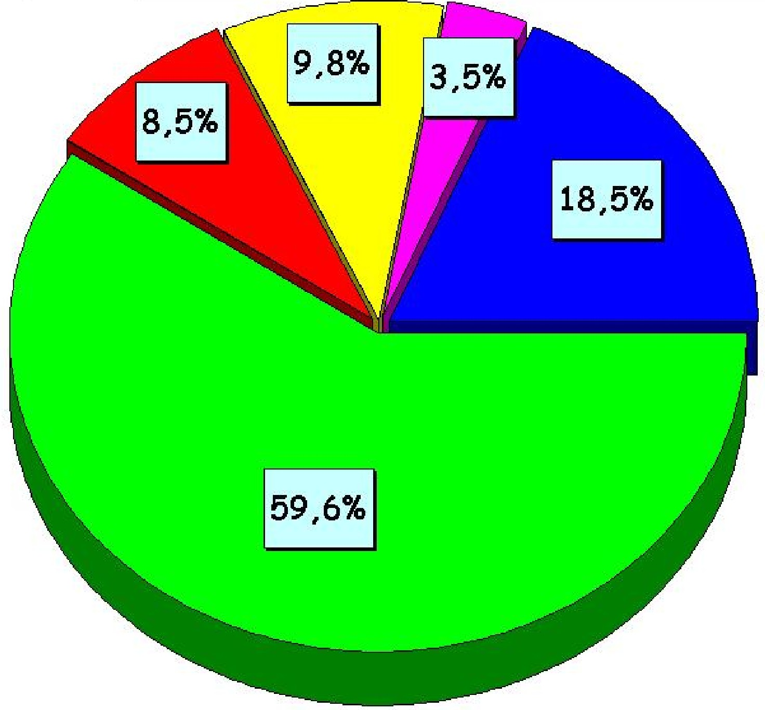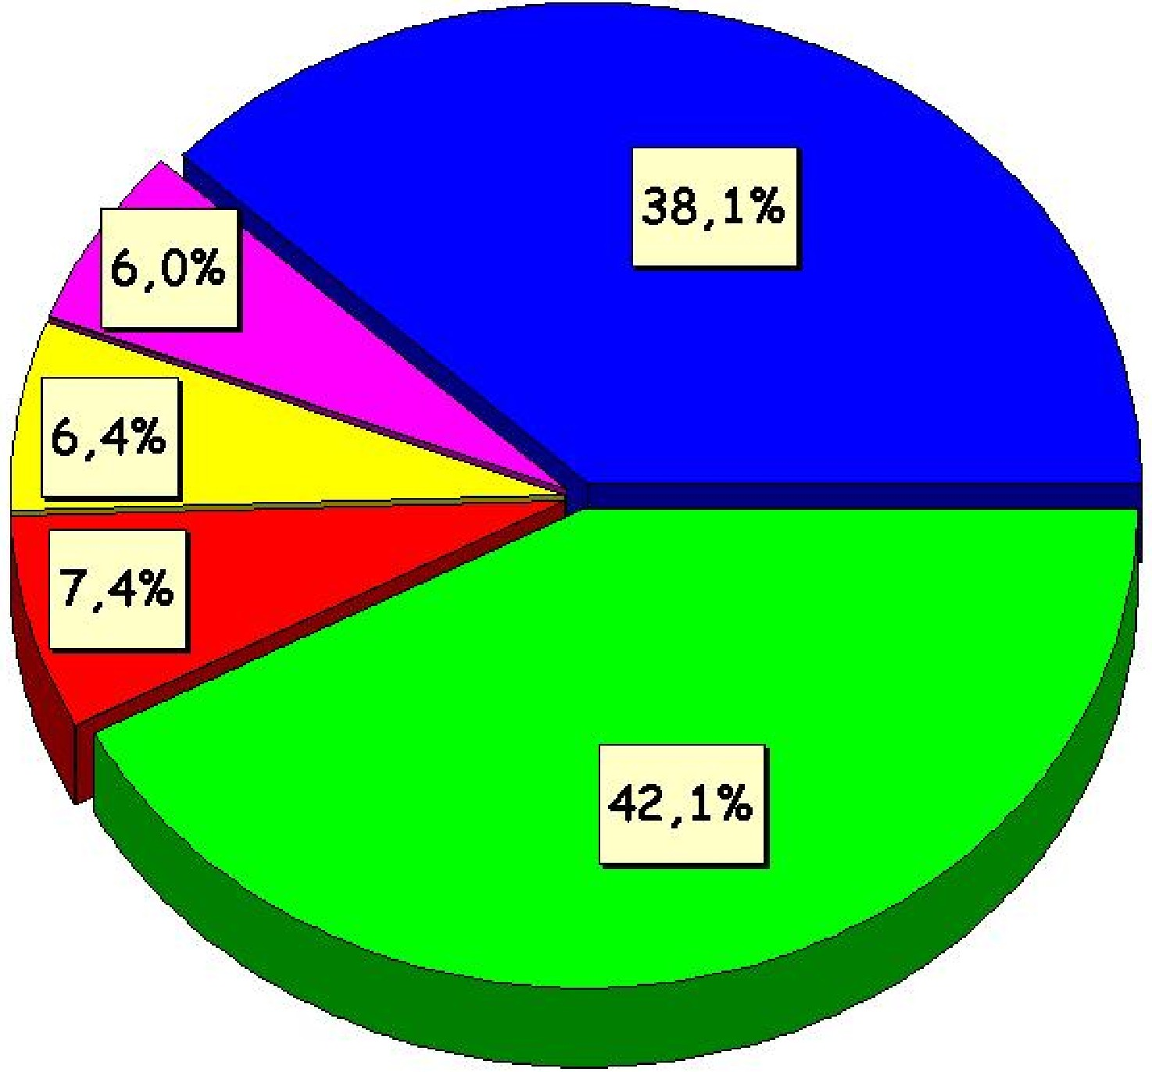
metro
5.996.118

10.147.247

auto
bus
other
taxi-shared taxi
This, of course, unless there is a substantial improvement of public transport and some measures are taken in relation to car use, which is the reason why the Government initiated in 2000 the ambitious Urban Transport Plan that will be described later on.

Although in absolute numbers there was an increase of 19,6% in transport by bus, car traveling increased also in absolute numbers in 276%.

As for the metro use (See Table 7), although it increased 46,3% in absolute numbers between 1991 and 2001, it also fell 16,2% in the modal partition, from 8,5% to 7.4%, inspite of the fact that the quality of the metro service is highly valued and praised by the citizens. Therefore, the decline in public transport demand shows a certain degree of independence in relation to the transport technology and even quality of service, overriden by car use.

Table 7
Metro passengers transported 1990-2004
 | 1990 | 1991 | 1992 | 1993 | 1994 | 1995 | 1996 | 1997
Passengers | 155,1 | 155,5 | 160,6 | 164,2 | 167,1 | 166,5 | 178,5 | 199,7
(in thousands)
 | 1998 | 1999 | 2000 | 2001 | 2002 | 2003 | 2004
Passengers | 196,4 | 184,8 | 207,8 | 202,5 | 198,9 | 203,3 | 231,8
(in thousands)

In Table 8 are shown other data that allow to see some other characteristics of the way urban transport demand is behaving. It can be seen that not only the use of private car increased significantly but also the use of shared taxis, which is the public transport mode more similar to the private car.

Table 8
Evolution of travel demand (motorized travels) in a working day

Mode | 1991 | 2001 | Var. (%)
 | Nr. % | Nr. % | Nr. %
Public
Metro | 510594 8,5 | 746928 7,1 | 46,3 -16,2
Alone | 291147 4,9 | 400307 3,8 | 37,5 -21,3
Combined | 219447 3,7 | 346621 3,3 | 58,0 -9,6
Buses | 3575942 59,6 | 4275913 40,8 | 19,6 -31,5
Shared taxis | 143352 2,4 | 406302 3,9 | 183,4 62,3
Sub-total | 4229888 70,5 | 5429143 51,8 | 28,4 -26,5
Private
Car | 1111772 18,5 | 3864938 36,9 | 247,6 99,1
Only driver | 772888 12,9 | 2353281 22,5 | 204,5 74,3
Accompanied driver | 338884 5,7 | 1511657 14,4 | 346,1 155,4
Taxi | 69143 1,2 | 206547 2,0 | 198,7 71,0
Others | 585315 9,8 | 971445 9,3 | 66,0 -5,0
Sub-total | 1766230 29,5 | 5042930 48,2 | 185,5 63,5
Total | 5996118 100,0 | 10472073 100,0 | 74,6 0
Source: Gibson, Jaime, “Análisis de Escenarios de Demanda”, (“Analysis of Demand Scenarios”), based on EOD Surveys 1991 and 2001 and data from Metro S.A., Coordinación General de Transporte de Santiago, 2002.

And this is worrying too because there are cities in Chile where shared taxis have ended up “killing” bus services, producing high levels of congestion in the main avenues and streets of those cities. However, when cities grow the most basic rationality would indicate that it is bus transport services the ones that should be developed, therefore reducing the role and importance of shared taxis.

Things have become complicated in relation to shared taxis because in the last few years and up until the creation of the Santiago Urban Transport Plan, SUTP, there had not been a policy addressed at shared taxis. Now, the SUTP includes such a policy, basically consisting in integrating also shared taxis to the Integrated Public Transport System, based mostly in complementing buses and metro, that it is going to be implemented.

As for car use itself, Table 8 shows that there has been an increase of more than 150% in the shared use of the private car, from 5,7 in 1991 to 14,4 in 2001. This is an interesting phenomenon because traditionally in Chile the use of the private car is very individualistic. A few years ago the Ministry of Transport and SECTRA carried out some pilot projects to test the possibility of promoting “car pooling” among Santiago car owners as an official policy, with limited success. Apparently now, perhaps stimulated by increasing congestion and the soaring rise of gasoline prices, car owners seem to be evolving in that direction.

When consideration is given to the distribution of urban transport demand among the different income groups, the results shown in Graph 3 demostrate something which seems natural. Car use is greater in higher income groups, and the use of public transport is greater in the middle and low income groups. But the way in which the car is used by the different income groups is something worth examining, as it will be shown later on.

Graph 3
Modal split of motorized trips in a working day, by income groups. 2001

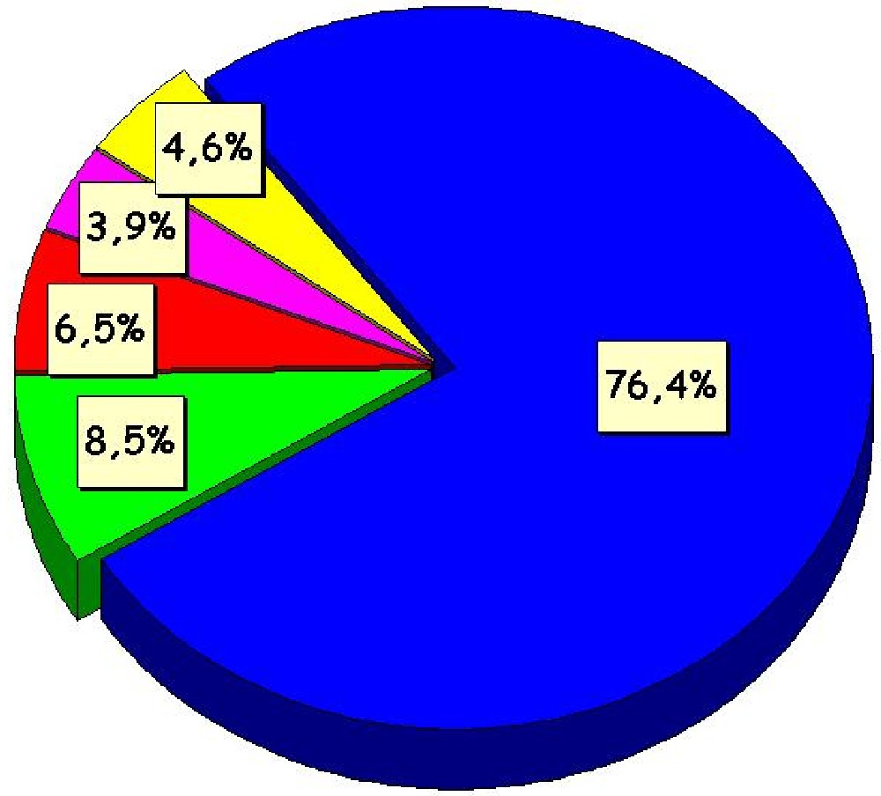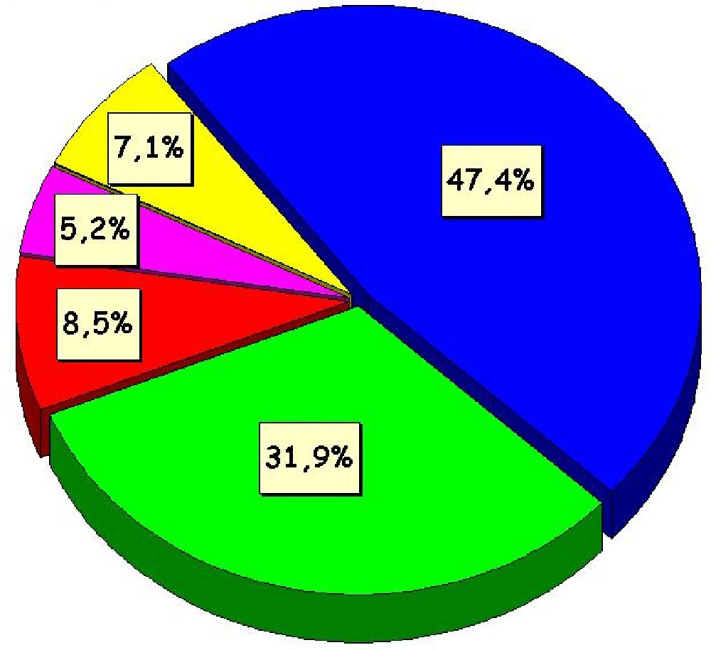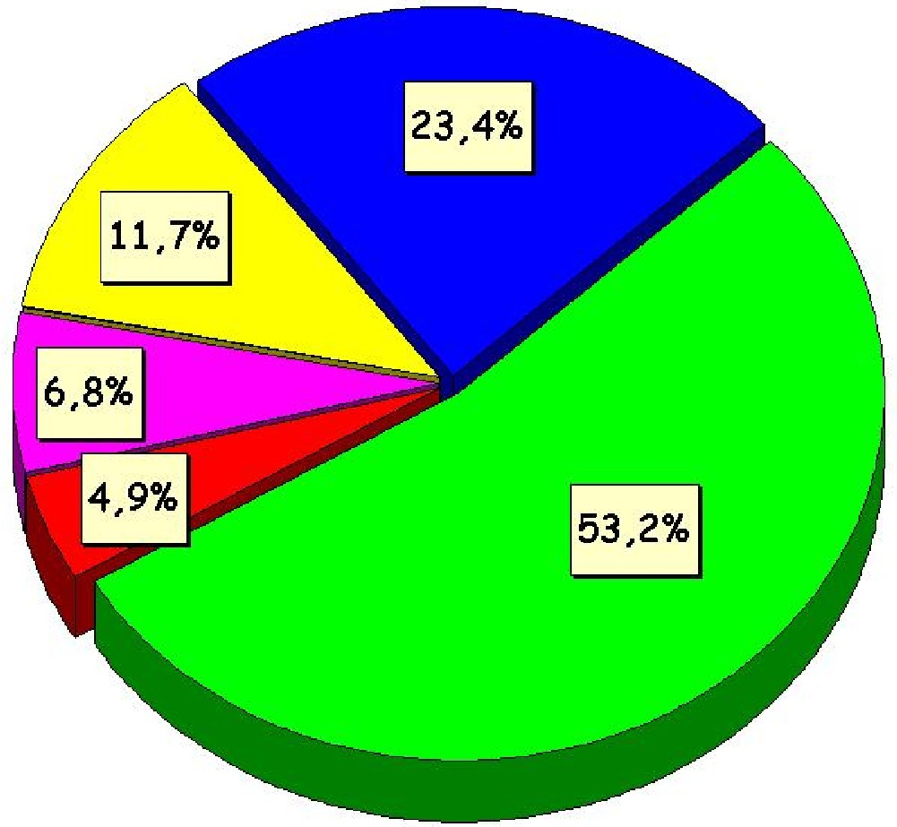
High Middle Low
Over US$ 2.760 mo. Between US$ 750- US$ 2.759 mo. Less than US$ 749 mo.
auto
bus
others
taxi & shared taxi
metro

But two facts attract powerfully our attention. First, obviously, given the high rates of sustained economic growth of the country during the last fifteen years, there has been a very fast increase of the city motorization rate: while between 1977 and 1991 there was an annual average increase of 15.025 cars, between 1991-2001 that figure raised to 42.918. But when those figures are looked at from the income group angle, it can be seen, as Table 5 shows, that such an increase has been clearly higher in the low income and middle income groups, in that order, than in the higher income groups. This result, however, might seem something logical, since the “have nots” obviously want to have what they do not, while those groups that already “have”, might feel a lesser urge to have an additional car. In Table 5 data about car rate per household are presented for a selection of some Santiago districts characterized typically by the notorious predominance of low, middle or high income families.

Table 9
Car rate by household in selected Santiago districts in 1991 and 2001

Income level | District | 1991 | 2001
 |  | Car household rate | Car household rate
Low | La Pintana | 0,05 | 0,18
 | Lo Espejo | 0,14 | 0,32
Middle | La Reina | 0,95 | 1,33
High | Las Condes | 1,21 | 1,25
 | Vitacura | 1,62 | 1,56
 | Providencia | 0,86 | 0,77
 | Lo Barnechea | 1,11 | 1,65
Source: EOD Surveys for Santiago 1991 and 2001

Second, even more striking is the fact that the use of the private car tends to be more intensive in the low income families than in the middle and high income ones, as it can be seen in Table 10

Table 10
Intensity of car use by income groups in 1991 and 2001
(pass/veh in working day)

Income Group | 1991 | 2001 | Variation (%)
Low | 2,78 | 5,08 | 82,9
Middle | 3,16 | 4,71 | 49,2
High | 3,01 | 4,31 | 43,0
Total 3,01 4,61 53,1
Source: EODs 1991 and 1992

Although all of the income groups have intensified the use of the private car in a way proportional to their income, the effect is clearly stronger in the low income group. And this group happens to be the main public transport user.

This evolution has clearly taken place because nowadays more low income people have access to buy a car in Chile. Car prices are rather low because import taxes are very low also. Besides, a car may be bought with ample loan facilities practically by anyone. On the other hand used cars are actually very cheap, since depreciation is very high and it takes place in very short period of time. short term, and there is no initial fee to buy them. In that sense, car secondary market in Chile has become very similar to that of the USA.

But it is very likely that this has also happened because of a more sociological reason, if the hypothesis is allowed here.

Poor people tend to socialize more than high income people in their neighborhoods. High income people tend to live in a rather secluded way, making mostly an inhouse life and not relating with next door neighbors; they also tend to make use of their vehicles in a predominatly individualistic way.

Low income people instead tend to live more on the street. Since they usually live in very tiny houses with no front garden and very little open space or patio inside, poor people tend to meet with their neighbors on the sidewalk in the afternoon and on weekends. They tend also to share common activities and celebrations (solidarity bingos, birthdays, Christmas, Independence Day, etc). In this picture, friendly relationships develop and agreements to go together to work, pooling their vehicles, is likely to occur and it frequently does. Actually, in a pilot project to test the possibility of implementing car pooling in Santiago some years ago, conducted by SECTRA, the test was clearly more positive on low income families than in high income families.

The more collective use of the private car among low income groups directly affects what could be conceptualized as the relative generalized cost of travelling by public transport or private car. Relative generalized cost is measured through the direct operational cost of car use (mainly gasoline consumption) plus the subjective value of time as perceived by users of one or the other transport modes.

Low income groups tend to travel longer distances than other groups, as stated before, and they also tend to use more than one bus route per trip, therefore paying twice or thrice the value of the tariff to complete their journey, since the Santiago public transport system dioes not operate in an integrated way. On the other hand, gasoline cost diminishes when the car is shared among a group of neighbors.

Therefore, the cost of traveling by car, especially if it is done collectively with a group of neighbors, clearly diminishes and is more convenient vis-a-vis traveling in public transport. Finally, the traveling time by car is cearly less than traveling by bus, when the bus system is not privileged by segregated and exclusively bus lanes.

The decline of public transport patronage is therefore a result of increasing private ownership of cars but also of a more intensive use of the car particularly by the social sector, low income group, that traditionally constitutes the bulk of public transport demand.

5.2 Bus and Metro service network

5.2.1 The bus network

People move according to the way in which activities are organized in the urban space, which change through time as the urban economy evolves and changes also. The bus service network has evolved historically in Santiago according to the way in which operators have seen such a change as experienced in terms of transport demand on the streets of the city. Based on practical observations and experience, traditional operators tend to practice a kind of primitive planning of their routes, rather than carrying out a technical planning based on systematic demand studies. Only in the last few years, when meeting a more technical competitive environment posed by the tender processes carried out since 1991 on, they have hired some professional assistance, such as transport engeneers, economists, financial analysts. But as these professionals informally comment, operators tend not to listen too much to expert advice and they tend to rely more in their iknstincs and experience.

Therefore bus operators have designed throughout the years the network of services according to the way in which they feel people move around the city. But they have done so not in a very rational way as to the organization of their routes, designing longer routes than they should in order to capture different niches of demand along a certain route. Niches of demand, besides, behave in a rather heterogenous way thorughout a day.

The present pattern of movement of people in the city may be seen in Graph 4, where the districts attracting (At) or generating (Gn) or having Internal (In) trips are identified, according to EOD 2002 data.

Graph 4 shows that inspite of the re-distribution of living and working places that has taken place in metropolitan Santiago in the last 10 to 15 years, there is still an important amount of travels (125.686) that are attracted to the city old center (Area A) because there still is there a strong concentration of public sector institutions as well as private commercial companies of varied sorts, as well as professional buffets of varied areas.

Graph 4
Travel pattern among and inside zones of Metropolitan Santiago
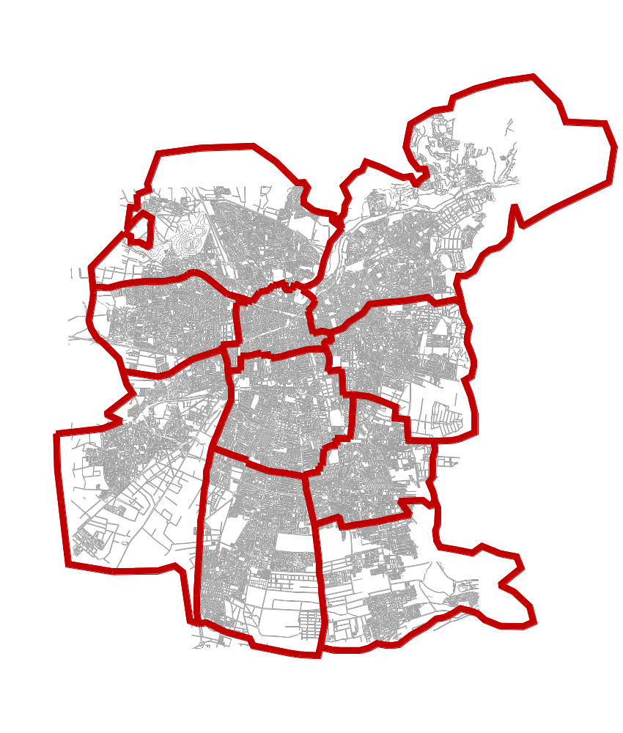
In =11.941
Gn=17.767
At=41.075
In=10.614
Gn=31.709
At=11.850
In =14.086
Gn=37.478
At=11.520
In =11.918
Gn=28.559
At= 9.693
In= 8.765
Gn=30.560
At= 7.437
In = 9.737
Gn=35.533
At=18.965
In=10.392
Gn=25.932
At=42.889
In=19.280
Gn=49.460
At=11.129
In=11.851
Gn=29.332
At=25.160
In=12.720
Gn=19.074
A=125.686
In: Internal
Gn: Generated
At: Attracted
A
B
C
D
E
F
G
I
H

J
Morning Peak:
449.752 trips/hour

Intra-zone bus trips
morning peak:
121.303 or 27%
Total Bus Trips at Morning Peak
Source: Travel Survey (EOD) 2002. Graph elaborated by the Coordinacion General de Transporte de Santiago, with som modifications introduced by the author of this report.

5.2.2 Metro network

As for the metro network, it is formed by three lines (See Graph 5). The first line (Line 1) runs from east to west along 15,9 kms, exactly beneath the main axis crossing the city, Providencia-Alameda.

The second line (Line 2) runs from north to south along 11,4 kms, beneath another important axis of the city, José Miguel Carrera Avenue, or Gran Avenida.

The third line (Line 5) runs also north to south (13,0 kms), but somewhat farther east from Line 2, running underground Vicuña Mackenna Avenue, connecting in Plaza Italia with Line 1 and in downtown with Line 2. The three Lines total 40,3 kms.

As a part of the Urban Transport Plan under implementation at present lines 2 and 5 are being extended. Line 5 is being extended from downtown to the west, up to Avenida Matucana, where there will be an Intermodal Transfer Station where suburban trains, metro and bus lines will interconnect. (See Graph 5). This Station is under construction using the private concession scheme. Investment is around 20 million dollars.

Graph 5
Existing and new metro lines with and new Intermodal Transfer Stations ( )

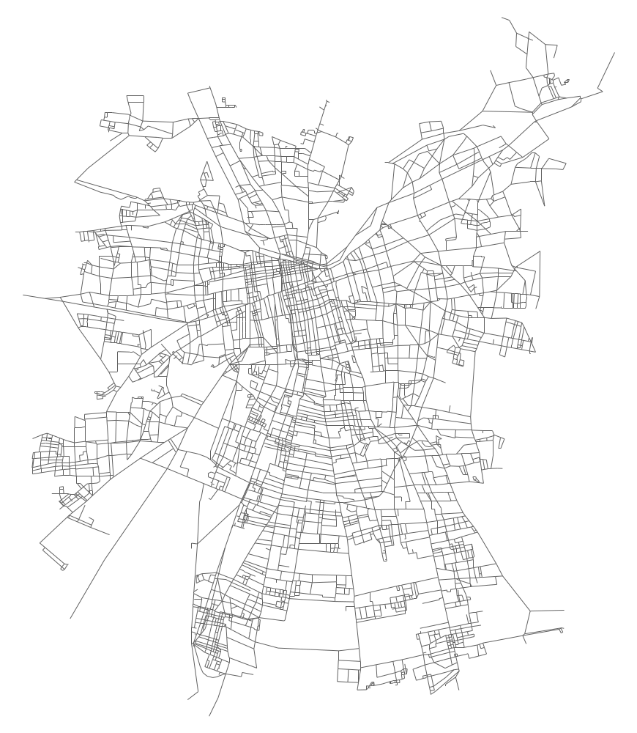
MAIPÚ
RINGROAD A. VESPUCIO
RINGROAD A. VESPUCIO
Tunnel
A. VESPUCIO
TOBALABA
A. VESPUCIO
PUENTE ALTO
METRO LINE 1
METRO LINE 2
METRO LINE 5
METRO LINE 4
PajaritosTransfer Station
Quinta Normal
Transfer Station
La Cisterna
Transfer Station
METRO LINE 4
Source: Coordinacion General de Transporte de Santiago

Line 2 is being extended to the south and to the north. To the south, from Lo Ovalle Station to Ringroad Americo Vespucio South. In this intersection there is going to be another Intermodal Transfer Station, interconnecting the metro network and bus services. This Station is also under construction using the private concession scheme. Investment is around 15 million dollars. Line 2 is being extended to the north from downtown to Ringorad Americo Vespucio North. At this juncture point there will be a simple bus-metro Transfer Station, given the lower level of demand.

Line 1 is not being extended, but a new bus-metro Transfer Station is being built, under the private concesssion scheme, to the west, in present Pajaritos Station, where an important number of passengers coming from the coast in interurban buses usually disembark and transfer to metro. It is expected that when the new Integrated Public Transport System would be functioning – with a single integrated tariff that will give access to the whole public tansport network of the metropilitan area- there will be an important increase of people transferring from the interurban coast buses to the System, accessing to it in that particular Metro station.

To finance the investment madfe in the three Transfer Stations mentioned, users, that is bus operators, train company, shared taxi owners, will have to pay a fee per vehicle according to the number of times they use them. Estimation of the impact of such a fee on the tariff payed by the users of public transport buses is very small, since it will be dispersed among all of the passengers of the system and not only on those passengers boarding the buses that will use those Transfer Stations.

Although not considered in the Urban Transport Plan, a new line is being built, Line 4 (orange dotted line in Graph 5), that goes from Puente Alto in the southeast to the Tobalaba Station of Line 1, located towards the east, far away from downtown. Line 4 also links Line 2 and Line 5 at the south. (See Graph 5, orange dotted line). This new line is being built because, as a consequence of the extension of Line 2 to the south and to the north, as well as of the other extensions, there will be a strong additional passenger load over Line 1, which is already near collapse (see figures of Table ). Therefore, this is strictly a metro problem, not a general problem of the public trassport system of the city. However, it might have had a different solution coming from the new design of the system itself

When Metro Company made the decision to build this Line 4 there was a heated debate between the Metro administration and the Coordinación General de Transporte de Santiago, in charge of implementing the Urban Transport Plan (Transantiago). The CGTS had the technical conviction that there might be a better solution for that problem of an overcharged Line 1 through the redisgn of the bus network on which it will be based the new Integrated Public Transport System (IPTS). A solution much more efficient in terms of social profitability of the investment, if account is taken of the fact that Metro carries a little over 800.000 passengers a day, a figure which is a little over the passenger load of the bus integrated system Transmilenio in Bogotá, Colombia, with a small fraction of the metro investment. According to CGTS, the urban axis under which runs Line 1 of the Metro (Providencia-Alameda-Pajaritos) will be drastically changed in the new network design to attend properly the concentrated demand on that corridor. Thus, segregated and exclusive lanes for buses will be set up, size of buses will be increased (articulated buses with 160 passengers capacity), frequency control and bus stops specially equipped for fast boarding/disembarking (Transmilenio-type) are going to be implemented. Therefore, CGTS thought it was completely possible to handle the overcharge on Metro Line 1. However, the problem was that at the time that the Metro Board of Directors made the decision to go ahead with the construction of Line 4 (2000) there was within the Government a low degree of confidence that PTUS or Transantiago was ever going to be implemented by the then existing transport authorities. So Metro decided not to wait and see if PTUS really happened and went ahead with the Line 4 investment. When PTUS implementation actually departed in march 2002, Line 4 was already being constructed.

When these Metro extensions and the new Line 4 are finished by the end of 2006, the Metro network will have an extension of 80 kms, double the amount of kilometers it had in 2000. But it will not double the amount of transported passenger, which are expected to rise in about 450.000 at best.

5.3 Public transport fares

5.3.1 Bus fares

The tariff structure of the bus public transport service in Santiago is very simple: there is a flat fare for all the existing services or routes (336) and its value is at present Ch$ 320, around USD$ 0.55 per unitary trip. Although the constitutional and legal principle still valid is that of “freedom of tariffs”, the tariff is actually established in the tender process by which the operators get their concession to operate.

Tariffs are adjusted according to a formula existing in the tender documents and the ensuing contracts. In the first tender process, in 1992, a formula was established, on the basis of a cost study made by a very prestigious private university. The study was validated by the operators themselves, who asked another university to carry out a similar study. No significant differences appeared between both studies. Thus the formula known as “the polynomial” was then officially established and it has been operating since 1992 up until today.

The polynomial takes into account the values of five variables. When the result of the calculations of the values of the polinomio that change through time (i.e, diesel, a “basket” of the three foreign currencies that have the greatest influence on the price of some crucial transport imputs, as buses itselves, spare parts and the like) show an accumulated value of over $ 5,6, the tarif is adjusted automatically in $ 10.

The establishment of the polynomial was a great step forward in public transport in Santiago. Historically tariff adjustments had been a big political problem for all governments. The polynomial set up a clear, tansparent technical process for tariff adjustment and it has been functioning now for 13 years with no problem whatsoever, whatever the country´s economic circumstances. The polynomial has never been challenged by transport operators and neither by public opinion.

This polynomial was meant to have a tarif technically undisputable and politically independent from occasional preasures and, therefore, a quite a balanced transport tariff. This is important not only because of the sensitivity of transport demand to tariffs. Even more important is the fact that tansport tariffs have an influence of around 15% on the Cost of Living Index (IPC). The Chilean economy es indexed and the IPC is the basis on which the UF is periodically adjusted. The UF is in turn the index by which all of the values in the Chilean economy are daily adjusted (bank loans for production or consumption purposes, house prices, all type of rentals, private deals, etc). Therefore the importance of objectifying transport tariffs and of liberating its adjustment from political preasures and circumstances.

The plynomial formula (See Annex 3) is based on four variables, those that have the greatest weight in transport costs. These variables are:

- Diesel price (Diesel)
- Index of Nominal Labor Cost (ICMO)
- Retail Prices Series, Item 229, Tires.
- Value of buying a new bus (INVA)

When the resulting value after applying the formula reach the sum of Ch$ 10, or a fraction of it (over Ch$ 5,6), the tariff is automatically adjusted. At present, with such a fast variation of oil prices in the world market, there has also been a fast and frequente adjustment of tariffs, practically every 2 weeks or so. But nobody protests, because everubody knows about the existence of the technical formula of adjustment and its ties with, mainly, international oil prices. But demand, of course, is affected, because of its sensitivity to tariff levels.

5.3.2 Metro fares

Metro, as an autonomous public company, has had up to now the freedom to establish its own tariffs, according to the decisions taken by its Board of Directors. Altough for a long time metro had also a single flat tariff, since 2000 it established a policy of differentiated tariffs, so as to manage demand to a certain extent (Table 11). This was mostly provoked by the increasing passenger load of Line 1, which concentrates the highest numer of trips, threatening its collapse at peak hours.

Table 11
Metro and metro-bus fares up to december 2004

Service | Tariff |  | Peak hour |  | Valley hour
Metro | Unitary Ticket |  | 400 |  | 310
 | Multivia card |  | 380 |  | 290
Metrobus | Tariff 1* |  | 300 |  | 300
 | Tariff 1 Multivia |  | 290 |  | 290
 | Tariff 1 Combined |  | 620 |  | 530
 | Tariff 2** |  | 270 |  | 270
 | Tariff 2 Multivia |  | 260 |  | 260
 | Tariff 2 Combined |  | 590 |  | 500
 | Tarif 3*** |  | 280 |  | 280
 | Tariff 3 Multivia |  | 270 |  | 270
 | Tariff 3 Combined |  | 600 |  | 610
 | Tariff 4**** |  | 250 |  | 250
 | Tariff 4 Multivia |  | 240 |  | 240
 | Tariff 4 Combined |  | 570 |  | 480
* Corresponds to Metrobus lines 33 and 34
** Corresponds to Metrobus line 35
*** Corresponds to Metrobus lines 02/05/40/44/50/51/52/54/55
**** Corresponds to Metrobus lines 01/03/53/58/60
Multivia: Contactless magnetic card that Metro introduced in 2003
Students: Tariff not included here. It is Ch$ 100. Primary students ride free
Note: This tariffs were valid as of December 2004

Up until 2003 Metro had been using the Edmonson carton tickets, but in 2003 it introduced a magnetic intelligent plastic card, called Multivia, in order to allow Metro to be incorporated into the Integrated Public Transport System that is being implemented as a part of the Santiago Urban Transport Plan 2000-2010.

When this new System becomes fully operational, Metro will have to relinquish its sovereignity on tariff policy and to become one operator more of such a System, as the bus operators, and paid for its services according to a formula agreed with the Ministry of Transport and the Ministry of Finance, Being a public company, Metro reports and is monitored by the latter, particularly in relation to investments and tariff policy. From september 2006 Metro will be paid according to the number of transported passengers, following an agreed, although toughly bargained, formula of costs per passenger.

5.4 Ticket types

As it was said, in the bus system there is just one single flat tariff for adults, and a special fare for college and university students. Primary school students travel free in all modes of mass public transport (buses and metro).

Metro has two general type of tickets for adults: one for Metro service alone, and one for Metro-bus service and there are differentiated tariffs for peak and valley hours for both types of tickets. There is special fare for students (Ch$ 100) and also for older people (over 65 years of age) (Ch$ 250) valid however only at valley hours.

In 2004 Metro sold 104.382.720 unitary tickets, 952.300 Metrobus tickets, 222.707 Multivia cards and 28.771.064 student tickets.

5.5 Passenger load factors and revenues

5.5.1 Bus services

In a survey conducted by the Metropolitan Secretariat of the Ministry of Transport in 1997 it was determined that the number of daily trips by tendered and non-tendered public transport buses was 4.550.000 (this figure is only a little higher than the figure obtained in the 2001 Survey). These trips were distributed between 82% adult pa ssengers and 18% student passengers.

It was also found that 7% of the passengers carried out an average of 1,2 transfers to complete their journey. The mean travel time is estimated in 25 minutes, pondered for all day and for both types of users. Adults have an estimated average travel time of 25 minutes, with 29 minutes in the morning peak, 21 at the noon peak and 31 at the evening peak.

It was also found that those routes that have a higher average demand per day tend to be served predominatly for those bus owners (natural persons mostly) who own the biggest amount of buses. The lower demand routes, in turn, tend to be served by those bus lines or “companies” constituted by a great amount of micro “entrepreneurs”, owning one or two buses each.

Therefore, the average figures mentioned before are quite unequally distributed between these two types of routes and bus operators, and profitability as well. It is precisely among small operators that “mortality” is higher, with a constant flux of people that are going out of business and new ones entering, the latter being usually the drivers of the same buses who buy the bus from his boss or entrepreneur that is leaving the activity.

Each tendered bus line serves daily and average of 14.473 adult passengers, plus 2.400 students. This gives a figure of 552 pax/day per bus. In each round trip (average 4,9 daily), each vehicle transports an average of 113 passengers.

These numbers, however, are very unequally distributed among the 326 bus lines existing in Santiago, both tendered (318) and non-tendered. (See Annex 2) This unequal distribution is closely related, as it has been pointed up elsewhere, to the size of the bus “company”, the bigger ones getting the better routes in terms of demand.

Information gathered in 2004 by SECTRA and CGTS in charge of the implementation of Transantiago, the Program of Public Transport Modernization of the Santiago Urban Transport Plan (PTUS), shows the following data (Table 12) in relation to anual number of passengers, revenues, bus/kilometers and service length for each one of the Santiago 318 tendered services and also for 8 additional non-tendered services. (See Annex 2 for the complete data series for the 326 tendered and non-tendered bus services in Santiago)

Table 12
Annual number of passengers, revenues, bus/kilometers and service length of Santiago bus transport services. 2004

Service Length (Km) | Total pass/year | Annual Revenues (Ch$)  (1 USD$=Ch$ 580) | Bus/Km Year
10 - 19 km | 17.557.667 | 4.089.799.649 | 7.186.572
20 - 29 km | 16.078.863 | 3.745.333.815 | 11.396.896
30 - 39 km | 28.428.163 | 6.621.921.475 | 13.254.589
40 - 49 km | 64.694.927 | 15.069.728.882 | 34.640.588
50 - 59 km | 277.726.808 | 64.692.363.644 | 139.149.067
60 - 69 km | 379.554.945 | 88.411.725.757 | 182.949.527
70 - 79 km | 380.128.572 | 88.545.343.945 | 194.311.624
80 - 89 km | 176.564.969 | 41.128.205.134 | 94.916.668
90 - 100 km | 24.310.943 | 5.662.875.553 | 17.428.097
Total | 1.365.045.857 | 317.967.297.854 | 695.233.628
Source: Coordinación General de Transporte de Santiago and SECTRA.

Routes between 50 to 79 kilometers concentrate the highest number of passengers (76,0%) and revenues (76,0%) . Movement of the people in the city tend to have a radial character, converging from different districts mostly to two or three areas in the central axis of the city where there is a concentration of economic and public sector activites. Profitable routes, therefore, tend to be those linking far away districts, practically in the periphery, and those concentrated areas and, therefore, longer routes. Local short routes attend around 24% of the demand.

5.5.2 Metro services

Line 1 transported between march-december 2004 an average of 548.415 trips in a working day. Line 2 tansported 143.086 and Line 5 transported 175.196 trips. They were distributed among different types of users in the following way in the three lines (Table 13)

As it is clear, Line 1 has the highest load of passengers, 63,2%, while Line 5, which serves the zones of the southeast of the city with the fastest population growth, La Florida and Puente Alto, has a passenger load of 20,2%. Line 2 in turn has only 16,5. As for type of tickets, the amount pertaining to students is quite important, 21,7% and it is also interest to appreciate the degree of penetration of the magnetic card in a short period of time, 33,7%

Table 13
Metro distribution of trips in a working day by type of passengers by lines

Tickets | Line 1 | Line 1 | Line 3 | Total
 |  |  |  | % Nr.
Unitary ticket | 228.316 | 60.501 | 68.504 | 41,3 357.321
Student ticket | 111.286 | 35.870 | 41.032 | 21,7 188.188
Free student | 9.768 | 4.557 | 3.154 | 2,0 17.479
Multivia card | 192.747 | 39.933 | 60.130 | 33,7 29 2.810
Old people | 6.298 | 2.225 | 2.376 | 1,3 10.899
TOTAL | 548.415 | 143.086 | 175.196 | 100,0 866.697
Source: Metro S.A, Memoria 2004, www.metrosantiago.cl

As for number of kilometers run by each line, Line 1 runned 23.564.952 Kms, Line 2 runned 9.116.965 kms, and Line 5 runned 12.414.670. The total number of kilometers runned in the whole metro network in 2004 were 45.096.587.

5.6 Structure and organization of urban public transport

5.6.1 Legal basis for organization and jurisdiction

In Chile there are two levels of government, the National Government and the Regional Governments, and one level of local administration, the Municipalities (351)

The national Government has the overall constitutional mandate over transport matters, as well as environment matters, which in the case of Santiago are always together. The Ministry of Transport is the only Ministry involved in planning, regulating and monitoring public transport. In this task it is technical assisted by the Eexecutive Secretariat of Transport (SECTRA), that depends from an Interministerial Committee, presided over by the Minister of Transport, and where other participants are the Minister of Public Works (MOP), the Minister of Housing and Urbanism (MINVU), the Minister of Planning and Cooperation (MIDEPLAN), and representatives of the Ministry of Finance (MINHAC) and the Ministry General Secretary of the Presidency (MINSEGPRES). SECTRA is a strictly technical body that carries out studies for different transport modes (public, railways, ports, etc), develops models for public transport design, prepares terms of reference for transport surveys, carries out the economic and technical feasability evaluation studies of transport projects, etc. It is a powerful transport planning instrument that has been working since 1985.

As for transport infrastructure, it is the Ministry of Housing and Urbanism the one in charge of building and maintaining streets and avenues in the city, although it is SECTRA who evaluates the investment projects. According to the Chilean Public Investment System every public investment project, whether from the national ministries, regional governments or munucipalities, and whatever its size in terms of investment involved, has to be technically evaluated and approved by the Bank of Projects. This Bank is under the responsability of the Ministry of Planning. No project can be executed without this evaluation of public and private profitability and approval by the Bank (RS)

But the Ministry of Public Works has also to do in terms of infrastructure for urban public transport as far as some of the Santiago avenues, particularly Ringroad Americo Vespucio, are considered within the category of “public highways”. MPW has the exclusive responsability over such a category.

Regional Governments were established in 1992 as a part of the Constitutional reform to the 1980 Constitution. The reform created this intermediate level of government in Chile. However, public transport planning, regulation and monitoring is not among the competences given to these Regional Governments. It was only in 1998, through a presidential decree, that some competences were given to some Intendentes (head of the regional executive power) to intervene in some matters related to public tansport. Such competences, however, refer mostly to environment related aspects. Nevertheless, since the Regional Council has to provide its first approval to investment projects proposed by the Municipalities to be financed by the National Regional Development Fund (FNDR) and since some of those projects are sometimes related to urban road construction, Regional Governments havo also some degree of participation in this public transport related matter.

Municipalities have some limited competences over transport matters, as the authorization for the use of certain streets and avenues for the use of public transport, although they may be overrruled by the Ministry of Transport when “the general interest of the city” is involved. Municipalities have also the legal right to express their opinion when public transport tender processes are carried out, but their opinion is not mandatory for the Ministry. Municipalities are also resposible for designing the “Plano Regulador” or Master Plan of the District, where decisions are made in terms of building new urban roads, expanding existing ones, changing the destination of some areas from rural to urban needs, leaving aside spaces to for the existence of bus terminals, etc. They are also in charge of bus stops within its District.

5.6.2 Organizational structure

The metropolitan public transport management system consists basically of one body, the Secretaria Regional Ministerial (Regional Metropolitan Secretariat), or SEREMITT, of the Ministry of Transport and Telecommunications. As a part of the country´s deconcentration policy, each line Ministry has a Regional Secretariat in each one of the 13 Regions of the country (actually, only 12 of the 20 Ministries have them). The Regional Secretariat is headed by a Regional Secretary appointed by the Ministry but his/her name comes previously from a three-name proposal made by the Intendente (the executive power, appointed by the President) of each Region. Each Regional Secretariat has its own technical and administrative staff and its competences come from a delegation of competences officially carried out by the corresponding Minister through a formal decree.

The Transport Metropolitan Regional Secretariat carries out the daily tasks of monitoring public transport in every possible aspect (frequencies, environment regulations, compliance of tender contracts, drivers´ behavior, bus cleanliness, quality of service, authorization to modify routes, etc) related to all modes of public transport (exception: Metro service). It also conducts fiscalization on the streets and of terminals. It also applies penalties when regulations and norms are broken.

From the Transport Metropolitan Secretariat depends a technical workshop, the “3CV”, the Centro de Control de Calidad de los Vehiculos (Center for Vehicle Quality Control), where buses are technically checked for gas emissions and different technical aspects. The 3CV Workshop also homologizes vehicles.

The Metropolitan Secretariat is related with the Unidad Operativa de Control de Transito, UOCT, (Traffic Control Unit), an autonomous technical public entity in charge of monitoring traffic in all of the metropolitan area, mostly for congestion management purposes.

There is no regulatory body dedicated to transport matters (as there is in relation to electricity, telecommunications, banks and financial institutions), altough the idea of creating one has been lingering from a long time now. From time to time it emerges the idea that the Ministry of Transport should be the planning and regulatory transport agency, while a separte, autonomous public entity should be created to supervise the transport industry, in all of its modes and activities, the Superintendent of Transport. But it has never existed the political will to go ahead with the idea and to transform it into a legal initiative.

5.6.3 Public sector operators

Metro Company (Metro Sociedad Anónima) is an autonomous public company, organized practically as a private company. It has a Board of Directors and a President of the Board appointed by the President of the Republic. The Board members are legally appointed by the Vicepresidency of the Corporación de Fomento de la Producción (CORFO), the public entity all public companies depend from. In fact, however, the President of the Republic and the Ministry of Transport have a strong influence about the names of the candidates finally appointed. It is of the exclusive competence of the President to appoint the Metro president of the Board. And it is the President also who appoints the Vicepresident of CORFO.

Inspite of the more or less political origin of their mandate, the Metro Board members are usually institutional representatives rather than strictly political appointees, with the exception of the President of the Board. That is, they usually come from the Ministry of Transport, the Ministry of Finance, the Ministry of Planning, the Ministry of Public Works. Only the President of the Board is more politically appointed, although tradition has been that highly technically qualified persons are appointed.

The result is that Metro has historically had a highly technical management and it is one of the more efficient public sector companies. This has led to the fact that Metro services are high quality and are strongly and positively appreciated by users and non users alike. The “santiaguinos” actually feel very proud of “their” Metro.

5.6.4 Private sector operators.

As it has been said, in Metropolitan Santiago (an in all of Chile actually) bus services are entirely operated by the private sector. The last presence of the public sector in bus services disappeared some 30 years ago, together with the clousure of the Empresa de Transportes Colectivos del Estado, ETCE, carried out by the dictatorship.

Bus services are provided under concession contracts granted by the Ministry of
Transport through periodical tender processes. The services are totally self financing through tariffs and there are no direct or indirect subsisides, except for infrastructure provision, some of it being of all-time exclusive use for buses (Avenue Grecia, 7 kms) or at certain periods of the day. The decades old practice of subsidizing bus owners through soft loans for buying buses (when part of those loans were actually never recuperated) ended in 1990.

Not all routes or segments of the routes are equally profitable, and, as it was stated elsewhere, there is a certain unequal distribution of routes among the different operators, the bigger ones serving mainly the more profitable routes. There is no compensation mechanism in place. This means that the segment constituted by the smaller bus owners is always operating “at the side of the precipice”, that is, with limited profitability and usually with higher operational costs, because their buses tend to be older and to have therefore higher maintenance costs and higher diesel consumption (they usually serve longer routes also). This is why the highest “mortality” rates of this sector is found among the smaller bus owners.

In Santiago there are 132 companies serving the 318 services tendered, although, as already explained, these are not actually formal companies but rather trade-union-like organizations. There are another 8 special non-tendered services.

5.7 Vehicle purchase, finance and insurance

Public transport operators are not seen as good clients by banks and financial institutions in general, with some exceptions. The exceptions are the biggest bus owners, who usually have access to bank loans. But for the great majority of bus owners, their only possibility is to get a direct credit from the bus provider companies, at very high interest rates.

There are two types of companies that provide buses: on the one hand, those who are big bus importers who represent in the country well known trademarks, mostly of Brasilian origin, as it is the case with Mercedes Benz, Marco Polo and Caio and, on the other hand, the Chilean bus assembling companies, mainly Metalpar, Cuatro Ases, Sport Wagon, Inrecar, in decreasing order according the share they have in the bus market.

The bus assembling companies import the bus chassis predominatly from Brasil (Mercedes Benz) and they assemble the bus in Chile, giving direct credit to bus buyers at very high interest rates. Actually, their more profitable activity is their financial line than their bus production-selling line. When a bus owner gets a credit he/she has to back up the credit giving as a guarantee not only the bus but usually also his/her house or whatever patrimony the importer or bus assembly company find adequate (real estate is preferred).

No special lines of credit are available from the bank and financial system. From the part of the Government, the policy of soft or subsidized loans ended completely in 1990 for all modes of public or private transport, including buses, taxis, freight trucks.

As for insurance, the Transit Law makes obligatory for all vehicle owners to have not only their vehicles insured but also its passengers and third parties eventually affected by accidents in which the vehicle is involved. Public transport bus owners, therefore, cannot get the Circulation Permit and cannot operate in the street if they do not have such an insurance. Bus owners get their insurance directly in the insurance market.

It is usually the trade union that represent them negotiating tariffs and conditions with the private insurance companies. Besides this formal insurance system, bus owners have an informal one, depending from the bus owners trade unions to which almost all of them belong. The informal system usually covers those aspects not covered by formal insurance companies, such as providing legal assistance in case of accidents or direct compensations to the victims of traffic accidents, or giving a temporary salary to the bus driver´s family while he is in jail because of his involvement in a traffic accident where people have been injured.

5.8 Operational staffing and skills

The Santiago bus public transport system is highly informal in all senses. They hardly comply with regulations and norms, if they do at all in some cases. This is why the monitoring anf fiscalization activity of the Ministry of Transport is usually very intense and pervasive.

Bus drivers are the visible face of the bus public trasport system and it is mostly through their performance, they way in which they drive or the way in which they relate to passengers that public transport users get their impressions about the quality of the service. Inspite ot this and of the bad reputation that public transport has among citizens at large, bus owners do not place a special emphasis in the quality aspects when they recruit their drivers. On the opther hand, the recruitment of bus drivers is not regulated by the transport authority, except for the general norm established in the Transit Law that drivers of passenger and freight vehicles must have a driver license of the Professional category. Only in the period 1990-1992 and active policy was promoted to enforce drivers´ training and to raise some requirements in terms of level of education, a policy afterwards abandoned.

No other special requirements are obligatory as, for instance, a psychological test of some kind, given the high levels of stress that a driver must endure while driving in congested Santiago and performing three or four simultaneous activitities, such as driving, selling tickets, opening the doors for passengers to board or descend, watching that people do not board the bus by the rear door without paying, etc. Neither a drug consumption test, inspite of the fact that studies carried out by the Government Commission for the Control of Drugs have established that drug consumption is very important among drivers, apparently to combat stress and fatigue (they are usually forced by their employers to work 12 or 14 straight hours, well beyond the legally allowed limit of work hours)

Traditionally drivers have been of a low level of education. However, given the more stringent regulations set by transport authorities in the last few years, this situation has been changing. Since in the last years there has been an overall modernization of the country and a general raise in the level of quality and qualifications of persons in a wide frange of matters, it has also happened in relation ti public transport. Thus, there have been some efforts on the part of the Ministry of Transport together with the Ministry of Education to strengthen drivers´s education whether by setting programs to allow drivers to complete their secondary level of education or through some special training courses and programs.

There are no reliable data as to the actual total number of public transport drivers in Santiago, since this is an information that the operators are always very reluctant to provide, even to transport authorities. It is estimated that they are around 10.000 to 11.000. Anyway, on the basis of the data gathered for 5.849 drivers that attended one recent program of nivelation of studies it is possible to determine their level of education (Table 14).

Table 14
Santiago public transport drivers by level of education

Education | Number | %
1° Primary | 2 | 0
2° Primary | 3 | 0
3° Primary | 6 | 0,1
4° Primary | 27 | 0,5
5° Primary | 42 | 0,7
6° Primary | 217 | 3,7
7° Primary | 113 | 1,9
8° Primary | 911 | 15,6
1° Secondary | 628 | 10,7
2° Secondary | 946 | 16,2
3° Secondary | 517 | 8,8
4° Secondary | 1.934 | 33,1
Technical | 76 | 1,3
University | 35 | 0,6
Superior Institute | 60 | 1,1
Industrial Educ, | 16 | 0,3
Commercial | 17 | 0,3
Unknown | 299 | 5,1
Total | 5.849 | 100
Source: Regional Metropolitan Secretariat, Ministry of Transport, 2004

Although there is a law that compels all employers in the country to train their personnel and there is a training fund financially feeded by the State, the employers and the workers, in the bus public transport sector there is very little use of such a fund. Decision to allow employees to get training is the employers´. The reason for this is that bus driver employers feel training as a threat to the contract conditions as they like it. They say, informally, that once a driver gets a higher training he feels he has the right to ask from his employer for a higher salary, something bus employers do not like at all. The solution: do not train your drivers. This common practice has begun to change in the last few years, given the stronger enforcement of the law that the Government is applying in relation to this sector in particular and also because some operators have begun to understand that getting modernized is also good business.

Table 14 above shows that drivers tend to have from the 8th grade of primary education to 4th grade of secondary education (84%), while the biggest group is that of drivers with 4th secondary level of education (33%). This is a somewhat strange data, since it comes from a list of drivers registered to attend a special course of “nivelation of studies”. These courses are usually given in Chile when people have not completed their secondary education and do not have, therefore, their Secondary Education License, a document the law makes obligatory for certain jobs or positions. One of those jobs is driving public transport vehicles. Therefore, to have such a strong group of drivers in the 4th secondary level as well as 3,6% with a level higher than secondary education, even some with university students (for which it is required to have the Secondary Education License), it looks a little odd. Anyway, the data give an idea of the educational profile of Santiago public transport drivers.

In relation to drivers´age, the available data show that drivers are predominantly not so young (Table 15). The great majority of them it is over 40 years of age and there is not a little percentage, 7,2 who are over 60. In an activity having the high levels of stress that it has to be a bus driver in congested Santiago, this is quite an age to be driving around.

Table 15
Santiago public transport drivers by age groups

Age group | Number | %
Less than 25 | 2 | 0
25 - 29 | 132 | 2,3
30 - 34 | 555 | 9,6
35 - 39 | 803 | 14
40 - 44 | 933 | 16,4
45 - 49 | 1.090 | 18,9
50 - 54 | 921 | 16
55 - 59 | 680 | 11,9
60- 64 | 410 | 7,2
Source: Metropolitan Regional Secretariat, Ministry of Transport, 2004

There have also been some special training courses organized by the Ministry of Transport and delivered by some private training institutions and universities.

Metro staff have definitely high formal training requirements and compliance on the part of the Metro administration is strict.

5.9 Bus system facilities and equipment

Garage and maintenance facilities are provided mostly by bus owners themselves. The bigger bus owners usually have their own garage and maintenance workshops. But the majority of bus owners usually keep their vehicles at night in their home or in their drivers´ home, except for a certain number of buses that remain at the terminal each night and during the day. Maintenance is usually done also at home or in very artisan-like workshops, or even in the street in front of the house of the bus owner.

Each bus line has its own terminal, usually of their property and, in a few cases, rented. Most of these terminals, however, do not have municipal permit to be there. This is an old and everlasting problem in Santiago. No government has been able to solve it. It implies the cumbersome subject of intervening over the Municipal Director Plans (Planos Reguladores) for organizing the municipal territory when municipalities clearly do not like to have public transport bus terminals in their territory.

This happens because of the environmental problem they usually pose (noise, gas emisions, dirty water that spills over from washing the buses and runs to the surrounding streets, undesirable businesses that spring around terminals, etc) and the negative impact that this has over the value of real estate near those terminals. It is an historical contradiction between the desire to have a bus service as close as possible and the desire not to be molested by the presence of the bus terminals.

In the original version of the Urban Transport Plan for Santiago, now in the process of implementation, it was considered to build a network of bus terminals through the private concession mechanism, so as to get high standard terminals, both in terms of construction characteristics, environment requirements and management efficiency of these facilities. But this part of the original Plan will not be implemented.

5.10 Financial environment

As it was stated already, the bus public transport system is self financed through tariffs. Therefore, there is no deficit of the system. Although the system has, of course, deficits, but mainly for the more inefficient, smaller bus owners, who have a kind of permanent survival strategy to stay in business. This is why they repair their buses themselves in their home workshops or in the street, they buy second hand parts, they overwork their drivers (when they have them) and do not comply with the norm of having two drivers per bus and many other norms and rules that would mean to increase their costs.

Before the tender processes began in 1992 and when there was no polynomic formula ruling tariff adjustment, these small bus owners were the ones usually preasuring permanently for increasing tariffs. In those times the level of tariffs was actually determined by the more inefficient small bus owners, who constitute the greatest bulk of bus operators. And since, at the sime time, they constitute the bigger proportion of voters in the operators´ trade unions, they usually had success is getting the organization to fight or actually to establish tariffs higher than actual costs allowed. In this sense, operators´ trade unions work, in fact, as a real oligopolic mechanism.

5.11 Role of the informal sector.

Although operators working informally are few in Santiago, given the close and strict fiscalization that the Ministry usually exerts (and corruption does not have a role in Chile in this matter, as in others), they cannot proliferate. The tendering area is that within the Americo Vespucio Ringroad and within that area there is a strict control over informal operators, or “pirates” as are called by the formal operators. The informal operators tend to concentrate therefore in certain peripheral areas of the city. But since the formal operators extend their service obviously beyond the Americo Vespucio Ringroad, they actually compete in the periphery with the informal operators.This is a situation of permanent friction and claims on the part of the formal operators to the Ministry of Transport to exert a more strict and harsh fiscalization in the peripheral areas against the “pirates”.

In the new Integrated System of Public Transport that is being implemented as a part of the Santiago Urban Tansport Plan, the existence of the informal operators will be in definite jeopardy and the idea is to eliminate such an activity.

5.12 Service supply characteristics

5.12.1 A public transport “system”?

Account must be taken of the fact that in Santiago there is no public transport “system” properly speaking, with all the components of such a system present and properly operating in an integrated way. This makes this service highly inefficient both in economic as well as in quality of service terms. Also, with a number of important externalities that bring about some significant negative effects on the Santiago population particularly in relation to health and quality of life.

Each bus line organizes its service independent from other lines that make even the same route, or at least parts of the same route. Although there are tarif agreements, there is no concertation of operation among lines, in the sense of integrating their services -agreeing, for instance, that one line would shorten the length of its route to feed another line, with an integrated tarif, thus reducing operational costs and increasing the number of passengers per bus and therefore profitability-. There is no integration and cooperation but rather competition. But competition is not only among “lines” serving the same, or part of the same route, but even among the buses of the fleet of the same line serving the same route. This happens, as it will be explained later on, because the “business unit” is the individual bus owned by an individual operator.

5.12.2 Some structural characteristics of bus services

5.12.2.1 Dispersed ownership structure of the bus fleet

A very important trait of the Santiago public transport “system” is that there is a strongly “atomized” structure of property of the buses. (See Table 16)

Table 16
Structure of property of the Santiago tendered bus fleet

Buses per Owner | N° of Entrepreneurs | % Buses
1 | 2,463 | 30,7
2 | 774 | 19,3
3 | 293 | 11,0
4 | 117 | 5,8
5 | 56 | 3,5
6 – 10 | 106 | 9,9
11 – 20 | 33 | 5,4
21 – 50 | 21 | 8,1
More than 50 | 3 | 6,2
TOTAL | 3,868 | 100%
Source: Metropolitan Regional Secretariat, Ministry of Transport and Telecommunications, 1998.

The Santiago tendered bus fleet has around 7.279 buses, owned by 3.868 operators. Around 50% of the operators own between 1 and 2 buses, while another 20% own between 3 to 5 buses. No more than 3 individual operators, not companies, own over 50 buses each.

The number of companies that have tendered the bus services is 132. But the number of companies functioning formally and really as such is very small, actually no more than 10, owning of around 500 or 600 buses. In many cases the bus owner is at the same time its driver.

Actually, many drivers become bus owners when the original owner, his boss, decides to sell it to buy a new one, or simply to leave the activity altogether. Then, from one day to the next a driver becomes and “entrepreneur”. (This is the fastest social mobilization mechanism in Chilean society. And this is no joke. The public transport operators, who usually have a very modest social origin, take a great pride in being identified and considered as “entrepreneurs” and they resent to be considered as just “operators” or simple “bus owners”. This sociological trait is a part of a whole subculture existing in this sector that has to be taken into account when public policies on public transport are devised and, particularly, when going through its tactical implementation).

As it was explained before, this atomized ownership structure and the way in which operators organize theselves to provide this service, protecting their ownership tie with their vehicles, are strong factors against a gereater efficiency of public transport, both economically and in relation to service quality. Protecting their bondage with their vehicle is also a very strong sociological factor present in the situation characterizing public transport in Santiago, and Chile for that matter. Acquiring a vehicle is a mechanism of at least symobolic social mobility for people that all of their lives were just drivers, salaried workers. In this way the machine itself becomes the corporeal symbol of the new acquired social status. But besides, for these families the vehicle has been the means to get a higher level of education for their children, even university education, or to buy a modest house. Thus, a very special bondage is created between the machine and the family of the owner, who takes care of the vehicle almost as if it were another member of the family. They agree on a name for the machine and call it by its name; on weekends all or most of the family members wash, clean and repair the machine, they put pictures of saints and all kinds of specially cherished ornaments inside.Ownership of the bus, in these cases, is quite more than ownership.

Therefore, when incorporating a bus to the fleet of a certain bus line, the owner usually wants to operate it himself, whether as a driver or as an individual manager of his/her own bus, and intervening in all the decisions partaining to the bus operation and maintenance. This sets up for the bus line a particularly cumbersome way of fleet management. Therefore, in any reform attempt it is crucial to try to break or transform this affective bondage between vehicle and owner, in order to create a more depersonalized and technical way of fleet management and maintenance.

(The first tender process carried out in 1992 made obligatory for bus owners to constitute formal companies and to gradually transfer ownership of the buses to the company to become patrimony of the company and transforming bus owners in shareholders. Because of that special relationship owner-vehicle, operators angrily claimed that they were being “expropriated” of their buses, and they strongly resisted such a requisite. Actually, many of the companies that were constituted at that time were just “paper” companies, just to comply formally with this condition, but the actual transfer of ownership of the buses only happened in a very limited number of cases).

      - A structural contradiction

The problem, however, is not only a matter of dispersed ownership. It is the existence of a structural contradiction existing in the “system” between, on the one hand, the nature of the service and the type of organization needed to deliver it efficiently, and, on the other, the way in which the operators actually organize themselves to provide this service. The bus ownership structure is a fact that obviously weights heavily on this contradiction.

In relation to the nature of the service, in order to give a public transport service with some minimum quality it is needed a group of, say, 20 to 35 or so buses in order to have some acceptable frequency between buses in a certain route of, say, 25 or 30 kms. long. This bus fleet serving a route is called a “line” in Chile. The logical thing would be that all of the buses working on a “line” and serving the same route or routes were organized as a company, where the buses belong to or are completely under the operational control of the company, the drivers were hired by the company, the buses were operated centrally by an “operations manager”, and the company kept a formal accounting system as such .

But this is not the case in Chile. “Lines” are not organized as companies but as a kind of trade union, with a president and an executive body. The president is usually the biggest bus-owner in the “line” and the rest of the members of the executive body are generally appointed by agreement, rather than elections, by all the bus owners working together in the “line”. The president of the “line” plays somewhat the role of the “general manager” of a company, while the executive body is somewhat equivalent to the “board of directors”, although they also act as the leadership of a trade union.

Each bus owner pays to the “line” for the right to work with his bus in that “line”. If a specific bus owner gets into some kind of problem with the president or the executive body of the “line”, he usually takes his bus out of the “line” and goes to some other “line” to work with his bus, previously paying the corresponding “right of entrance” to this new line. Sometimes, when a group of bus owners get into difficulties with the president of the line, they separate from this “line” and they constitute another “line association” and create a new route. It is common to see, therefore, that a certain line is left without the necessary buses to keep the frequency of service informed and controled by the transport authority. Then, sometimes painted signs appear on the windows of the buses of that particular line inviting other bus owners to become part of it, sometimes “free of charge”. Otherwise, the line might be fined by the transport authority.

Each bus owner hires his/her driver, makes sure that the driver gets in time at the terminal to work (or the bus owner stands for and replaces the driver when the man does not show up to work), controls the way in which the driver operates the bus and collects the money from his bus at the end of each day; he also carries out the bus maintenance (usually in a small shop at his home, or even in the street right in front of his home). Although at each terminal there is a person authorizing each bus to begin its service, controling frequencies at least at the start of the route, it is the bus owner who actually controls the operation of the bus all along the route (i.e., hiring people, called “the parrots”, that along the route give to the driver information as to how far away is the preceding bus of the same “line”, so that the driver slows down in order to allow passengers to gather in the next bus stop, or accelerates in order to try to overpass the preceding bus).

Therefore, the “business unit” is not the whole fleet of a “line” giving the service on a certain route, but each individual bus. The thing that most worries the individual bus owner is not as much the efficiency with which the demand of that route is being covered and satisfactorily attended, as it is how much money he/she makes with his/her specific bus. The bus owner estimates his/her profitability bus by bus, usually not giving too much importance to the quality of the service given by the bus fleet of the line in which his/her bus operates. He worries mostly about the economic performance of his/her own bus and the way in which the driver treats the bus itself. (Actually, many bus owners have installed videocameras on their buses in order to check the way in which the driver drives and how he behaves in relation to the machine, rather than in relation to passengers; videocameras are also used to control onbus evasion, that is, tickets sold whose value the driver does not report at the end of the route, the money going to his pocket, an evasion that owners estimate in around 20% to 25% of the total amount of tickets sold daily, that is around four to five hundred thousand dolars; onboard videocameras have also demostrated that they are a good deterrent of onbus crimes).

This “atomization” of the business unit and the inexistence of a company organization covering all of the bus fleet serving one or several routes has a number of consequences.

One, the economic exploitation of the bus fleet of a “line” according to the usual economic rationality of any company is not possible, or very difficult. Two, the heterogeneity of technologies of a line bus fleet makes difficult not only a corporate image of the line but also maintenance costs more expensive. Three, there are no “scale economies”: each bus owner makes its own maintenance, buys by the price of the unit his own parts for repairs, buys his diesel at the gas station as anybody else with no capacity to negotiate its price by volume with the diesel distributors. Four, the individual bus owner is not a very qualified client for the financial entities, since the only capital he/she usually has is the bus alone, therefore he/she usually becomes a captive of the bus selling companies which give them direct credit at very high interests.

And still another consequence is that, since there is “freedom of tarifs” (up to today), the medium level of the tarif tend to be set by the more inefficient operators, and therefore there is no inecentive for improving performance, productivity and the quality of service, and therefore tarifs tend to be higher than they should for the majority of bus owners, if average costs are taken into account. And transport demand is very sensible in relation to tarifs, as some studies have shown; therefore the whole business deteriorates economically when tarifs are overpriced.

But there is another factor preasuring on the operational costs also. Since there is “freedom of routing”, the operators of each line create their own specific route they want to serve, on the basis of their very specific, concrete and day-to-day “study of demand” or “on-the-streets survey”. If they find that the route they have created is not giving the results they expected, they usually ask the transport authority to authorize certain changes in the routing.

The criterion the operators use to create a route might be defined as “brooming the demand”. As it is known, public transport demand varies not only during the day but also along a certain bus route, therefore buses may go full in some parts of their route while in others, at the same hour of the day, may go almost empty. Therefore when one sees the graphic representation of a specific route (any of the 318 existing in Santiago), one can observe that its design is usually very intricated and circunvoluted, going in an out of some parts of the main avenues and circunvoluting into neighborhoods here and there. This, inspite of the fact that the physical organization of the city streets follows rather closely the Spanish pattern, that is, streets that run rather straightforward from north to south and from east to west.

Actually, when looking at the graphic representation of all the existing routes in Santiago, one may characterize it as looking like a “spaghetti plate”, with every line circunvoluting endlessly, looking for the passengers. This means that each bus runs daily more kilometers than it should, and therefore its operational costs are also higher than they should. This fact puts an additional presure on tariffs and passengers usually travel a longer time than they should. The latter element is important, since studies show that in Santiago the value of time has increased significantly for public transport users.

Finally, the whole system works with very high levels of informality and laws are broken every day and in everyway on all kinds of matters: labor, taxes, social security, etc.

      - The “tradeunionized” entrepreneurial organization of the operators to provide the service

As it was pointed up before, to deliver the service the operators are organized as trade unions line by line, corresponding each line, generally, to a certain specific route. In Santiago there are 318 tendered lines that criss-cross the city in all directions. And there are 132 “companies” providing the service.

However, more than a company organization, each “line” has a trade union type of organization, legally recognized as such. This means that the “company” has no president of the Board but a president of the trade union of the line; bus operators are not shareholders but just persons that provide one or two buses to the line paying a fee and administrative expenses, under a de facto contractual basis, so that the line may provide in turn the service tendered. The president of the line tade union is elected periodically by the bus owners that work in that line. There is a tendency to elect as president the biggest bus owner of the line, although all votes have the same value (that is, the “weight” of the vote of a certain bus owners does not necessarily depend on the number of buses he/she owns, a fact that makes really big bus owners little attracted to be a member of such trade unions)

At the same time, practically all of the lines belong, at the same time, to some of the existing four legal organizations of the operators:

- Asociación Gremial Metropolitana, 4.300 buses
- Asociación Gremial de Buses y Taxibuses de Santiago, 2.800 buses
- Asociación Gremial de Transporte de Pasajeros Siglo XXI, 430 buses
- Asociación Gremial de Empresas de Transporte de Pasajeros, 230 buses.

Each one of these organizations or “federations of lines” have an Executive Body and a president elected periodically by the Council of Presidents of the lines.

At the same time, these four organizations usually work together under the umbrella of a de facto organization that they call Consejo Superior de Transporte (Central Transport Council), whose executive body is constituted by the president and the members of the executive body of each one of the four organizations. This is actually the “Joint Chiefs of Staff” entity that confronts or negotiates with the Government when it tries to move forward a policy or measures of modernization of public tansport.

But this trade union type of organization of the operators is not only a power instrument in its relationship with the government and politicians in general. Its leadership actually exerts a strong power to keep control of the members of the organization as well, the great majority of them small and medium size “entrepreneurs”. Control over the membership is pervasive and some of the means to get it are close to maffia-type of methods . If an operator does not comply with the rules set forth by the leadership, they are excluded not only from the “line” in which they work but they are barred from all the “lines” existing in Santiago. And, sometimes, even out of business altogether in the rest of the country. The system of “black lists” operates, although it is strongly denied by the trade union leadership. But, at the same time, there is also a benign, paternalistic relationship of the latter with the membership: if someone has some relative gravely ill and does not have the money to treat him/her at a good clinic, the Asociación Gremial loans him/her the money at low interest rates; or parents with a number of small kids going to school are given notebooks and pencils free at the beginning of the school year, etc.

5.13 The apparent advantages of the existing bus services

There are some studies of Santiago present public tansport service that place some emphasis on the advantages that it would have, as the wide spatial coverage of the services, good accessibility and high frequency of the services, its adaptability to demand evolution, the conveniet level of tariffs and unsubsidized operation, the low number of transfers that have to be made to complete a journey.

A summary analysis made by CGTS in 2003 arrives at the following conclusions.

As for spatial coverage, it is true that existing services allow a coverage of practically all possible relevant O-D pairs in the metropolitan area. This wide coverage may perfectly be kept in a system organized in a very different way because such a coverage is the consequence of a high number of public transport users (4,5 million trips a day). This is the driving force that has led operators to organize as many routes as as extended as the existing ones. This ample coverage, however, is reached in a very inefficient way of organizing tyhe routes, as it has been stated elsewhere.

In relation to the flexibility of supply, it is also true that the present system adapts very fast to the changes in demand, creating new routes. However, such a flexibility, again, is made possible because of the high existing demand. But also because there is an oversupply of services in some of the more “juicy” routes, which leads some operators to leave them and explore new demand niches and try new routes. This advantage, in fact, comes out from an inefficiency of the organization of services, that nobody plans rationally ahead of the btendering processes (as it was stated elsewhere, it is the operators who propose the routes to be tendered; there is no route planning on the part of the transport authorities, so far. This will change radically in the new system under implementation).

As for the frequency of services, it is also true that it exists, but mainly in those parts of some routes that are particularly heavy in demand terms. Practically all bus lines existing in Santiago want to pass through these “juicy” parts. (If not all of the operators do it is because the leadership of the trade union organization of the operators tend to be the ones that operate in those “juicy” routes and therefore there is a practical segmentation of the market, mostly for inner political reasons of the operators´organization). But, as one goes farther away from these parts of routes or routes with higher or concentrated demand, the situation varies in a significant way.

In any case,the frequency of the services is not a characteristic that can exist only in the present system. A good planning of the services based on specialization, integration and coordination may even improve this factor, particularly in the areas that today do not have such a benefit.

In relation to tariffs and subsidies, it is also true that the services are self financed with the tariff and the level of tariffs seems somewhat acceptable. However, studies show that public transport demand in Santiago is highly sensitive to tariffs. Operators know that every time the tariff rises because the polynomial formula of adjustment determines that it should be adjusted, a certain not negligible number of people stop using public transport and transfer to walk or bicycle. Therefore, to keep tariff at reasonable levels is a substantial part of keeping in business. As for subsidies, it is true that there are no direct subsidies. But infrastructure is subsidized and, indirectly, the price of diesel, which usually gets adjusted in a lower percentage than gasoline.

As for the number of transfers, this is a clear advantage of the present organization of the services. As it was stated elsewhere, only 7% of users need to transfer once or twice to complete their travel journey. This advantage will be lost in the future system under implementation, where a high number of people will have to transfer. But practically with the same tariff existing today (this is the estimated value of the future “integrated tariff”) users will have access practically to all the metropolitan space, transfering from one line to another and even to the metro network with the same tariff.

Finally, one of the more negative aspects of the existing services is that of the externalities, mostly environmental, both atmospheric and noise. There are studies that show that the contribution of public transport to air polution is such that in the winter period, when the thermic layer lowers over the city entraping gases and polutants, there is an importan increase in respiratory diseases of infants and old people,increasing substantially health expenses.

5.14 Operational characteristics

The total fleet of buses in Metropolitan Santiago in 2005, including all types of buses and services rendered is 12.437. (See Table 17)

The public transport fleet whose services have been tendered is 7.279, distributed in 318 bus routes and 132 companies. To this tendered fleet it must be added the 249 bus fleet attending non-tendered services, working mainly in some inter-district peripheral zones of the city.

A small fraction of the buses, 391, attend around 28 routes integrated to the metro network, Metrobus, but in a rather imperfect way, particularly because of the lack of dedicated infrastructure which could make passengers transfer more comfortable and easier. Very recentrly a nagnetic card payment system, Multivia, used by Metro was also extended to the Metrobus services.

The average length of routes is around 62,6 kms, both senses. The maximum length is 85 km. and the minimum is 31,4. But 95% of the tendered bus fleet have routes of an average length of over 50 km. The average number of kilometers that a bus runs every day is around 300. The average frequency in the tendered fleet is 7,2 buses/hour. The average number of daily round trips is between 4 to 6. It takes around one hour and a half usually to complete a round trip.

The routes network looks like a “spaghetti plate”, that is, when graphically represented routes mingle among one another in an intricated pattern. Transport demand is obviously not evenly distributed along a certain route. Therefore each bus line tries to “sweep” demand wherever this is found. So buses go around entering and exiting the main avenues, looking for those points where people tend to concentrate waiting for public transport.

For instance, of the existing 336 bus lines, 113 enter Vicuña Mackenna Avenue at different points along its extension of 28 kms., which goes from downtown Santiago to a district located at the southeast side of the city, Puente Alto (Graph 4, from Area D to Area J)

Thus, routes are usually significantly longer, and trips longer in time also, than if they were organized following a more or less straight line beween departure and arrival points. This means a greater fleet of buses needed per route and higher operational costs. And these factors obviously preasure for higher tariffs. This is the reason why in the new Urban Transport Plan for Santiago being implemented at present one important change is the one introduced in the route network. The idea is to adapt routes to the east-west, north-south organization of avenues and streets of the city, making trips more direct and shorter in kilometers and time, reducing investment needs and operational costs.

Table 17
Buses in Metropolitan Santiago by year of fabrication and modality
Buses

Year of fabrication | Non-tendered serv. | Rural | Interurban | Tendered services | Rural Metrobus | Urban Metrobus | Urban Express Serv. | Rural Peripheral | Airport Services | Total

1978 | 0 | 0 | 0 | 0 | 0 | 0 | 0 | 0 | 0 | 0
1979 | 0 | 0 | 0 | 0 | 0 | 0 | 0 | 0 | 0 | 0
1980 | 0 | 0 | 0 | 0 | 0 | 0 | 0 | 0 | 0 | 0
1981 | 0 | 0 | 0 | 0 | 0 | 0 | 0 | 10 | 0 | 10
1982 | 0 | 0 | 0 | 0 | 0 | 0 | 0 | 7 | 0 | 7
1983 | 0 | 0 | 0 | 0 | 0 | 0 | 0 | 0 | 0 | 0
1984 | 0 | 0 | 0 | 0 | 0 | 0 | 0 | 3 | 0 | 3
1985 | 0 | 0 | 28 | 0 | 0 | 0 | 0 | 5 | 0 | 33
1986 | 0 | 0 | 42 | 0 | 0 | 0 | 0 | 8 | 0 | 50
1987 | 0 | 0 | 49 | 0 | 0 | 0 | 0 | 22 | 0 | 71
1988 | 0 | 1 | 50 | 0 | 0 | 0 | 0 | 35 | 0 | 86
1989 | 0 | 4 | 63 | 0 | 0 | 0 | 0 | 46 | 0 | 113
1990 | 0 | 2 | 131 | 0 | 0 | 0 | 0 | 36 | 0 | 169
1991 | 122 | 73 | 112 | 116 | 4 | 0 | 0 | 49 | 0 | 476
1992 | 57 | 102 | 113 | 496 | 7 | 0 | 0 | 16 | 0 | 791
1993 | 4 | 78 | 246 | 1021 | 3 | 0 | 7 | 18 | 0 | 1377
1994 | 3 | 73 | 268 | 1773 | 1 | 0 | 17 | 1 | 0 | 2136
1995 | 0 | 62 | 184 | 444 | 0 | 0 | 9 | 3 | 0 | 702
1996 | 0 | 127 | 274 | 444 | 5 | 0 | 4 | 3 | 0 | 857
1997 | 0 | 111 | 157 | 587 | 5 | 0 | 7 | 2 | 0 | 869
1998 | 0 | 145 | 212 | 867 | 2 | 0 | 1 | 2 | 0 | 1229
1999 | 7 | 43 | 110 | 222 | 3 | 0 | 1 | 0 | 0 | 386
2000 | 9 | 119 | 143 | 254 | 6 | 0 | 1 | 3 | 1 | 536
2001 | 9 | 90 | 176 | 216 | 11 | 0 | 1 | 2 | 68 | 573
2002 | 33 | 178 | 224 | 684 | 15 | 0 | 2 | 2 | 18 | 1156
2003 | 5 | 69 | 214 | 155 | 0 | 329 | 6 | 3 | 26 | 807
Total | 249 | 1277 | 2796 | 7279 | 62 | 329 | 56 | 276 | 113 | 12437
Source: Metropolitan Regional Secretariat, Ministry of Transport, 2004

There is no integration between the different bus services, neither between the bus network and the metro network. Therefore, if someone has to use two or more bus lines, or a combination of bus and metro, to complete his/her trip, he/she has to pay complete tariff each time he/she boards a new bus line or the metro. Actually, 7% of the passengers use more than one bus line, or a combination bus-metro, to complete their journey. And these passengers are usually those who live in the periphery of the city and therefore tend to be low income people. An integrated public transport system, where there is the possibility of combining bus services and bus and metro services to complete a journey paying a single integrated tariff, would greatly favor particularly this segment of public transport users.

6. Other characteristics of the bus services

6.1 Monitoring and enforcement

Given the characteristics of the Santiago bus public transport “system” explained elsewhere, s system which is not such, a mixture of the formal (concession contracts) and informal spheres (informality with the tendered services and outside the tendered area), makes monitoring a difficult exercise. The Metropolitan Regional Secretariat of the Ministry of Transport is the instance in charge of monitoring the services. It does it through its technical personnel and also through a special Fiscalization Unit. However, the Secretariat is clearly understaffed and it lacks the necessary resources to carry out an efficient monitoring and fiscalization of a complex “system”.

The Secretariat has the competence of applying penalties for infractions related to the terms of the concession contract signed by the operators. Together with signing the contract the operators have to suscribe a bank document in favor of the Ministry which can be cashed in case they are sanctioned for non-compliance with some of the contract terms. The Secretariat also applies sanctions when some of the general requirements applicable to all modes of public or private transport are not complied with.

The Secretariat works closely with the special Transit Unit of the National Police, as well as with the municipal inspectors that also have competence for enforcing the Transit Law norms.

Since the bus transport system is not organized as such and there are no mechanisms of normal and daily recolection of information, the Secretariat is left to the will of the operators in terms of information. The Secretariat is frequently asking for information on operations to the operators, but they usually are reluctant to provide it, or they do it in a usually incomplete way or they delay endlessly. The Secretariat does not have efficient mechanisms to enforce this type of requests or the infractions on the legal obligation operators have whatever information they are asked for by the transport authorities.

6.2 Bus routing and scheduling

Bus routing is established by the operators themselves when they tender for the services they want to serve. But once they have established their routes, whatever modification they want to introduce in the future has to be authorized by the Regional Metropolitan Secretariat. According to the Tender Documents, routes can be modified up to a 10% of their initial length. Sometimes, under some special circumstances the Secretariat approves the formation of a complementary route to the main one (“variante”), usually to attend a non-attended demand.

Bus scheduling is established by the operators, but complying at least with the minimum frequencies established in the Tender Documents and contract. Non-compliance with this minimum may be sanctioned by the Regional Transport Secretariat.

There is no formal and systematic information to users about bus scheduling. Users just wait. But since there is an oversupply of buses, particularly in the main avenues of the city, the user always has the possiblity than more than one line service may accomodate his/her need. It is the users that live far away, in the peripheral districts, who have only one or two lines that reach their point of destiny, the ones who have the greatest problems, particularly at peak hours or late in the evening, when frequencies are lower.

Buses that reach the periphery usually stop running at 22:30 or 23:00, because drivers do not dare to drive in some particularly dangerous places at night. At late night hours, then, it is the shared taxi the preferred mode of transport, since for a modest additional sum of money the drivers may even approximate to their home the late night, or early morning, clients.

6.3 Fleet maintenance

As stated elsewhere, maintenance practices are quite heterogeneous, depending on the degree of modernity of the operators themselves. Usually big bus owners tend to have their own, well equipped workshops for maintenance. But there also cases among them where maintenace practices have a more artisan character. The great majority of bus owners have quite informal and inefficient maintenance practices.

This is the reason why their buses are frequently ticketed by Ministry inspectors and the policy for not complying with emission standards and other norms, as well as frequently rejected at the private Technical Revision Plants authorized by the Ministry of Transport as well as the 3CV Center of the Ministry itself. This means that those buses with problems are banned from circulating for days, until they make the necessary repairs, what means that their owners often loose quite an amount of revenues. This adds to their usually complicated financial situation and it creates an incentive for keeping informal, cheaper maintenance practices. It is a vicious circle affecting mostly to small bus owners, the majority.

6.4 Vehicle operating costs

The General Coordination of Santiago Trasport conducted an analysis of the structure of costs of public transporet companies in 2004. Given the heterogeneity that the different public transport companies show in a number of important aspects, a distinctions is made between different types of companies. These are “constructed” (or “ideal type”) companies and do not necessary match any real existing company.

As it has been stated in other parts of this report, each bus route has to be served by a certain bus company having a minimum bus fleet to comply with the frequency requirements. Given the bus ownership structure, the company of public transport (CPT) usually corresponds to a group of bus owners, each one owning one or two buses, that simply get together to provide the service. Each route is then served by just a group of operators, each one organized with different levels of formality among themselves. Each bus belonging to a certain bus operator is incorporated into a bus line by way of paying to the line trade union a certain amount of money (which varies according to the profitability of the route served by the line). The bus owner also pays a certain amount for administrative expenses of the line, some bus services (i.e.,cleaning) and other concepts.

The ideal-type companies distinguished are four:

- Type 1: The bus owner operates and manages jus one single bus that he incorporates to a certain bus line paying a fee, plus administrative and other expenses. The owner himself carries out the operations needed to operate a bus (driving, maintenance, basic repairs, etc). In this case, the bus has a higher degree of reliability, since the owner lives daily from what this bus provides him in terms of revenues and therefore he tries that the bus never stops working. This type of owners usually get his bus through a direct credit from the bus importer or bus assembling companies, at high interest rates.

- Type 2: The bus owner operates between 2 to 4 buses. He also incorporates these buses into a bus line paying a fee and expenses. Usually he or a son or some other relative drives the buses. The way in which he administer the buses is highly informal. Usually there is no maintenance program for the buses. When drivers are hired, hiring is very informal (rarely there is a contract). This type of bus owners is 36,1% of the tendered buses. Vehicles operating under this modality also have a somewhat higher degree of reliability, for the same reason given above.

- Type 3: bus owners operate between 5 to 20 vehicles. As in the previous types, he incorporates the buses to a bus line paying a fee and expenses. Even though some bus owners may drive one of the buses, it is hired drivers who conduct the vehicles. But usually this type of operators has a more formal administration of his buses, with a maintenance program in specific workshops, usually his own. Inspite of this, these buses tend to be less reliable because the relationship between bus and owner is mediated by the driver, whose daily salary sometimes does not depend necessarily from a bus actually working. This type of bus owners is 18,8% of bthe tendered buses. This type of bus owners have greater financial alternatives to buy his buses.

- Type 4: They own and operate a quantity of over 20 buses. Therefore, they are in a position of operating a bus line singlehanded, by themselves, without the need of having some other bus owners incorporated to the line they have in concession. They usually carry out a programed and periodic maintenance and administration of the vehicles. They usually own one or more terminals and their own workshop for maintenance. The reliability of these buses is, however, lower, since buses are in the hands of drivers who usually care little about the condition of the bus. On the other hand, these bus owners have the greater amount of alternatives to find financial backing to buy their buses. They are around 14,3% of the tendered buses. (See Table 18)

Costs are estimated according to six main items:

- Administative expenses: The payment the bus owner does to the bus line for bureaucratic tasks related to the administration of the line trade union-type of entrepreneurial organization (accountants, secretaries, administrative personnel). They are considered as permanent on short term basis.
- Terminal expenses: It includes all expenses involved in the operation of the terminal, including the value of the terrain and the infrastructure built on it, the personnel necessary for the operational control and terminal fiscalization. They are considered permanent on short term basis.
- Acquisition of buses: Expressed through amortization expenses to replace the buses when needed.
Table 18
Number of operators by type of bus company

Company type | N° operators | Bus fleet (*) | Costs  ($/month-bus)
1 | 2,463 | 2,463 | 2,482,366
2 | 1,184 | 2,895 | 2,884,890
3 | 195 | 1,623 | 3,344,300
4 | 24 | 1,052 | 3,567,130
TOTAL | 3,866 | 8,033
Source: Ministry of Transport, 2004
(*) Fleet of companies Type 1 and Type 2 are obtained directly since there is available information about companies that have 1, 2, 3, 4 y 5 buses respectively. However, for companies Type 3 it was considered that on the average they have 8,3 buses and companies Type 4 have an average of 43,8 buses.

- Bus operational costs: Consumption of inputs such as diesel, lubricants, tires. Besides, expenses related to parts replacement because of use (brakes, filters, alternator, etc)
- Labor expenses: Drivers salary, social laws, pension fund, vacations, indemnification when the driver is fired, etc.
- Taxes, permits, insurance: Annual circulation permit payed to a municipality, periodic obligatory technical revisions, obligatory insurance for vehicles and drivers.

Table 19 presents the estimation of the monthly private cost per bus for the different types of “companies” described above. (This value is complemented with the monthly affluence estimated also for types of companies by the SECTRA study “Analysis of the modernization of public transport: Fifth Stage. Design Study”, 2002)

Table 19
Average monthly private cost per passenger ($ passenger) by type of bus company

Type of company | Cost ($/month-bus) (*) | Affluence  (pass/month-bus) | $/passenger
1 | 2,482,366 | 9,386 | 264
2 | 2,884,890 | 12,277 | 235
3 | 3,344,300 | 14,704 | 227
4 | 3,567,130 | 11,790 | 303
Average (**) | 3,069,659 | 12,039 | 255
(*) Chilean pesos from august 2002
(**) Of the four types of companies
Source: Coordinación General de Transporte de Santiago and SECTRA.

Table 19 shows that for the first three types of companies the cost per transported passenger tends to diminish as the size of the company increases. Gthis, in turn, increases profitability.

But in the Type 4 companies the situation is different. The estimated cost per passenger is the highest. Therefore, profitability of these companies should be lower. But then other considerations must be taken into account. Companies Type 4 usually belong to entrepreneurs who own other parallel lines of business also, somewhat related to the transport activity (import/selling of urban buses or interurban de luxe buses, maintenance and repair services, distribution of transport inputs, freight trucks). Therefore, among these companies a certain vertical integration phenomenon takes place. This generates diversity economies that might explain the higher per passenger cost.

The more important components of cost, in terms of magnitude, are drivers´salary and diesel consumption.. Both together represent around 60% to 65% of the monthly operational costs of buses in Santiago (depending of course on the type of company). In the third place is the cost of buying buses and fourth, the maintenance and repair cost. (See Tables 20 and 21).

Table 20
Summary of average monthly private cost (Ch$/month-bus) by type of bus company (*)
Type of Company | General Expenses | Insurance | Bus Amortization and Automatic Ticketing (**) | Drivers | Diesel | Lubricants | Tires | Maintenance and Repair | TOTAL
1 | 288,326 | 28,000 | 463,575 | 671,412 | 763,560 | 29,345 | 80,889 | 157,259 | 2,482,366
2 | 163,347 | 37,500 | 489,904 | 878,285 | 992,250 | 28,747 | 88,917 | 205,940 | 2,884,890
3 | 230,534 | 44,630 | 422,452 | 1,252,498 | 1,051,380 | 26,354 | 89,278 | 227,174 | 3,344,300
4 | 401,646 | 65,519 | 435,396 | 1,113,601 | 1,115,043 | 36,156 | 106,883 | 292,886 | 3,567,130
Average | 270,963 | 43,912 | 452,832 | 978,936 | 980,558 | 30,151 | 91,492 | 220,815 | 3,069,659
(*): Chilean pesos of august 2002. (**) Introduced in 1998 by the Government, but useless at present
Table 21
Average monthly private cost by item and type of bus company
Type of Company | General Expenses | Insurance | Bus Amortization and Automatic Ticketing | Drivers | Diesel | Lubricants | Tires | Maintenance and Repair | TOTAL
1 | 11.6% | 1.1% | 18.7% | 27.0% | 30.8% | 1.2% | 3.3% | 6.3% | 100.0%
2 | 5.7% | 1.3% | 17.0% | 30.4% | 34.4% | 1.0% | 3.1% | 7.1% | 100.0%
3 | 6.9% | 1.3% | 12.6% | 37.5% | 31.4% | 0.8% | 2.7% | 6.8% | 100.0%
4 | 11.3% | 1.8% | 12.2% | 31.2% | 31.3% | 1.0% | 3.0% | 8.2% | 100.0%
Average | 8.8% | 1.4% | 14.8% | 31.9% | 31.9% | 1.0% | 3.0% | 7.2% | 100.0%

On the other hand, As it can be seen in Table 22 the cost of transported passenger may vary from Ch$ 229,6 (US$ 0,40) to Ch$ 303,7 (US$ 0,52) among the different types of companies, the lowest corresponding to the medium size companies (between 5-20 vehicles) and the highest to the big ones (over 20 vehicles).

Table 22
Average monthly private costs (*) by type of bus company

Company type | Pass/month-bus | Km/month-bus | $/month-bus** | $/passenger | $/bus-km
1 | 9.386 | 8.906 | 2.407.836 | 256,5 | 270,4
2 | 12.277 | 9.174 | 2.910.161 | 237,1 | 317,2
3 | 14.704 | 9.345 | 3.376.514 | 229,6 | 361,3
4 | 11.790 | 9.615 | 3.580.757 | 303,7 | 372,4
* Costs do not consider investment profitability rate
** Chilean pesos of august 2002
Source: SECTRA, “Análisis modernización del transporte público, VI Etapa”, august 2003.

Something different happens in relation to cost per bus/km, since that cost increases as the size of the company is bigger. This might seem somewhat contradictory since supposedly bigger companies can take advantage of economies of scale and of diversity. But, account must be taken that these values are very sensitive to demand estimation.

7. Options for reform

Of course, there are as many options for public transport reform as policy makers may want to define according to their specific urban realities. In the case of Santiago there have been, since the 90´s, two big reform moments based on one single reality: the provision of public transport by private operators. The driving idea behind those two moments was that an efficient, precise, imaginative and modern application of market principles and mechanism of intervention may improve dramatically the quality of public transport services and at very convenient tariffs, with moderate levels of investment.

7.1 Regulation of public transport between 1990-1994. The first tender process

As it was already described in Section 4 above, the situation of public transport in Santiago at the end of the 80´s was desastrous and public opinion and all political sectors agreed on that. Eeverybody felt that something drastic had to be done. Thus, the second important change in public transport in Santiago occurred at the beginning of the 90´s, when the first democratic government after the military dictatorship took power (march 1990-march 1994) and decided to do something drastic about this problem.

This effort was based on an early design of a public transport policy that was carried out in the long period of 16 months that elapsed between the plebiscite of October 1988 won by the democratic forces and Inauguration Day on March 1990. During this period an intensive work was developed to prepare the program and sectoral policies of the government-to-be. One of the technical Commissions that worked intensively during this period was the Transport Commission. This Commission got together the best group of transport experts of the country. So, when the new government took power, all the policy definitions and pre-decisions had already been devised, at least in general terms. The new transport authorities designed the plan thorugh which such a policy was going to be implemented, devised the strategy of implementation, and created the regulations and legal mechanisms necessary to implement the policy and plan.

For carrying out this policy the Government sent some new laws to Congress for approval and dictated a number of decrees and resolutions referring to all possible aspects that needed improvement and modernization in relation to public transport. Most, if not all, of that legislation continues to be in practice up until now, with minor modifications.

While the implementation strategy was being designed and the new laws were in the process of approval by Congress, two measures were taken in order to decompress the acute public opinion preasure vis-a-vis the extremely bad situation of public transport and, particularly, its heavy contribution to air pollution. In this way some political space was created to have the time to put into motion the implementation strategy defined and to get approved by Congress the new laws needed.

First, a decree was dictated in may 1990 establishing the restriction by digits to the circulation of private vehicles. This meant a reduction in 20% in the number of private vehicles of all kinds circulating, diminishing congestion and air pollution too.It has to be taken into account that the second more important polutant of Santiago air was street dust coming from the circulation of vehicles over more than 800 kilometers of unpaved streets that existed at the time in Santiago.

Second, in november 1990 a decree was dictated by which a maximum age of ten years was allowed for public transport buses to operate in Santiago, which affected to 2.600 buses of Santiago oversized bus fleet. Then in january 1991 an “immediate approval” law was passed in 15 days in Congress to authorize the Government to buy the buses that were going to be withdrawn from operation, to sell those in better conditions out of Santiago (actually, 260) and to pay a special indemnification to drivers left unemployed because of this measure (around 1.200). In one month 2.600 old and contaminating buses stoped to circulate in the streets of Santiago, at a cost of US$ 15 million. An immediate reduction in the amount of particles in suspension was observed and the situation of air contamination began to improve clearly.

The new law allowing government to franchise public transport services through a tender process was approved by Congress by the end of 1990. In the first half of 1991 the tender process was prepared and the first tender invitation was carried out in the third quarter of that year.

The reaction of bus operators to this new law and to the announced tender process was drastic. Bus operators responded with the two national strikes in 1991 in response to the real and present “danger” of being regulated again by the State. They succeeded in paralyzing a 100% of public transport in the whole country. The purpose was to topple the Minister and in this way to stop in its tracks the tender process initiated. But both strikes failed in their objectives, the Minister kept his post and the policy continued to be applied. And the decisive reason for the success of the Government was the huge citizens´ support that found the new policy under implementation.

The first tender invitation for concessing public transport services, carried out by mid 1991, was “tailored” for the operators, making things as little threatening for them as possible, to incentivate and ensure their participation in the tender process. No changes in the route network were introduced, although it was clear at the time that the existing network and the way in which the routes were organized, as it was explained before, was highly inefficient and costly. The market of public transport in Santiago was practically “closed” so that the existing operators could not be defied and displaced by newcomer investors (the closure mechanism was to allow to participate in the tender only those proponents having buses already in operation in Santiago and they had to present the bus or buses physically to the transport authorities).

Why was this “skewed” or less competitive tender organized this way?. Mostly because it was thought at the time that the most important, strategic obejective was, as the authorities said then “to get the tiger into the cage”. That is, to have this highly unregulated, informal and chaotic activity to come into terms about the need to be regulated and even planned about by the transport authority. The improvement of the system of public transport and the construction of public transport system as such had to be postponed for a second stage of the modernization process.

When the operators felt the public opinion and political preasure about the urgent need to be regulated upon, they offered, as a last minute proposal, to regulate themselves –meaning to improve service, which in Santiago it meant at the time to reduce the number of buses in the streets particularly at non-peak hours, to get the bus fleet to become younger or newer, to keep tarif closer to actual costs, to avoid competition onto the streets, i.e, crazy “races” between buses of the same “line”, etc.

When they were given the opportunity and time to do so and failed, no other “contention barrier” was apparently left to them: they had attempted striking and failed, they had attempted negotiating the terms of their own change and they also failed. In the course of their resistance to be regulated they had lost strength, public opinion was massively against them. They had no other way out but to accept the policy being implemented by the transport authority. But they did not. As a last attempt to paralyze the new policy, they boycotted the first tender invitation. Only seven out of 346 lines operating in Santiago at the time presented their proposals to the tender. The tender failed, of course.

Therefore, the transport authorities change their tactics. In order to ensure their participation at the second tender process, which was called by the end of 1991, the transport authority introduced a crucial modification in the tender document. Tender was opened this time to whoever investor wanted to get into the activity. The “market-clousure” condition established in the first tender process that only those investors having buses operating in Santiago could paricipate in the tender was removed. Instead, the new tender documents established that any investor could participate, whether they had buses or not.The only condition for those investors that did not own buses was to present a Central Bank document ensuring that, in the case of winning the tender, the investor was going to be allowed to have the necessary foreign currency to import the buses needed, which is a very simple requierement to comply with.

The second tender process was successful. The tender mechanism and the resulting contracts between the private tansport operators and the State have been used from then on as the main instrument of regulation of public transport in Santiago. In 2001 the use of the mechanism was extended to the third biggest city, Concepción, and in 2005 it will be extended to the second biggest city, Valparaiso.

The criterion of competition in the tender process was not the tarif but the quality of service, expressed through the average age of the bus fleet, to have a human or mechanical device to sell the tickets on board (in the existing system it was the driver who sold the tickets), the environmental friendliness of the bus technology (meaning complying with Euro II emission norms), and tarif (althoug a tarif “ceiling” and a“floor” was established, keeping alive the principle of “freedom of tarif”.

One very important and obligatory requisite established in the tender documents was that the operators should present themselves and operate as formal companies, under whatever legal model they decided. The idea was to put an end to the “tradeunionized” type of organization they used to be able to operate, respecting a type of property of the buses which was completely anachronic in relation to the modern entrepreneurial companies needed. The physical property of the buses and the physical operational linkage of the bus owner with the bus had to be changed to a paper property, company-like type of property and management and to a “de-personalized” operation of the buses. A word was invented to characterize this obligatory process: the “entrepreneurization” of bus operators.

The consequences of the second and third tender process (realized in 1993) were quite impressive.

The bus fleet, that was around 11.400 (after the forced withdrawal of 2.600 buses in early 1991), went down to 8.500. An important number of buses were replaced by new, less contaminating buses (around 3.500 between 1992 and 1994). ). In 2002 and 2003 the bus fleet was additionally reduced in around 1.800 buses, because the 3.500 buses bought for the tender processes of 1991 and 1993 reached the 10 years allowed for their survival in the system and a number of them were not replaced by new buses (given the fact of the uncertainties created by the new Public Transport Plan being implemented from 2002 on, as we shall see later on).

The number of buses circulating by the main avenue of the city, the Alameda, went down from 750 to 550 by the hour at the peak hour. The average number of passengers by bus went up from around 300 to 500 or 600, improving notoriously the profitability rate of the operators.

The average duration of each trip improved in around 30% (together with other traffic management measures taken in relation to the main corridors of the city.

Finally, although many of the operators grouped legally among themselves under some type of company, in many cases such companies were just “paper” companies, although a certain number of such companies became in time real enterprises, having very good economic results.

Besides the tender processes carried out, there were also a number of measures taken in relation to public transport in the 90´s on a number of aspects, all of which tended towards a formalization and improvement of the services. Most of those measures, if not all, are still in practice at present.

Inspite of the success of the tender mechanism, it was even clear for transport authorities even at the beginning of the 90´s that public transport needed a still major transformation, changing the service network and the way in which operators operate it, and creating an integrated public transport system. At the time, the lack of the necessary data to carry out a technically adecuate planning and design of the new system led authorities to postpone such an objective for a future stage. That stage came about only eight years after, in 2000.

7.2 The regulation of public transport in Santiago between 1994-1999

Advances made in relation to public transport at the beginning of the 90´s were quite important for all accounts. Not only the State recovered its capacity to regulate a very sensitive public service but the service itself improved notoriously for the average citizen and also as a business for the operators, as it has already been pointed up.

In the period 1995-1999, under the following Administration, actually nothing new came about in relation to public transport, except that in 1996 a Master Transport Plan was elaborated, but it was based mainly on infrastructure and practically none of the projects included was carried out. Instead, there were some important setbacks in relation to the advances made under the previous Administration, as university specialists and studies done by the National Association of Engeneers, the National Society of Transport Engeneers and other organizations have indicated.

First, the process of “entrepreneurization” of the operators did not have the chance to reach greater maturity and development. After the third tender process, in 1996, the transport authority of the new Administation that took over in 1994 eliminated the requisite for the operators to be a formal and acting company in order to be able to participate in the tender. The consequences of this were very negative. Some of the public transport companies that had reached a certain level of development found themselves in a very unequal situation of disloyal competence in relation to those operators that in fact continued to operate as in the past, and those companies finally were dissolved by its owners.

Entepreneurial formalization of an activity has some “costs” that informal operation does not have; hidden costs become actual costs; income statements for tax purposes are based on an estimated income declared by the informal operator, and not on his real income, while those organized as a company had to declare and pay taxes on their real income; everything that is bought by the formalized operator has to be with a formal bill and paying VAT to be included in his formal accounting, while the informal operator massively evades to pay VAT and does not have the legal obligation of accounting for his activity.

But not only this negative effect existed for not keeping a policy that had a long-term objective that had to be followed coherently throughout an important number of years. There was also an effects perhaps more important: the citizens´ loss of credibility in relation to the public transport authority. And this is something very serious indeed. Credibility is half the success possibility of a public policy. When an authority abandons a policy whose implementation represented quite an importan effort and costs for those obliged to make the change, there is a big loss of respect and credibility for whatever the public authority tries to do in the future. This affects not only the persons that did not continue implementing the policy but whoever comes into the same position of authority in the future. This is what happened in Santiago. By the beginning of the 2000´s the public transport operators, particularly those more modernization-oriented, had a deep disbelief and distrust in relation to whatever changes the transport authorities wanted to introduce. Citizens, on their part, no longer believed the announcements made by the transport authority about oncoming changes in public transport.

Second, not only the “entrepreneurization” of operators was left aside by tyhe transport authorities between 1994-1999. The biggest loss of credibility came about in relation to one of the more badly implemented measures in the history of public tansport in Chile: in 1997 the transport authority decided to implement automatic ticketing machines on board each one of the 8.900 buses. This meant an investment of more than US$ 50 million that the 3.600 operators had to do.

The introduction of this new technology was not based on any kind of systemic need (i.e, integration among the different urban transport modes), but just because the transport authority felt it was necessary to “modernize” the archaic way of ticket selling on board by the driver. When the introduction of a new technology is not a part of a solution to some problem that cannot be solved otherwise, failure is at the next turn of the road. This is what happened in Santiago. After four months of their instalation on every one of the 8.900 buses, the automatic ticketing machines were useless. The specific reasons for this to occur, besides the general one already given, were several, but it is not the case to enter in details here. But the important thing was that this failure was so huge that the loss of prestige and credibility of transport authorities fell to the lowest level ever not only among transport operators but among citizens at large as well.

7.3 Reform of public transport in Santiago 2000-2005: The Urban Transport Plan for Santiago 2000-2010 (PTUS)

It was in this contex that a new Government of the same political coalition that has been governing the country since 1990 took over in march 2000. By that time public transport had deteriorated and many of the advances made at the beginning of the 90´s were lost or seriously undermined and problems multiplied. It was amply felt that public transport was needing a major overhaul again.

Sensing this situation, the new Government constituted a team of specialists to draw a policy on urban transport for Santiago that would take upon the advances made at the beginning of the 90´s and would give a strong modernization impulse to this activity. This is how it came about the Urban Transport Plan for Santiago 2000-2010 in August 2000, known by its Spanish acronym PTUS, and later re-baptized as “Transantiago” (although the latter covers only one of the 10 programs of the PTUS, that referred to modernization of publlic transport ).

7.3.1 Main elements of the The Urban Transport Plan Santiago 2000-2010

The PTUS has four main characteristics. First, the public transport policy is designed taking into account the major trends of urban development that the city of Santiago has been going through and it will likely follow in the next couple of decades. Second, an attempt is made to have a comprehensive and systemic apoproach to urban transport as a whole, including all modes of transport, public and private, of persons and goods that move around using and competing for the same, always scarce urban avenues and streets. Third, public transport is looked upon as a system in itself, were all modes of transoport have been, up to now, interacting and competing among themselves instead of cooperating and integrating their operation thus accomplishing a system efficiency rather than an individual modal efficiency. Fourth, the policy is thought about trying to intervene not only on the supply side of the public transport equation, as it is usually the case with public transport policies, but also on the demand side.
Starting from this broad perspective, the PTUS proposes ten interlocked programs:

- Program 1: Modernization of Public Transport, creating an Integrated Public Transport System, including buses, metro, shared taxis, suburban trains. It also proposes measures in relation to tural and interurban transport that use an important part of te avenues and streets of the city, as well as terminals.

- Program 2: Reglation of other services that transport people, such as school transport, tourist transport, private transport services.

- Program 3: Infrastructure investment and regulation of private transport: infrastructure for private transport, parking policy, regulation of car use, facilitation of bicycle use.

- Program 4: Modernization of traffic managament in the Metropolitan Area.

- Program 5: Safety issues in the urban transport system.

- Program 6: Management of urban transport demand: impact of the Education reform on urban transport, labor localization and trips to work, parkings, car use tariffication.

- Program 7: Institutional requirements for the implementation of the Plan and management of the new public transport system: creation of a Plan Management Directorate and of a new Metropolitan Transport Authority, special measures to manage traffic congestion, legal permanent committees for citizens´ participation in transport matters.

- Program 8: Modernization and strengthening of the fiscalization capacity of public authorities at different levels.

- Program 9: Citizens´ participation mechanisms in the design and implementation of the Plan and in the functioning of the future Integrated public Transport System.

- Program 10: Communication strategy.

Up to now, the main advances in the implementation of the PTUS have been concentrated around Program 1, by all means the more complex and challenging of all the Programs, geared at creating an Integrated Public Transport System.

The creation of such an IPTS, bringing together and coordinating the functioning of bus services, metro, shared taxis and suburban trains is of course a major task in itself but also because it implies a close and efficient coordination among a number of different public instituions that deal with different aspects of public transport services, and also between government institutions and municipalities of Metropolitan Santiago

To carry out such a task and following the recommendations of the PTUS the Government created in march 2002 a special Directorate. The Directorate was constituted by the Minister of Public Works and Transport, who presided it, the Minister of Housing, the Undersecretary of Transport, the Undersecretary of Housing, the Undersecretary of Public Works, the Intendente of the Metropolitan Region, the director of the National Environment Commission and the General Coordinator of Santiago Tansport. Under this Directorate there was an Executive Secretariat, with its own competences, technical staff, budget. It was called Coordinación General de Transporte de Santiago (General Coordination of Santiago Transport). The Coordination had the responsability of designing and implementing all of the diffrent aspects needed by the creation of an Integrated Public Transport System as well as the rest of the programs of the PTUS.

Previous to the formation of the Directorate, along 2000, 2001 and 2002, the Government invested an important amount of money in carrying out a number of necessary studies on a wide variety of aspects, in order to have the necessary information and data for the design of the new transport system. It was SECTRA, already mentioned, and the Department of Studies of the Undersecretary of Transport of the Ministry of Transport that carried out those studies, tendering them to consulting firms, universities and individual specialists. In time, the Coordinación General de Transporte de Santiago also carried out a number of additional studies needed.

The Integrated Public Transport System has four main components. The first one is the strategic pillar of the whole public transport reform building. The remaining three are the financial management, technical and infrastructure supports of the new system:

- A structural modification of the bus service network and industry: (a) creating trunk and feeder services, simplifying the network and reducing dramatically the number of kilometers run by the whole Santiago bus fleet; (b) looking for an integration among the different modes of transportation (bus, metro, shared taxis, suburban trains), integration meaning that users may combine and transfer between different modes to complete a travel journey (bus-bus, bus-metro, bus-train- metro-train), using the same mean of payment (an intelligent contactless magnetic card) and paying just a single “integrated tariff”; (c) modifying drastically the way in which bus transport services are produced, operated and managed by operators, compelling present bus operators to become real modern and efficient entrepreneurs and opening competition to foreign transport investors and operators to change the general business climate of public transport production and operation; (d) professionalizing public transport drivers and changing their present salary payment formation and mechanism.

- An automatic ticketing system using the contacless magnetic card as the universal mean of payment among all modes of public transport, with a financial institution concentrating and managing transport revenues (transfering funds among transport operators and to those services payed with transport revenues) according with the daily instructions of the Transport Authority.

- A center for bus fleet management and information, where the whole bus fleet frequencies and services will be monitored, programmed and coordinated with the metro services, and where information useful for operators and users will be produced and distributed.

- A dedicated infrastructure public and private investment program, including: segregated and exclusive bus lanes in the more important trunk corridors, intermodal transfer stations (1 for bus-metro-trains combination and 2 for bus-metro combination), bus-bus transfer stations according to concetration of transport demand in some specific points of the city, bus stops (joint management between the Transport Authority and Municipalities). Bus terminals, which are a private facility built and managed by bus operators, are supposed to become a higher quality network in terms of material conditions and adequate urban surrounding and environment friendly.

The Program became under full implementation in march 2002 in its original version. However, after a change in direction, from april 2003 there have been a number of important modifications to the original design. Such modifications have elicited some doubts as of the real possibility to have sometime an Integrated Public Transport System in Santiago as originally designed.

    - The implementation of Transantiago

Anyhow, quite an impressive amount of work has been developed so far. The new service network has been redesigned and the new bus services have been already tendered (January 2005). There was a number of proponents to the tender of services in the Trunk Corridors Troncales), among them some foreign companies from Spain (2), France (1), Colombia (2) Some of the national. operators presented proposals also for the Trunk Corridors and they won some, although they concentrated their preferences in the Feeder Services because these services implied to have companies with smaller capital. Feeder services in the ten Areas into which Metropolitan Santiago was divided,.

The Financial Administration entity has already been tendered and there was a consortium of the biggest banks of the country that presented the best offer and the decision to assign them the contract is still pending. The Bus Management and Information entity is being tendered soon. The infrastructure program has been advancing also, although at a slower pace and in a much limited form as it was originally planed. The new System is supposed to be functioning by September 2006.

Other Programs of the original PTUS have not been implemented so far or are under partial implementation only.

Although operators at the beginning of the implementation of the Plan presented strong resistance (actually they carried out a whole blockade of the Metropolitan Santiago in August 2002), the high degree of citizens´ support to the new policy and plan and the way in which the Government managed the conflict brough about an strategic defeat for the operators. They finally came to terms with the new policy and participated in the tender process of bus services. There was also an important degree of participation of foreign investors in this tender and there was finally one foreign company that won two of the more important trunk corridors tendered.

Santiago, May 2005

ANNEX 1

Sources consulted

Coordinación General de Transporte de Santiago, CGTS (www.Transantiago.cl)
SECTRA, Secretaría Ejecutiva de Transporte (www.sectra.cl)
Secretaría Regional Metropolitana de Transportes, Ministerio de Transportes y Telecomunicaciones (www.moptt.cl)
Metro S.A. (www.metrosantiago.cl)
Fernández & de Cea Ingenieros Limitada (main consultant company for SECTRA studies)
Jaime Gibson, transport engeneer, former member of the CGTS original technical team; professor of the Department of Industrial Engeneering of the Universidad de Chile.
Sergio González Tagle, transport engeneer, Aristo Consultores, former Undersecretary of Transport, former member of the technical team that elaborated the Santiago Urban Transport Plan 2000-2010; former member of the original CGTS technical team.
Marcelo Farah, transport engeneer, former member of SECTRA, former member of the CGTS original technical team; former advisor of one of the Colombian companies that won the tender process carried out in January 2005.
Paola Fonfach, transport engeneer, present member of the CGTS technical team
Mónica Zucker, present member of the CGTS technical team
Guillermo Muñoz, transport engeneer, member of SECTRA.
Francisco Unda, transport engeneer, former membefr of the CGTS original technical team; advisor to one of the Colombian companies that won the recently tendered services in Santiago in January 2005.
Germán Correa, head of the technical team that created the Santiago Urban Transport Plan 200-2010 (PTUS) and former General Coordinator of the Coordinación General de Transporte de Santiago (CGTS) for the implementation of the Santiago Urban Transport Plan

ANNEX 2

Annual number of passengers, revenues, bus/kilometers and service length of each one of the 326 bus lines of Metropolitan Santiago in 2004.
Bus Lines | Total pass/year | Anual Revenues (Ch$)  (1 USD$=Ch$ 580) | Buses-Km Year | Service Length [Km]
703 | 3.451.475 | 803.970.306 | 2.388.401 | 100,97
694 | 6.141.013 | 1.430.458.318 | 4.140.476 | 98,08
668 | 4.570.028 | 1.064.520.512 | 4.011.720 | 95,03
655 | 4.484.696 | 1.044.643.871 | 3.477.030 | 91,94
681 | 5.663.731 | 1.319.282.545 | 3.410.469 | 90,18
422 | 3.493.518 | 813.763.460 | 4.188.429 | 88,77
352 | 6.361.828 | 1.481.894.024 | 2.889.070 | 87,74
670 | 6.236.344 | 1.452.664.419 | 2.071.193 | 87,56
430 | 7.021.041 | 1.635.448.006 | 3.280.374 | 86,74
698 | 2.472.445 | 575.919.686 | 2.047.539 | 86,56
626 | 6.506.947 | 1.515.697.239 | 3.245.203 | 85,81
669 | 4.326.901 | 1.007.887.710 | 2.020.573 | 85,42
676 | 5.590.175 | 1.302.148.804 | 3.194.526 | 84,47
124 | 4.757.869 | 1.108.275.380 | 2.310.759 | 84,15
652 | 5.155.685 | 1.200.940.715 | 3.964.085 | 84,11
711 | 5.674.649 | 1.321.825.827 | 3.179.777 | 84,08
379 | 4.584.973 | 1.068.001.911 | 2.432.671 | 84,07
386 | 2.812.682 | 655.172.715 | 1.985.800 | 83,95
708 | 4.831.475 | 1.125.420.771 | 2.760.652 | 83,84
623 | 6.428.353 | 1.497.389.987 | 3.160.489 | 83,57
333 | 7.111.377 | 1.656.490.348 | 3.527.088 | 83,55
631 | 5.254.547 | 1.223.969.204 | 2.745.176 | 83,37
618 | 7.592.637 | 1.768.592.890 | 3.513.157 | 83,22
614 | 8.012.686 | 1.866.437.087 | 2.739.578 | 83,2
378 | 2.640.557 | 615.078.704 | 2.734.639 | 83,05
682 | 4.021.722 | 936.800.867 | 2.727.066 | 82,82
245 | 5.840.497 | 1.360.457.628 | 2.905.334 | 82,66
602 | 6.281.751 | 1.463.241.272 | 2.716.200 | 82,49
615 | 7.116.580 | 1.657.702.370 | 3.321.078 | 82,48
129 | 5.909.910 | 1.376.626.334 | 2.323.435 | 82,04
372 | 3.820.494 | 889.927.721 | 3.100.736 | 81,99
371 | 5.599.250 | 1.304.262.685 | 2.697.760 | 81,93
622 | 3.332.372 | 776.226.990 | 3.093.172 | 81,79
211 | 7.613.008 | 1.773.337.833 | 3.413.951 | 80,87
809 | 4.836.471 | 1.126.584.634 | 3.054.598 | 80,77
404 | 4.978.700 | 1.159.714.734 | 2.657.588 | 80,71
130 | 5.328.033 | 1.241.086.606 | 2.280.104 | 80,51
429 | 5.019.492 | 1.169.216.575 | 2.634.868 | 80,02
173 | 3.680.427 | 857.301.090 | 3.023.586 | 79,95
385 | 2.628.031 | 612.161.159 | 1.889.053 | 79,86
714 | 3.333.303 | 776.443.688 | 3.020.183 | 79,86
433 | 5.029.726 | 1.171.600.518 | 3.015.645 | 79,74
374 | 6.207.701 | 1.445.992.432 | 3.003.543 | 79,42
643 | 5.832.926 | 1.358.694.006 | 2.614.783 | 79,41
377 | 4.304.984 | 1.002.782.478 | 1.876.043 | 79,31
376 | 3.873.268 | 902.220.696 | 2.242.154 | 79,17
125 | 8.858.766 | 2.063.518.894 | 2.989.172 | 79,04
186 | 7.741.651 | 1.803.303.439 | 3.335.853 | 79,02
213 | 7.161.707 | 1.668.214.011 | 2.978.961 | 78,77
361 | 5.661.747 | 1.318.820.542 | 2.229.410 | 78,72
358 | 3.798.086 | 884.708.051 | 2.967.237 | 78,46
212 | 6.671.203 | 1.553.958.368 | 3.694.959 | 78,23
115 | 3.176.821 | 739.993.486 | 2.140.782 | 77,96
375 | 5.499.746 | 1.281.084.803 | 2.562.428 | 77,82
612 | 7.937.256 | 1.848.866.824 | 2.939.629 | 77,73
321 | 5.266.799 | 1.226.823.120 | 2.546.293 | 77,33
705 | 4.436.418 | 1.033.398.162 | 2.540.037 | 77,14
359 | 7.735.564 | 1.801.885.431 | 4.173.190 | 76,83
666 | 3.040.347 | 708.204.055 | 2.216.807 | 76,61
210 | 7.521.727 | 1.752.075.450 | 3.229.048 | 76,49
710 | 10.312.484 | 2.402.140.978 | 2.887.818 | 76,36
637 | 6.317.456 | 1.471.558.188 | 2.882.145 | 76,21
300 | 4.095.847 | 954.067.082 | 2.504.475 | 76,06
128 | 5.889.453 | 1.371.861.301 | 2.495.914 | 75,8
366 | 7.907.056 | 1.841.832.131 | 2.863.993 | 75,73
349 | 5.792.631 | 1.349.308.038 | 2.491.963 | 75,68
611 | 5.081.212 | 1.183.593.382 | 2.709.546 | 75,54
427 | 2.714.102 | 632.209.970 | 2.852.269 | 75,42
182 | 4.152.276 | 967.211.526 | 2.127.172 | 75,11
370 | 4.031.636 | 939.110.151 | 2.836.385 | 75
161 | 5.670.543 | 1.320.869.368 | 2.468.255 | 74,96
380 | 4.304.481 | 1.002.665.346 | 3.011.841 | 74,8
617 | 4.141.971 | 964.811.068 | 2.818.989 | 74,54
203 | 3.447.558 | 803.057.743 | 2.060.869 | 74,42
214 | 3.977.193 | 926.428.470 | 2.100.267 | 74,16
135 | 5.909.910 | 1.376.626.334 | 2.094.886 | 73,97
632 | 3.148.022 | 733.285.408 | 1.745.943 | 73,81
110 | 1.556.618 | 362.591.146 | 2.022.429 | 73,65
184 | 4.190.191 | 976.043.227 | 2.582.324 | 73,47
621 | 4.083.609 | 951.216.390 | 2.998.686 | 73,45
304 | 5.264.013 | 1.226.174.133 | 3.462.915 | 73,36
355 | 1.571.796 | 366.126.736 | 2.118.713 | 73,22
241 | 4.159.454 | 968.883.569 | 2.452.346 | 73,2
106 | 1.557.251 | 362.738.726 | 2.008.974 | 73,16
139 | 6.083.714 | 1.417.111.370 | 2.893.039 | 73,16
302 | 3.573.925 | 832.493.006 | 2.057.220 | 72,64
100 | 5.793.019 | 1.349.398.236 | 2.742.595 | 72,52
165 | 4.298.165 | 1.001.194.224 | 2.050.989 | 72,42
242 | 4.407.072 | 1.026.562.367 | 2.382.643 | 72,36
707 | 3.861.845 | 899.559.845 | 2.382.314 | 72,35
152 | 7.181.299 | 1.672.777.743 | 2.735.788 | 72,34
113 | 6.215.533 | 1.447.816.711 | 3.053.433 | 72,33
335 | 6.138.156 | 1.429.792.911 | 3.049.633 | 72,24
627 | 4.319.364 | 1.006.132.233 | 2.041.643 | 72,09
140 | 5.604.549 | 1.305.496.961 | 3.394.757 | 72,03
354 | 4.427.517 | 1.031.324.749 | 3.384.389 | 71,81
180 | 5.590.464 | 1.302.216.116 | 2.888.629 | 71,74
200 | 3.745.973 | 872.569.167 | 2.071.836 | 71,6
201 | 3.498.015 | 814.811.082 | 2.068.942 | 71,5
119 | 7.125.920 | 1.659.878.022 | 3.364.808 | 71,24
102 | 4.843.052 | 1.128.117.472 | 2.813.160 | 71,14
332 | 3.772.393 | 878.723.334 | 2.551.723 | 71,14
417 | 12.191.681 | 2.839.872.359 | 3.806.799 | 70,97
428 | 8.494.622 | 1.978.696.901 | 2.329.300 | 70,74
619 | 4.280.646 | 997.113.423 | 2.537.375 | 70,74
116 | 3.315.482 | 772.292.634 | 1.671.904 | 70,68
233 | 5.345.474 | 1.245.149.307 | 2.666.202 | 70,5
240 | 6.508.351 | 1.516.024.302 | 2.314.483 | 70,29
353 | 7.158.019 | 1.667.354.856 | 2.658.260 | 70,29
327 | 5.442.789 | 1.267.817.502 | 2.080.331 | 70,22
364 | 2.453.299 | 571.459.872 | 2.030.457 | 70,17
141 | 5.783.264 | 1.347.126.126 | 2.461.063 | 70,02
620 | 4.700.898 | 1.095.004.837 | 2.297.031 | 69,76
373 | 4.234.307 | 986.319.383 | 2.637.460 | 69,74
231 | 5.079.177 | 1.183.119.364 | 3.290.653 | 69,67
178 | 4.060.112 | 945.743.127 | 2.753.449 | 69,63
109 | 5.437.791 | 1.266.653.092 | 2.292.421 | 69,62
154 | 5.475.408 | 1.275.415.566 | 2.292.421 | 69,62
168 | 6.173.708 | 1.438.074.287 | 2.792.395 | 69,35
649 | 6.050.055 | 1.409.271.115 | 2.621.576 | 69,32
307 | 6.884.293 | 1.603.594.598 | 2.614.769 | 69,14
357 | 9.525.353 | 2.218.790.563 | 3.910.257 | 68,72
424 | 4.897.552 | 1.140.812.595 | 2.260.481 | 68,65
709 | 5.143.542 | 1.198.112.321 | 2.885.416 | 68,35
800 | 3.204.924 | 746.539.856 | 1.934.591 | 68,31
347 | 3.620.410 | 843.321.186 | 1.927.794 | 68,07
662 | 4.539.751 | 1.057.468.060 | 1.600.704 | 67,67
232 | 4.459.244 | 1.038.715.146 | 2.378.114 | 67,66
205 | 6.317.511 | 1.471.571.051 | 3.243.759 | 67,1
127 | 2.727.853 | 635.413.178 | 1.848.745 | 66,76
303 | 3.844.067 | 895.418.703 | 2.517.575 | 66,57
216 | 4.618.844 | 1.075.891.507 | 2.190.675 | 66,53
658 | 2.806.124 | 653.645.100 | 1.836.837 | 66,33
138 | 6.172.098 | 1.437.699.235 | 2.798.030 | 66,28
653 | 3.494.952 | 814.097.420 | 2.501.313 | 66,14
179 | 8.502.781 | 1.980.597.534 | 2.172.894 | 65,99
330 | 4.073.225 | 948.797.593 | 2.172.894 | 65,99
301 | 3.209.163 | 747.527.160 | 1.905.742 | 65,86
166 | 3.203.521 | 746.212.909 | 1.862.656 | 65,77
155 | 4.807.469 | 1.119.828.968 | 1.862.090 | 65,75
220 | 4.079.401 | 950.236.199 | 1.861.240 | 65,72
634 | 3.750.534 | 873.631.582 | 1.900.244 | 65,67
137 | 4.251.648 | 990.358.758 | 2.161.698 | 65,65
218 | 5.319.314 | 1.239.055.840 | 2.160.052 | 65,6
654 | 2.830.956 | 659.429.529 | 2.472.950 | 65,39
434 | 4.719.475 | 1.099.332.171 | 1.546.535 | 65,38
206 | 6.317.511 | 1.471.571.051 | 3.152.876 | 65,22
329 | 4.006.210 | 933.187.457 | 2.147.210 | 65,21
651 | 3.673.996 | 855.803.204 | 2.461.982 | 65,1
315 | 3.717.055 | 865.833.091 | 1.837.167 | 64,87
169 | 1.844.942 | 429.752.016 | 2.726.264 | 64,58
164 | 4.374.446 | 1.018.962.605 | 2.119.880 | 64,38
419 | 5.583.720 | 1.300.645.190 | 2.716.977 | 64,36
675 | 4.432.914 | 1.032.581.980 | 2.117.246 | 64,3
659 | 5.355.024 | 1.247.373.921 | 2.429.458 | 64,24
221 | 3.852.355 | 897.349.384 | 2.105.063 | 63,93
638 | 5.055.937 | 1.177.705.944 | 2.103.746 | 63,89
248 | 4.848.120 | 1.129.298.091 | 2.095.185 | 63,63
426 | 6.791.117 | 1.581.890.633 | 2.093.868 | 63,59
177 | 3.738.944 | 870.931.819 | 2.402.985 | 63,54
616 | 3.945.993 | 919.160.934 | 2.310.015 | 63,41
630 | 3.987.236 | 928.767.921 | 1.834.848 | 63,41
150 | 4.587.334 | 1.068.551.744 | 2.070.818 | 62,89
118 | 4.602.156 | 1.072.004.297 | 1.687.124 | 62,84
228 | 5.175.575 | 1.205.573.772 | 2.371.974 | 62,72
311 | 4.922.088 | 1.146.527.685 | 2.369.327 | 62,65
158 | 9.194.726 | 2.141.775.905 | 2.641.411 | 62,57
134 | 4.827.970 | 1.124.604.347 | 1.479.829 | 62,56
356 | 5.354.967 | 1.247.360.617 | 1.739.564 | 62,41
685 | 2.619.440 | 610.159.860 | 1.726.344 | 62,34
381 | 2.115.787 | 492.841.266 | 1.334.127 | 62,29
346 | 8.157.199 | 1.900.099.224 | 2.625.792 | 62,2
246 | 4.826.604 | 1.124.286.230 | 2.045.793 | 62,13
101 | 4.334.555 | 1.009.670.747 | 3.186.390 | 62,06
111 | 4.595.489 | 1.070.451.393 | 2.346.258 | 62,04
237 | 7.292.041 | 1.698.573.383 | 2.617.349 | 62
114 | 3.744.489 | 872.223.392 | 2.174.958 | 61,88
406 | 3.737.005 | 870.480.081 | 2.036.903 | 61,86
418 | 4.862.780 | 1.132.712.892 | 2.036.244 | 61,84
217 | 5.648.481 | 1.315.730.267 | 2.326.970 | 61,53
239 | 5.244.022 | 1.221.517.690 | 2.312.221 | 61,14
157 | 4.260.095 | 992.326.224 | 1.730.115 | 61,09
153 | 3.134.541 | 730.145.077 | 2.007.597 | 60,97
226 | 5.311.180 | 1.237.161.088 | 2.305.036 | 60,95
405 | 3.446.637 | 802.843.179 | 2.564.157 | 60,74
318 | 5.432.319 | 1.265.378.482 | 2.294.825 | 60,68
324 | 4.314.030 | 1.004.889.710 | 2.294.068 | 60,66
309 | 3.460.484 | 806.068.772 | 1.432.757 | 60,57
143 | 3.058.500 | 712.432.422 | 1.662.154 | 60,53
326 | 3.962.953 | 923.111.541 | 1.711.423 | 60,43
171 | 3.341.011 | 778.239.344 | 1.984.877 | 60,28
317 | 1.658.702 | 386.370.094 | 1.701.228 | 60,07
103 | 3.676.964 | 856.494.531 | 1.700.661 | 60,05
639 | 4.913.836 | 1.144.605.728 | 2.270.999 | 60,05
105 | 3.731.952 | 869.303.137 | 1.692.165 | 59,75
230 | 4.285.663 | 998.281.905 | 2.252.846 | 59,57
160 | 4.070.320 | 948.121.087 | 1.954.254 | 59,35
423 | 3.470.802 | 808.472.066 | 1.951.620 | 59,27
123 | 3.734.074 | 869.797.496 | 2.220.700 | 58,72
108 | 6.862.213 | 1.598.451.301 | 3.339.537 | 58,69
234 | 2.981.780 | 694.561.631 | 2.216.162 | 58,6
238 | 2.981.780 | 694.561.631 | 2.216.162 | 58,6
151 | 3.654.127 | 851.174.917 | 1.929.229 | 58,59
104 | 3.508.919 | 817.350.898 | 1.653.649 | 58,39
162 | 2.724.502 | 634.632.541 | 1.649.967 | 58,26
163 | 2.724.502 | 634.632.541 | 1.649.967 | 58,26
342 | 4.803.758 | 1.118.964.675 | 2.743.424 | 58,21
641 | 6.813.476 | 1.587.098.633 | 2.199.900 | 58,17
367 | 2.691.438 | 626.930.883 | 1.643.170 | 58,02
243 | 4.530.723 | 1.055.365.201 | 1.633.258 | 57,67
691 | 4.196.146 | 977.430.241 | 2.351.999 | 57,61
810 | 1.715.050 | 399.495.530 | 1.630.426 | 57,57
227 | 3.369.258 | 784.819.015 | 2.064.262 | 57,55
235 | 3.875.974 | 902.851.064 | 1.893.997 | 57,52
345 | 4.771.161 | 1.111.371.531 | 2.170.780 | 57,4
225 | 5.684.724 | 1.324.172.533 | 2.167.755 | 57,32
145 | 4.439.089 | 1.034.020.204 | 1.877.533 | 57,02
316 | 8.667.441 | 2.018.952.480 | 3.241.667 | 56,97
132 | 4.454.703 | 1.037.657.363 | 1.862.057 | 56,55
133 | 5.115.558 | 1.191.593.801 | 2.138.634 | 56,55
247 | 5.573.472 | 1.298.258.059 | 2.134.474 | 56,44
344 | 5.585.473 | 1.301.053.522 | 2.374.188 | 56,24
603 | 2.169.547 | 505.364.042 | 1.263.125 | 56,16
337 | 2.483.434 | 578.479.376 | 2.007.948 | 55,98
650 | 3.179.898 | 740.710.417 | 2.113.296 | 55,88
144 | 2.819.208 | 656.692.896 | 1.321.107 | 55,85
308 | 4.013.559 | 934.899.442 | 1.838.020 | 55,82
600 | 5.554.756 | 1.293.898.569 | 2.108.758 | 55,76
209 | 4.675.032 | 1.088.979.726 | 1.676.908 | 55,74
149 | 3.203.354 | 746.174.090 | 1.834.069 | 55,7
343 | 3.675.952 | 856.258.755 | 1.822.873 | 55,36
207 | 4.902.714 | 1.142.014.900 | 2.329.018 | 55,17
341 | 4.728.070 | 1.101.334.052 | 2.076.234 | 54,9
807 | 4.019.181 | 936.208.925 | 3.115.346 | 54,75
ES28 | 1.424.395 | 331.791.752 | 1.557.295 | 54,73
204 | 3.813.348 | 888.263.257 | 2.645.283 | 54,72
401 | 2.457.822 | 572.513.459 | 1.800.812 | 54,69
219 | 2.859.231 | 666.015.659 | 1.197.329 | 54,37
174 | 2.810.976 | 654.775.457 | 1.531.303 | 54,07
362 | 5.259.033 | 1.225.014.193 | 2.274.138 | 53,87
148 | 6.938.956 | 1.616.327.348 | 2.270.339 | 53,78
411 | 3.107.473 | 723.839.974 | 1.354.058 | 53,7
706 | 4.425.459 | 1.030.845.395 | 1.764.921 | 53,6
399 | 3.120.394 | 726.849.711 | 2.026.313 | 53,58
MB44B | 2.128.809 | 495.874.720 | 1.707.334 | 53,58
607 | 4.331.385 | 1.008.932.251 | 1.761.957 | 53,51
305 | 2.944.182 | 685.803.864 | 1.734.627 | 52,68
MB44A | 2.649.520 | 617.166.687 | 1.692.695 | 52,64
117 | 5.383.749 | 1.254.064.838 | 2.080.410 | 52,61
224 | 4.049.454 | 943.260.623 | 1.730.347 | 52,55
407 | 3.045.147 | 709.322.033 | 1.517.128 | 52,43
340 | 3.455.401 | 804.884.793 | 1.721.127 | 52,27
136 | 2.522.403 | 587.556.648 | 1.975.637 | 52,24
313 | 3.483.751 | 811.488.310 | 1.312.201 | 52,04
236 | 4.173.522 | 972.160.367 | 1.711.578 | 51,98
351 | 2.272.773 | 529.408.939 | 1.708.285 | 51,88
396 | 3.405.746 | 793.318.387 | 1.707.297 | 51,85
395 | 2.574.363 | 599.659.870 | 1.703.346 | 51,73
131 | 4.325.398 | 1.007.537.621 | 1.217.264 | 51,46
122 | 3.167.697 | 737.868.255 | 2.415.872 | 51,26
185 | 4.803.822 | 1.118.979.519 | 2.151.292 | 50,96
394 | 2.762.485 | 643.480.070 | 1.443.226 | 50,96
397 | 3.460.976 | 806.183.352 | 1.921.178 | 50,8
393 | 3.960.701 | 922.586.802 | 1.896.974 | 50,16
MB75 | 2.098.335 | 488.776.128 | 1.363.444 | 50,13
244 | 4.067.320 | 947.422.287 | 1.893.571 | 50,07
432 | 1.792.526 | 417.542.490 | 1.384.066 | 49,98
ES24 | 1.297.905 | 302.327.889 | 1.122.440 | 49,85
390 | 2.590.017 | 603.306.310 | 1.415.851 | 48,93
392 | 3.357.431 | 782.063.972 | 1.377.805 | 48,65
403 | 2.661.147 | 619.874.944 | 1.332.005 | 48,1
431 | 3.564.779 | 830.362.769 | 1.359.396 | 48
172 | 3.755.429 | 874.771.735 | 1.579.867 | 47,98
121 | 2.386.309 | 555.855.393 | 1.442.249 | 47,94
120 | 5.674.346 | 1.321.755.112 | 2.726.710 | 47,92
142 | 3.567.007 | 830.881.655 | 1.811.883 | 47,91
ES5 | 1.374.607 | 320.194.439 | 1.126.903 | 47,64
328 | 5.068.243 | 1.180.572.557 | 1.799.403 | 47,58
ES6 | 759.978 | 177.025.758 | 1.125.011 | 47,56
147 | 4.594.191 | 1.070.149.018 | 1.797.890 | 47,54
ES4 | 968.418 | 225.578.732 | 1.095.443 | 46,31
414 | 2.974.025 | 692.755.314 | 1.946.125 | 46,1
601 | 3.292.073 | 766.839.920 | 1.517.305 | 46,08
MB71 | 2.853.534 | 664.688.741 | 1.362.775 | 45,14
MB52 | 2.842.045 | 662.012.422 | 1.019.299 | 45,03
112 | 1.205.154 | 280.722.942 | 1.043.876 | 44,13
605 | 3.479.968 | 810.607.135 | 2.014.798 | 42,75
805 | 1.131.945 | 263.669.942 | 1.165.965 | 41,17
388 | 1.069.088 | 249.028.366 | 962.504 | 40,69
803 | 2.434.760 | 567.141.327 | 1.111.019 | 40,12
MB34 | 1.223.429 | 284.979.776 | 848.454 | 38,96
382 | 2.577.106 | 600.298.750 | 1.565.916 | 38,89
MB51 | 1.506.960 | 351.024.219 | 1.109.138 | 38,67
412 | 4.622.040 | 1.076.635.993 | 1.460.549 | 38,62
338 | 2.611.737 | 608.365.567 | 1.547.394 | 38,43
MB70 | 5.426.370 | 1.263.992.751 | 852.910 | 37,3
713 | 1.103.569 | 257.060.020 | 998.873 | 35,27
MB77 | 2.375.758 | 553.397.747 | 1.362.592 | 34,65
802 | 1.776.202 | 413.740.041 | 810.642 | 34,27
MB76 | 1.663.677 | 387.528.917 | 848.385 | 33,77
808 | 1.090.919 | 254.113.434 | 750.796 | 31,74
MB50 | 2.450.399 | 570.784.261 | 1.098.942 | 30,66
806 | 3.667.554 | 854.302.521 | 1.670.622 | 29,36
MB02 | 538.338 | 125.397.934 | 508.252 | 28,36
ES3 | 670.300 | 156.136.498 | 399.039 | 28,18
ES2 | 1.994.950 | 464.694.177 | 654.758 | 27,68
MB40 | 1.991.554 | 463.903.066 | 1.702.342 | 26,47
MB53 | 1.834.262 | 427.264.235 | 1.025.537 | 26,37
MB33 | 291.423 | 67.882.703 | 851.928 | 25,01
MB54 | 966.283 | 225.081.267 | 1.098.040 | 23,61
MB55 | 1.167.375 | 271.922.871 | 1.110.849 | 23,57
MB82 | 2.034.568 | 473.922.656 | 1.357.390 | 23,47
MB58 | 922.256 | 214.825.888 | 1.018.139 | 21,15
MB35 | 371.253 | 86.477.926 | 853.681 | 19,6
MB05 | 2.772.420 | 645.794.346 | 511.976 | 17,85
MB59 | 817.137 | 190.340.052 | 1.355.065 | 17,12
MB60 | 686.275 | 159.857.568 | 1.016.719 | 16,55
MB01A | 4.995.796 | 1.163.696.990 | 510.443 | 15,13
MB93 | 332.185 | 77.377.643 | 855.381 | 14,79
MB03A | 746.912 | 173.982.133 | 509.974 | 13,34
MB03B | 2.706.310 | 630.394.996 | 507.258 | 12,16
MB79 | 2.773.721 | 646.097.458 | 857.241 | 12,08
MB01B | 1.355.658 | 315.780.535 | 208.833 | 6,19
 | 1.365.045.857 | 317.967.297.854 | 695.233.628
Source: Regional Metropolitan Transport Secretary of the Ministry of Transport and General Coordination for
Santiago Transport, CGTS, 2004

ANNEX 3

METHODOLOGY FOR TARIFF ADJUSTMENT FOR METROPOLITAN SANTIAGO TENDERED BUS LINES

- INTRODUCTION

The following methodology will be used to determine adjustments of bthe value of the maximum tariff of the services concessioned according to the 1998 tender documents that are the framework of the resulting service contracts.

2. METHODOLY FOR TARIFF ADJUSTMENT

2.1 Component factors of the methodology

During the timespan of the validity of the services contracts tariff adjustment will have direct relationship with the variations experienced by the following factors associated to the cost structure of the bus public transport services:

- Price of Diesel
- Nominal Index of Cost of Work Force (Indice Costo Mano de Obra Nominal) (ICMO)
- Retail Price Series (Serie de Precios al por Mayor), ítem 229, Tires.
- Price of the Bus to be replaced (Valor de reposición de Bus) (INVA)

2.2 Definition of base value of these factors

Diesel, ICMO and Tires base values will be those reported for the month of January 1998 in the monthly statistics published by the National Institute of Statistics, INE. Specifically, the value of diesel will correspond to that published by INE in the additional retail price Tires value will correspond to that published by INE in item 229 of retail prices.

INVA corresponds to an index related to the weight of additional investments over the initial base price of the bus to be replaced. The initial base price of the bus to be replaced, INVA, is definied by that corresponding to January 1998.

These values will be fixed and they will be valid for the calculation of the tariff variations all along the concession period.

3. ESTIMATION OF THE MONTHLY TARIFF INDEX

Starting in the first month of the actual implementation of the concession contracts the estimation of gthe tariff variation will be carried out considering the base values established for theb factors and the valid values they have at that time.

3.1 Diesel, ICMO and Tires

For Diesel, ICMO and Tires the valid values will be those reported by INE at the date the estimation is made. The adjustment mechanism will depend on the variations shown by the tariff index “TI”, defined as the pondered sum of the variations experienced by the factors Diesel, ICMO and Tires.

Then, TI is defined: :
- i : Month in which the tariff estimation is made
- Xi : Value of factor “X” reported for the mont i
Defining a variation coefficient of factor X between the date established for the base value and the values reported for month i, the following is attained:

V(Xi) = (Xi)/ (Xo) -1

3.2 Additional Investment Index (INVA)

As “additional investment” will be considered the minimum investment needed to comply with the obligatory norms to provide a concessioned service which would result applicable after January 15,1998 and which is not contemplated in the present Tender Document.

INE will produce a orice indicator of the relevant price of a public transport bus which would comply with all the requierements established by the Ministry of Transport. The additional investment will be computed at the moment in which it would become obligatory according with the norms dictated by the Ministry. It will be estaimated in the following way :

V(INVAi) = (INVAi) / (INVAo) - 1

While INE produces the price indicator mentioned, it will be understood that such a price corresponds to the value of Ch$ 38 milliions (without VAT).

3.3 Ponderators

Ponderators a, b ,c and d represent the pondered participation of factors Diesel, ICMO, Tires and VAT, respectively, in the structure of public transport services. On the basis of the relevant cost structure for public transport activity, the following are the pondered values :
a = 0.23 b = 0.33 c = 0.05 d = 0.39
- Variation of the monthly tariff index of month i

The variation of the tariff index of the month i V (IT)i will be determined according to the followin formula :

V(IT)i = 0.23 * V(Diesel)i + 0.33 *V(ICMO)i + 0.05 *V(Tires) + 0.39 *V(INVA)i

4. TARIFF OF MONTH i

The tariff corresponding to month i (TSPi)will be estimated every month, according with the following formula:

TSPi = TSPo * (1 + V(IT)i) , where:

- TSPois the average proposed tariff of the proposals that won the tender process. Given the fact that the direct application of the Methodology for Tariff Adjustment will give as a result in complete numbers but in fractions of numbers, tariffs will be adjusted in multiples of Ch$ 10. For doing this the mechanism of adjustment is defined in the following table

(TSPi - TSPo) = Ri | Effective Tariff
Ri < 5 | TSPo
5 <= Ri < 15 | TSPo + 10
15 <= Ri < 25 | TSPo + 20
25 <= Ri < 35 | TSPo + 30
35 <= Ri < 45 | TSPo + 50
45 <= Ri < 55 | TSPo + 60
And following the same way

The Metropolitan Regional Transport Secretariat of the Ministry of Transport and Telecommunications will publish in its Office boards every 11th of each month the values of each one of the variables included in the estimation of the tariff index and the result of the analysis of the tariff variation. If the established conditions for an adjustment in tariffs are met, the concessionairees would be allowed to adjust the value of their tariff starting from the 15 day of the month in which the estimation is made. Nevertheless, the adjustment mechanism considers a special clause:

In December 1999 the Ri value will be compared with value 15. If at the date in which the estimation is made the Ri has not reached a superior value of 15, then an adjustment of Ch$ 10 is produced automatically in the system. Then, from the following month on, the next adjustment will take place when the Ri is equal or greater than 25. On the contrary, if the Ri value is greater than 16 but smaller than 25, there is no tariff adjustment. For the following months the criterion for tariff adjustment is maintained just the same.

5. CHANGE IN THE DEFINITION OF SOME FACTOR OR INDEX OF THE FORMULA

It might be possible that some of the institutions that produce the data related to the variables or indexes that are part of the tariff adjustment formula might introduce some changes in the methodology to estimate such values. In such a case the necessary modifications to the formula will have to be carried out in order to adjust its operation following the general rule as it is presented here. If a change is produced in any of the factors or indexes related to the estimation of the Tariff Index, the procedure will be the following:

Let it be :
- X = Value of the factor or index associated to the cost structure.
- Xa =Value of the factor or index corresponding to the month in which the mopdification is introduced, according to the original way of carrying out the estimation.
- Xb = Value of the factor or index corresponding to the month in which the modification is made, according to the new way of carrying out the estimation.
- Xc = Value of the factor or index informed in the month in which the estimation is made, according to nthe new way of making the estimation.
- Xi = Value of the factor or index for month i.

Then, the new value of X in the month i is: Xi = Xc * Xa /Xb

