**Developing the Capacity of Sub-National Entities to Access Market Based Debt Financing**

Kirti Devi and Luciana Silva

*Prepared as background material for the FY 2018-20 strategy, this working note addresses “why, what, where and how” for the SNTA Program.*

**Introduction**

1. **Rationale**

Reliable infrastructure is critical for growth and poverty reduction. Investment in energy, water and sanitation, telecommunication and transport, positively impact economic development, boost productivity, and facilitate trade. Infrastructure investment creates jobs which are critical for ensuring stability in economies with a burgeoning young population. Inadequate infrastructure disproportionately impacts poor, often leaving them vulnerable to the politics of patronage for access to basic services, while others opt out of the public system, at times at cost to the environment.

Many countries are urbanizing[1] within the context of increased decentralization and fiscal adjustment. And sub-national entities are increasingly responsible for developing and financing infrastructure and providing services. However, given the context of: evolving decentralization and, regulatory and policy frameworks; limited capabilities; and weak domestic financial and capital markets, they are unable to access financing and remain dependent on national governments.

Since infrastructure investment tends to be lumpy and long-term, financing on a pay-as-you-go basis limits the ability of sub-nationals to develop critical infrastructure at the necessary pace. This underscores the need for access to long-term financing. Infrastructure assets have long lives, and long-term financing is also desirable to ensure inter-generational equity. The second issue is that these assets generate revenues in local currency and hard currency loans expose sub-national entities to exchange rate risks that they are not well positioned to manage. This places a corresponding emphasis on the need for mobilizing private capital in domestic financial and capital markets for long-term lending for infrastructure development.

1. **Elements of a System of Sub-National Financing Framework**

Decentralization (political, administrative, and fiscal) is still relatively recent in many countries. The decentralization context (assigned mandate and fiscal resources; authority to raise revenue through taxes and/or charges, borrow, pledge assets, hypothecate taxes, etc.), regulatory frameworks (property rights, contract enforcement, creditor protection, etc.), institutional and administrative structures, economic and environmental regulations, public and private sector capacity (and entrenched interests), depth of financial markets, all impact sub-national infrastructure development and financing decisions.

Any borrowing essentially creates a liability that needs to be repaid from future revenues. Credible capital investment plans and financial reporting systems, predictable long-term cash flows that can ensure debt repayment, and regulatory frameworks that withstand governmental change, are necessary for entities to be able to access long-term financing (as well as, to enter into credible contractual arrangements with the private sector).[2] In practice, in developing countries, where taxes and tariffs are often inadequate and affordability is low, an entity may tap multiple financing sources for a project: blending free and/or less-expensive resources, such as any capital grants and concessional loans, with commercial sources.

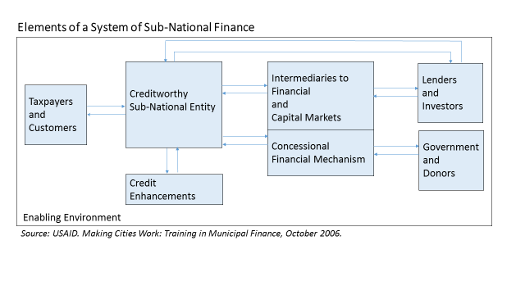

The WB-IFC’s Sub-National Development Program had identified in its paper to the Board that to support sub-national entities to access finance in domestic financial markets it is important to: establish a track record of timely debt repayment by sub-national entities; support demand for local long-term financing for infrastructure development and incrementally replace government lending by commercial lending; and, substantially recover costs through service tariffs and local taxes to improve the creditworthiness of the entity. This approach fits well with the larger institutional goal of developing domestic financial and capital market.[3]

Markets impose discipline on borrowing entities. As more and more subnational entities become creditworthy and seek financing without central government support, information and the markets ability to assess and price risks associated with such long-term debt will improve. As supporting frameworks mature, participation of long-term investors will increase and financing will become more predictable.

**Table: Results and Development Impacts**

|  |  |  |
| --- | --- | --- |
| Problems/Obstacles | Results | Development Impacts |
| Inadequate financing for  infrastructure results in low quality, limited availability of services | Greater access to financing will increase and improve infrastructure services | Higher, pro-poor growth; and lower poverty |
| Rising incomes will expand access and  increase affordability of infrastructure |
| Central government is major government social programs source of financing | Creditworthy sub-national entities attract financing without central government support | Increased fiscal space for other  government social programs |
| Financing is more predictable and  capital budgeting is more efficient |
| Financial and capital markets impose discipline on borrowing entities |
| Limited number of creditworthy entities | Growing number of creditworthy entities | Greater domestic investment, reduced capital outflows, promotion of private  participation in infrastructure |

*Source: ---. (June 2006). “Sub-National Development Program”, Board Paper. World Bank.*

1. **PPIAF’s Sub-National Technical Assistance Program (SNTA Program)**

The SNTA Program is managed as a non-core fund within PPIAF. Over the past three years, the portfolio has averaged Technical Assistance grants at approximately $4 million annually.

**PPIAF’s Sub-national Technical Assistance (SNTA) Program**

*Objective.* Its primary objective is to help sub-national entities develop their capacity to access market based financing without sovereign guarantees in order to improve infrastructure services.

*Sub-National Entities.* Clients of the SNTA Program include the following entities:

* Special-purpose government entities (utilities, authorities, special districts, state-owned enterprises, but with a focus on utilities delivering natural monopoly infrastructure services).
* General-purpose sub-national government entities (provinces, states, municipalities, etc.)
* Development finance institutions with a focus on infrastructure lending.

*Technical Assistance.* Technical Assistance activities include capacity building designed to improve the creditworthiness of sub-national entities and their investment projects, as measured by appropriate local credit ratings and/or actual access to financing.

*Portfolio Targets and Priorities:*

* Africa: 50%
* Middle Income Countries 50% and Low Income Countries 50%
* The program prioritizes SECO focus countries (Indonesia, Vietnam, Egypt, Ghana, South Africa, Tunisia, Colombia, Peru)
* Additional considerations: Poverty and gender considerations are required to be embedded in all activities; Fragile and Conflict Affected Countries; Climate Change

*Current SNTA donors:* DFID, SECO, Australian DFAT, AFD

The SNTA Program is positioned downstream of long-term sector and market reforms (such as those undertaken by the World Bank and bilateral program by DFID, USAID) and upstream of direct sub-national lending and investment (such as by IFC, AFD, others). The program improves the capacity of sub-national entities to access market based financing focusing its technical assistance at improving the creditworthiness of subnational entities and projects (borrowers), and connecting creditworthy borrowers to long-term financing.

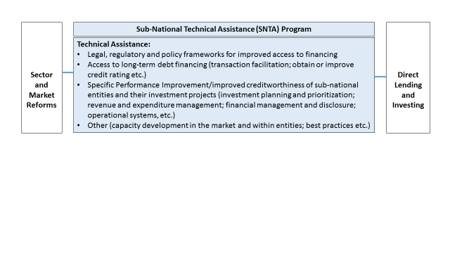

**Official Financing for Sub-Nationals**

1. **International Cooperation**

Three summits in 2015 set the stage for international cooperation over coming decades and include specific action areas regarding sub-national infrastructure development and finance:

* Third international conference on [Financing for Development](http://www.un.org/esa/ffd/) in Addis Ababa, Ethiopia in July 13-16, 2015: Under the resolution adopted by the General Assembly, the action area pertaining to “domestic public resources” commits to scaling up international cooperation to strengthen capacities of municipalities and other local authorities; and, the action area on “domestic and international private business and finance” agrees to work towards developing domestic capital markets, using blended finance instruments across key development sectors, including those led by sub-nationals.

<http://www.un.org/ga/search/view_doc.asp?symbol=A/RES/69/313>)

* [UN General Assembly](https://sustainabledevelopment.un.org/?page=view&nr=1064&type=13&menu=1300) which adopted a new set of Sustainable Development Goals (SDG) in New York, USA, in September 2015: Goals identified in the 2030 Agenda for Sustainable Development include a focus on sustainable cities.

<https://sustainabledevelopment.un.org/content/documents/7891Transforming%20Our%20World.pdf>)

* The [21st Conference of the Parties (COP21)](http://www.cop21.gouv.fr/en) of the UN Framework Convention on Climate Change (UNFCCC) in Paris, France in December 2015, which adopted a binding agreement on the long-term reduction of greenhouse gas emissions.

1. **Official Financing for Sub-Nationals**

The table below maps the experience of multilateral and bilateral agencies that offer loans and/or credit enhancement directly to sub-national entities.

|  |  |
| --- | --- |
| **Multilateral and bilateral agencies that offer loans and/or credit enhancement directly to sub-national entities** | |
| IFC’s Global Experience in Sub-national Finance | In 2003, the World Bank and IFC established the Municipal Fund for direct lending to sub-national entities without sovereign guarantees. The lending was from IFC’s balance sheet (in accordance with its Articles of Agreement, IFC operates on commercial terms and to make a profit). Building upon this experience, in 2006 the World Bank and the IFC launched a joint pilot program, the Sub-National Development Program (SND), which launched a: (i) Financing Window (Sub-National Finance Program)[4]; and, (ii) Technical Assistance Window (which would become PPIAF’s SNTA Program)[5].  IFC Sub-national lending is mainly aimed at Middle-Income Countries, however this does not exclude Low-Income Countries. The objective of IFC’s SN Finance program are to:   * Finance local infrastructure development projects; * Assist sub-national entities to gain access to financial markets; * Deepen financial markets.   As of September 2015, IFC reported an exposure of USD3.75 billion in 53 sub-national projects and 26 clients in 13 countries. The numbers include both Municipal Infrastructure and Other Subnational (transactions with SOEs and Financial Institutions) with approximately equal share (by volume). The program’s commitments are predominantly in Europe, Middle East and North Africa (41%); followed by Latin America (28%); and Asia (25%); and Africa (6%; South Africa, Kenya, Senegal). In terms of sector coverage, transport/roads lead, followed by power, water, and multiple sectors. Most exposure is in debt: foreign currency loans (54%) and local currency loans (24%). (Refer annexure 1 for details.)  *(Source: IFC sub-national finance practice pitch book).* |
| Note: In 2015, IFC launched a Cities Initiative that took stock of all IFC’s engagements with cities to report that: “IFC invested $6.8 billion in 221 city related projects and provided advisory services through an additional 164 projects to 87 cities in over 60 countries during 2004-2013)” Based upon this IFC proposes to have a relationship-based approach for cities, going forward.  *(Source: IFC Cities Initiative Fact Sheet).* |
| EBRD Non-sovereign public sector lending | EBRD supports projects in over 30 countries from Eastern Europe to Central Asia and the southern and eastern Mediterranean.  EBRD has been the leader in lending directly to sub-national entities since 1994. As of April 2014 EBRD had financed more than 300 projects in the municipal sector, with 55% financing made at the sub-national level, and another 20% raised from the private sector in the form of debt and equity in PPP arrangements or privatization. Within the municipal sector, EBRD channels its funding for water and wastewater treatment systems, urban transport, district heating and solid waste management through a specialized unit: the Municipal and Environmental Infrastructure (MEI) team. EBRD’s municipal lending program totaling some €4.5 billion (as of April 2014) has also enjoyed significant additional external co-financing. This additional co-financing comes in the form:   * B-loans from commercial banks, for a total of €1.5 billion * EU grant financing for capital expenditures, totaling €3.5 billion * Other IFI financing which has totaled €1.1 billion   Thus, in all EBRD municipal sector financing has resulted in €6.1 billion on additional co-financing  EBRD’s approach is to enhance the efficiency of its clients and promote commercialized focus in its projects. The aim of this focus is to create additional revenue generation on the part of clients.  *(Source: --- (April 2014). Accelerating Infrastructure Delivery: New Evidence from International Financial Institutions. World Economic Forum).* |
| European Investment Bank | * Focused on member countries, traditionally requiring sovereign guarantees * Direct and intermediated lending to investment grade local public authorities (regional and local authorities and public sector companies) in member states and non-member states, in recognition of the strategic importance of regions and cities for growth and development. * Financing for urban transport, district heating, waste incineration, urban development, social housing, urban water scheme, and regional water programs. |
| AFD (French Development Agency) | * Direct loans, credit guarantees and private equity that it provides to non-sovereign entities, that is, public sector borrowers whose debt has no state or central bank backing. * Loans for financial intermediation via loans and grants to national institutions on-lending to local governments * AFD has increased such financing by 37% since 2012. IN 2014 non-sovereign financing reached €2.6 billon, accounting for 33% of AFD’s commitments.   CEFEB, business university of the AFD, supports training programs  Strengthened by this positioning, AFD aims to specialize in financing municipalities and other non-sovereign public administrations.  *(Source: Annual Report 2015)* |
| KfW Development Bank | * Intermediated loans. KfW provides long term loans for promotion of banks, credit cooperatives and similar (such as Municipal Development Funds). For example, in 2015 KfW provided a USD100 million loan to the Colombian development bank Findeter. Findeter acts as an on-lending institution: funds flow from there to local banks that are in contact with the local municipalities. This allows the banks to grant loans to small and medium-sized cities too. MIGA is providing a guarantee of $95 million covering non-honoring of financial obligations by a state-owned enterprise to KfW * KfW has been an important and active financing partner of German municipalities for many years.   *(Source: Website)* |
| Inter-American Development Bank | * Based upon the experience of their two-year pilot program, in 2006 expanded lending to private, state-owned and mixed capital companies without sovereign guarantees in all economic sectors. * An evaluation for the period 2007-2010 found only modest delivery of loans to sub-nationals. Actual delivery was to three projects to enterprises partially or wholly owned by a sub-national government, or six projects if PPPs, where the authorizing counterpart is a public sub-national entity, were included. This modest success was attributed to the following: sub-national governments were excluded and sub-national enterprises treated on par with other structured and corporate finance loans; no specific institutional unit was charged with this agenda; and, lack of complementary grant resources to nurture the market and improve the competitiveness of these loans. The eligibility criteria essentially excluded most subnational enterprises. The absence of a dedicated unit facilitated a crowding out of these loans given that sub-national operations are more costly to prepare.   *(Source: (2012) Evaluation of the IDB’s Non-sovereign Entities: 2007-2010. Office of Evaluation and Oversight)* |
| Asian Development Bank | * 2005 introduced non-sovereign public sector lending. * 2011 mainstreamed non-sovereign public sector lending (predominantly to SOEs) |
| USAID’s Development Credit Authority (DCA) | USAID’s Development Credit Authority (DCA) provides partial credit guarantees to financial institutions for local currency loans, leases and letters of credit, or for underwriting bonds or other debt instruments for DCA’s technical assistance clients. DCA assists municipalities, other sub-nationals, financial institutions, and private enterprises. For example, the DCA provided partial credit guarantees to the pooled finance transactions in Tamil Nadu and Karnataka (the first two pooled issuances in India). In 2011, DCA provided a partial credit guarantee to the bond issued by Novi Sad, Serbia’s second-biggest city (the first municipal bond issuance in the country).  *(Source: Website)* |

*Sources: Extracted from Annual Reports, other reports available on the web, pitch-books, websites*

|  |
| --- |
| **Increasing Resources from Non-Traditional Sources such as Foundations (especially for Cities)** |
| Rockefeller Foundation and WBG   * 2014: $1.5 million to the City Creditworthiness Initiative, developed and supported by SNTA. * 2015: $10 million to IFCs Project Development Facility, of which $3 million is for cities to help move the deal forward) |
| * Rockefeller Foundation: 100 Resilient Cities ($100 million; focused on mid-tier cities) * Gates foundation (technical assistance to Dakar, Senegal) * Bloomberg’s C40 network (focus on 65 larger cities) |
| * Urban Climate Change Resilience Trust Fund: ADB, Rockefeller Foundation, DFID, CDIA (Asian Cities Program, initial financing of $140 million from Rockefeller Foundation, United Kingdom and United States) |
| * Rockefeller foundation outreach to Corporate Social Responsibility resources (CISCO, Veolia) (Siemens) |

**Sub-Sovereign Infrastructure Debt Financing: Loans and Bonds**

1. **Experience in Developed Countries**

In North America and Europe sub-national governments are important players in the public sector. With outstanding debt of 3.7 trillion in 2011, the U.S. municipal securities market is the largest in the world. State and local governmental entities access the capital market directly or through intermediaries such as state bond banks and state revolving funds. Such annual issuances ranged from US$ 499 billion in principle (2010) to US$ 355 billion in principle (2011).[6] Unlike the U.S., sub-sovereign bond issues in Canada are not tax exempt; however – as compared to European local governments, Canadian provinces have tax raising and policy making authority and bonds are a popular financing instrument.[7]

In Europe, loans (including from specialized lenders) and bonds have been used at the sub-sovereign levels of government (regional and local authorities), with capital market financing expected to rise.[8] The newly established French local government funding agency: Agence France Locale (AFL; modeled on the experience of Nordic countries) successfully launched its inaugural bond issue in March 2015. The United Kingdom, and possibly Germany, are also exploring establishing such a local finance agency for joint-participation by local governments in capital and credit markets.



*DE: Germany; ES: Spain; FR: France; IT: Italy; UK: United Kingdom; BE: Belgium; SE: Sweden*

*Source: As presented in EU monitor. DB Research (www.dbreasreach.com)*

1. **Emerging Experience in Developing Countries**

In developing countries, government and Development Finance Institutions lending (including concessional lending) continues to dominate sub-national infrastructure financing, especially in Africa. Some Eastern European countries such as the Russian Federation, Czech Republic, Romania, Poland and Serbia have entered the municipal bond market. Other countries such as Mexico, India and South Africa have also had modest success with municipal bond issuances. The new budget law that came into effect in China in 2015 allows provincial level governments to issue debt: loans and bonds (subject to approval).

Specialized funds and financial intermediaries for local and regional governments are already operational in many countries, though varied depending upon their objectives, ownership structures and functions. Such as: municipal development funds; specialized lending intermediaries for local and regional (for example [FINDETER in Colombia, a second tier specialized development bank, partially funded in the market](https://collaboration.worldbank.org/docs/DOC-6602?uploadSuccess=true)); bond banks that borrow from the debt capital market on behalf-of, or to re-lend to, participating local governments, bond banks (an example is the WB supported [Tamil Nadu Urban Development Fund in India, which over time transitioned to public-private ownership and served as an intermediary for pooled financing](https://collaboration.worldbank.org/docs/DOC-6602?uploadSuccess=true) for smaller municipalities in the state), and revolving funds.

**SNTA Program (May 2007 to Current): Lessons and Opportunities**

Supporting sub-national lending is most appropriate in the countries, that are decentralized (political and administrative, and fiscal), and where the sub-national borrowing framework is adequate and access to financial and capital markets exists. However, the decentralization context is still evolving in many countries, especially in Africa, and often sub-national governments have a limited mandate and authority to borrow. In recent years the SNTA program has increased its focus on enhancing capacity and creditworthiness of municipalities, upstream nature of support - rather than on supporting financing only. Such assistance is resource intensive (people, time and money): capacity weakness is usually more significant at the local level than at the national level; municipal projects tend to be smaller in terms of investment required (as compared to other infrastructure) and more political (therefore may take longer to materialize); and, when working with cities it is important to consider inter-governmental relationships and to engage, as appropriate, with all levels of government.

Utilities and SOEs offer a more immediate opportunity for sub-national financing, since utilities have greater borrowing autonomy when compared to municipal governments. However, their standalone creditworthiness is weak. The SNTA program’s approach has been to incrementally (rate, size, tenor) transition sub-national entities from government borrowing to commercial borrowing. Further there continues to be asymmetry of information regarding the viability of sub-national entities and projects, and there continues to be a valid role for specialized lenders.

Almost every country needs a tailored response, and borrowers need to be viewed in their local context. Broadly speaking, the program approaches Technical Assistance in Low- and Middle- Income Countries differently, as follows:

* Low Income Countries: Emphasizing credit skill and culture (credit ratings, systematically improve municipal finances to strengthen creditworthiness, financial assessments), and supporting pilot transactions.
* Middle Income Countries especially that are decentralized: Emphasizing credit culture and access to finance; exploring ways to achieve scale and leverage through pooling; and supporting pioneering transactions.

The SNTA program supports credit ratings across activities in its portfolio, with the dual objective of facilitating access to debt financing, as well as, supporting credit skills and culture.[9]

During the current strategy period, with a view to systematically identify and reach reform-minded cities and utilities with customized technical assistance, and to engage with them on a programmatic basis, the SNTA Program launched the following initiatives:

* FY 2015. “City Creditworthiness Initiative”, in partnership with the WB’s Urban Global Practice and the Rockefeller Foundation, which aims to support cities to improve their creditworthiness to access private financing for climate-smart infrastructure development.
* FY 2016. “Financing Universal Access to Water Supply and Sanitation”, in partnership with the WB’s Water Global Practice, which aims to facilitate access to financing for water utilities.
* FY 2017. SNTA proposes to launch a program, in partnership with ESMID, to support market borrowing by identified entities in: Kenya, Rwanda, Tanzania, and Uganda.

1. **Sub-National Governments**

The decentralization context, especially a sound fiscal decentralization framework that supports responsible borrowing, is critical. Sufficient and reliable, revenue streams are important for cities to be able to invest in infrastructure, operate and maintain assets, and provide services at optimal levels.[10] Of equal importance is sound financial management and the availability of audited financial statements. As a tier of government, an important dimension is cities ability to set-policy.

The market is highly differentiated. LAC and EAP present opportunity. Both regions are decentralized and have financial and capital markets. LAC is the most urbanized developing region in the world with nearly 80% of the LAC population lives in urban areas. Current TA in LAC includes the recently completed activity to support financing of energy efficiency in street lighting in Brazil, assessment of municipal finances for a city in Ecuador, and a pioneering transaction to support Tax Incremental Financing in Colombia. As per IFC, there is opportunity for sub-national financing in Colombia and Peru. (Note: At present, SNTA does not support activities in Brazil, Mexico and Argentina).

EAP is more than 50% urban, and local governments are important players in the public sector. Current TA in the region includes capacity development for municipal bond financing in Indonesia, and the creation of a city infrastructure financing facility in Vietnam. As per S&P, the Philippines, Indonesia, Vietnam, Thailand, and China offer opportunity. (Note: At present, SNTA is selective in supporting activities in China)

In ECA, the SNTA program has had some success in supporting sub-national lending in Turkey, where - based upon feedback from the WB’s City Creditworthiness Academy - there may be additional opportunities.

In contrast, while Africa and Asia remain mostly rural, with 40 and 48 per cent of their respective populations living in urban areas. The urban areas of Africa and Asia will absorb nearly all of the projected growth of the world population. Asia despite its lower level of urbanization, is already home to 53 per cent of the world’s urban population. And as per S&P, given its context of decentralization and financial and capital markets, India presents opportunity for sub-national financing. (Note: Currently SNTA does not support activities in India).

Africa is less decentralized (most cities in African countries have a limited mandate and authority to borrow; refer annexure 2 for details), and the financial (banking sector) and capital market, is weak. The urban population is expected to triple in Africa by the year 2050. However the urbanization context in Africa is different. In a 2009 report, the Commission on Growth and Development identified that in sub-Saharan Africa urbanization has been accompanied by very low growth and is concentrating poor people in cities rather than the countryside. Countries such as South Africa, which has a strong legal, regulatory and policy framework, present opportunity for sub-national financing.[11] Our current assistance to cities in Africa emphasizes partnerships and focuses upon supporting improved financial management, creditworthiness, and legal and regulatory frameworks in countries such as Ethiopia, Tanzania, Uganda, Mozambique and Senegal. And a pioneering transaction to support Tax Incremental Financing in South Africa.

The Middle East is also less decentralized and the current TA emphasizes municipal lending frameworks. In North Africa, the recent decentralization in Morocco has created interest.

**Considerations in Prioritizing the Selection of Local Governments for Technical Assistance:**

* Focus upon strategic/economically important cities/urban agglomerations (key city and its suburban cities): A vibrant local economy can impact a city’s creditworthiness since it influences the ability of a city to generate revenues (and therefore ultimately capacity to repay debt).
* Focus upon larger tier I cities AND/OR expand assistance even further to tier II cities: This decision merits discussion and an appreciation of the country context as well as what the Technical Assistance aims to achieve and what other resources may be available within the country.
* Scaling-up and replication (assistance to a larger number of tier I and II cities), needs to be done within the context of deeper country engagements that support legal and regulatory frameworks for sub-national borrowing. SNTA may consider partnering with other multi-lateral and bilateral country programs.
* If scaling-up is the objective, pooled finance within the context of a municipal financing framework may be an alternative to evaluate.
* The approach would need to vary across regions. Given the pace of urbanization, EAP and South Asia may be candidates for such an approach. In Africa, the first step would be to take stock of countries with a large number of tier II cities and the financial capacities of such cities. This would inform decision regarding interventions and appropriate resources.

1. **Municipal and State-Owned Public Utilities**

The key consideration in working with utilities and SOEs is whether they operate on commercial principles and determining their corporate governance structure (especially the separation of ownership and management roles). An understanding of regulations and public policy, and rationalization of tariffs, so that utilities can substantially recover costs remains important. (Note: Support for economic regulatory reforms is typically addressed under PPIAF grant funding).

Many of the current SNTA activities in the East and Southern Africa region are focused upon municipal and state owned utilities. The technical assistance emphasizes improved creditworthiness by strengthened the financial viability of the entities and their projects. For example, assistance to the Lusaka Water and Sewerage Company in Zambia included support to obtain a shadow credit rating; support for improving the management of working capital; hands-on support for implementing staff performance contracts; and, a review of cost recovery for sewerage services; and, an analysis of financing options for developing priority sewerage infrastructure. The SNTA program also supported capacity building activities to replicate local best practices. Similarly, in Malawi, the SNTA program is supporting state owned energy utilities ESCOM to obtain a shadow credit rating, review of its corporate taxes, and conduct a financing options analysis to explore access to local debt market. Coordinated efforts have worked well in activities where SNTA has supported utility creditworthiness on the heels of significant investment in infrastructure (and by extension, improved service coverage and increased revenues).

The technical assistance also focused upon facilitating improved access to financing, where the appropriate. For example, in Kenya, SNTA has partnered with Efficient Securities Markets Institutional Development (ESMID) to support the Kenya Roads Board to issue bonds in the local capital market.

SNTA is exploring a program, in partnership with ESMID, to support market borrowing by identified entities in: Kenya, Rwanda, Tanzania, and Uganda.

**Opportunity for Technical Assistance for SOE Turnaround**

PPIAF-SNTA and IFC have been discussing the potential to pilot activities that focus on the turnaround of state owned energy utilities, especially in Africa. Based upon IFCs experience of working with YESB (power distribution company in Myanmar) to provide TA support for evaluating short and medium term capex, corporatization and E&S against the backdrop of a potential equity investment. As reference: IFC retained a combination of investment bank, management consulting firm, and technical advisory firm for about one million dollars to provide this Technical Assistance.

Our proposition is that such TA can bring significant business know-how to these companies. Ideally the TA would target state owned energy utilities in the Transmission and Distribution space (T&D has had lesser success in attracting private sector participation as compared to power generation); which are relatively well run, independent i.e. have no explicit sovereign guarantee, are starved of money with the possibility for reasonable tariff in the future.

The technical assistance is expected to focus upon developing and implementing a comprehensive and realistic turnaround plan (including corporatization, governance, financial and operational restructuring, valuation, capex planning, HR support, procurement review, etc.) against the backdrop of a potential transaction such as debt or an equity investment. Such TA would need to retain services from a combination of investment bank, management consulting firm, and technical advisory.

1. **Intermediaries**

In the recent years, the SNTA program has been investigating the opportunities presented by intermediaries for facilitating sub-nation access to finance. Credit pooling benefits issuers by spreading administrative costs across a number of participating entities. The portfolio’s geographic diversification and the use of credit enhancements can improve credit ratings. There are policy, legal, capitalization, ownership and management decisions that inform the design of such structures. Protection from government interference in credit decisions is critical. In terms of the pooling arrangement, agreeing upon liability – joint and/or several - is important. (Note: The potential role for such entities to support project development and capacity building, is not discussed here). In terms of the development agenda, in some countries, pooling may be a way to scale-up and replicate.

In 2009 the SNTA program has helped the Mexican State of Quintana Roo structure a series of pooled borrowing transactions worth about $196 million. And the program plans to support a paper to study the U.S. Bond Bank model during the current year. In FY15 the program sponsored a study tour for participants from South Africa, Colombia, and Peru, to KommuneKredit in Denmark and Agence France Locale in France (pooled finance agencies, Nordic model).

Currently the program is providing technical assistance to develop the capacity of the Municipal Development and Lending Fund in West Bank and Gaza, to assess and lend to creditworthy municipalities. Similarly the program is supporting the establishment of a City Infrastructure Financing Facility in Vietnam. And supporting Technical Assistance to the Kenya Pooled Water Fund (under the “Financing Universal Access to Water Supply and Sanitation” program).

**Recommendations for the SNTA Program Strategy (2018-2020)**

The SNTA Program is unique in its global reach and its emphasis upon developing a sustainable market-based approach for infrastructure financing (which is key to achieving the SDG goals). The program improves the capacity of sub-national entities to access to long-term market based financing in domestic markets. The program’s approach emphasizes improved creditworthiness of sub-national entities and their projects (critical to this is improved mobilization of own source revenues - taxes and user charges); and facilitating access to long-term financing in local markets.[12] This works dovetails with the efforts of PPIAF. The lack of creditworthiness of local counter parties, lack of depth of capital markets, and limited local currency funding are identified as barriers to project development (PIDG).

The sub-national financing framework is still developing in most countries. The SNTA program is well positioned given its ability to support and connect critical elements within this framework, and over the years has accumulated significant knowledge in supporting subnational entities, which allows it to add value.

When assessing TA grant requests, the program is attentive to the level of decentralization (administrative, political and fiscal), as well as to the level of development of financial and capital markets and sub-nationals policies and experience in accessing debt financing.

**SNTA Program: Operational Constraints**

* The SNTA program’s biggest constraint is that it does not directly implement activities. Activities are led by WB Task Team Leaders (TTL) and the Technical Assistance needs to have been prioritized under the Systematic Country Diagnostic and linked to WBG operations. The SNTA strategy will need to appreciate this limitation of the program vis-à-vis activity design, prioritization and implementation.
* SNTA is once removed from implementation of the Technical Assistance and twice removed from the client. As a result client, stakeholder and partner relationships sit with the implementing team.
  + Thus far, the program has benefited significantly from feedback from donor country teams (at the application no-objection stage), as well as from implementation support for selected activities. WB and donor country teams offer rich insight and local knowledge, and the program will benefit from increased communications at the operational level. Such dialogue will facilitate better identification of opportunities.
  + The program should emphasize outreach to the professional community (credit rating agencies, financial institutions and intermediaries, etc.) and partner organizations working on the subject.

**Program priorities that will guide SNTA funding decisions during the period 2018-2020**[13]**:**

1. **Programmatic and Opportunistic Support in MICs and LICs**

* Middle Income Countries (MIC): Prioritizing TA in MICs that are decentralized, and have financial and capital markets, would be expected to improve outcomes with respect to financing opportunities.
  + The program proposes to expand TA to upper MIC, on strategic (access to finance) and selective (critical/innovative) basis. Experience with sub-national finance, is still in the introductory and has not matured to a growth phase. To stay relevant, it is important for SNTA to be opportunistic about finding successes where the program can, both for demonstration and for lessons/exposure to pioneering activities.
  + Eligibility of MIC countries for TA support is to be agreed and guided by donors.
* Low Income Countries (LIC) and Countries Where Decentralization is Still Evolving: Activities focused upon improving the creditworthiness of sub-national entities, especially in Africa and in LICs, are resource intensive and will take longer to materialize.
  + The program proposes to continue such TA on a programmatic basis, with a phased approach, targeting incremental outcomes.
  + Such TA would be undertaken within the context of deeper and longer reforms. And partnership/collaboration with donor programs/resources that are focused upon sector and market reforms would be expected to improve outcomes.

1. **Prioritized Technical Assistance**

* Programmatic Initiatives (Monitor and Evaluate – Incorporate Lessons and Feedback – Strengthen): Strengthen support to the Programmatic Initiatives launched during the ongoing strategy period
* Pilot TA Activities to Address Following
  + Pilot TA activities that focus on the turnaround of State Owned Energy utilities
  + Intermediaries/pooled finance: Systematically build this body of knowledge and TA experience.
* Coordinate efforts with PPIAF’s Climate Change Non-Core Fund and WBG Climate Change CCSA. As possible, compliment their activities with TA to support financing and policy options at the sub-national level to help countries meet their national pledges/action

1. **Partnerships and Collaborations (Leveraging relationships, knowhow, and resources)**

(Annexure 3 maps TA programs and initiatives).

* Partnerships: SNTA has benefited from implementing support from WBG and donor country teams. Efforts have also worked well in activities where the TA was coordinated with investment in infrastructure (and by extension, improved service coverage and increased revenues).
* Implementing partnerships with donor programs/resources including foundations
* Coordinate efforts with other resources/investments
* Collaborating Organizations: As appropriate, continue to collaborate with other TA programs and initiatives targeted at sub-nationals, to compliment with TA for financing and efforts.

1. **Knowledge and Outreach**

* Continue to capture and disseminate lessons, as is already envisaged under PPIAF’s knowledge initiative.
* Play an active role in analyzing, synthesizing and disseminating the results and lessons learned of own programming and research, and of donor and partner organizations.
* Engage selected international and national development communities (inside and outside the Bank) in targeted countries and sectors to analyze needs and opportunities and how to respond most effectively to such opportunities.
* Emphasize outreach to the professional community and partner organizations working on the subject. This could include convening periodic roundtables, participating in conferences and events.
* Strengthen SNTA brand recognition

**Annexure 1: Experience of IFC’s Sub-National Finance Program**

**IFC Global Experience**

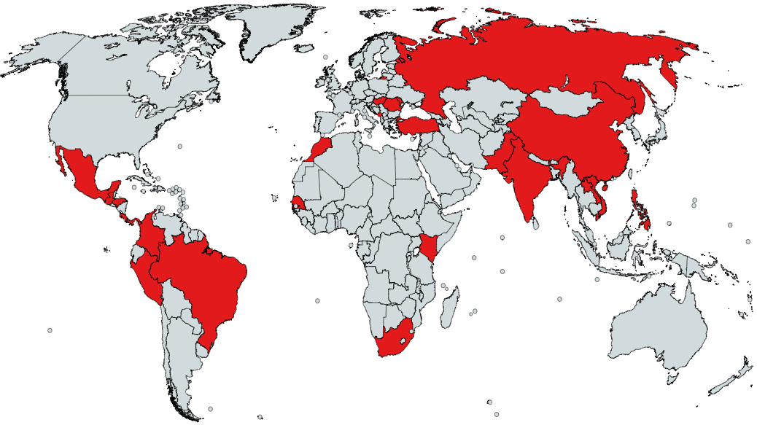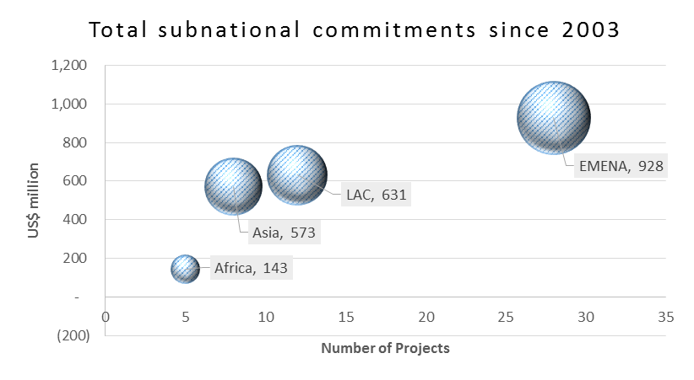

Eligible Clients

**Eligible Clients**

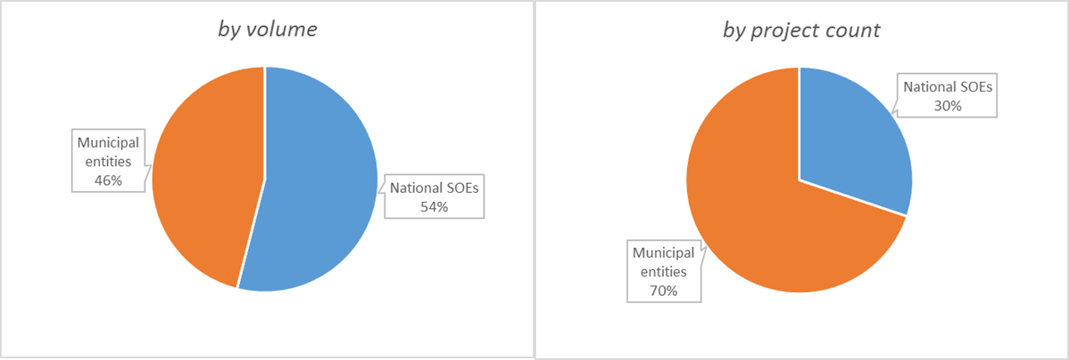

**Sector Coverage**

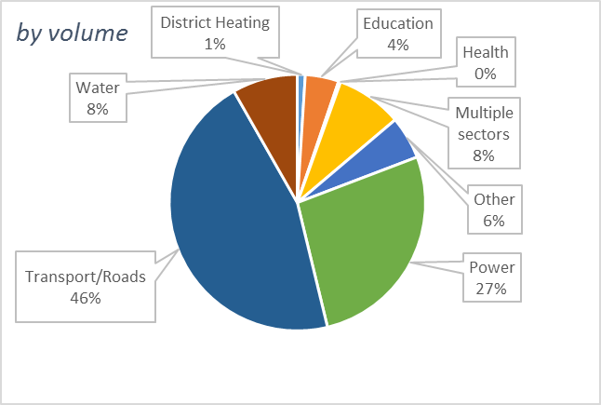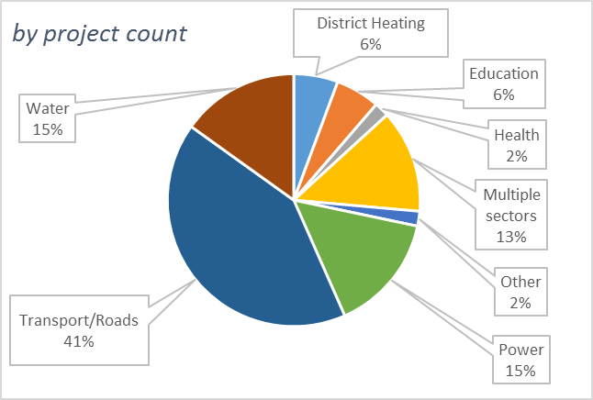

**Available Financing Instruments**

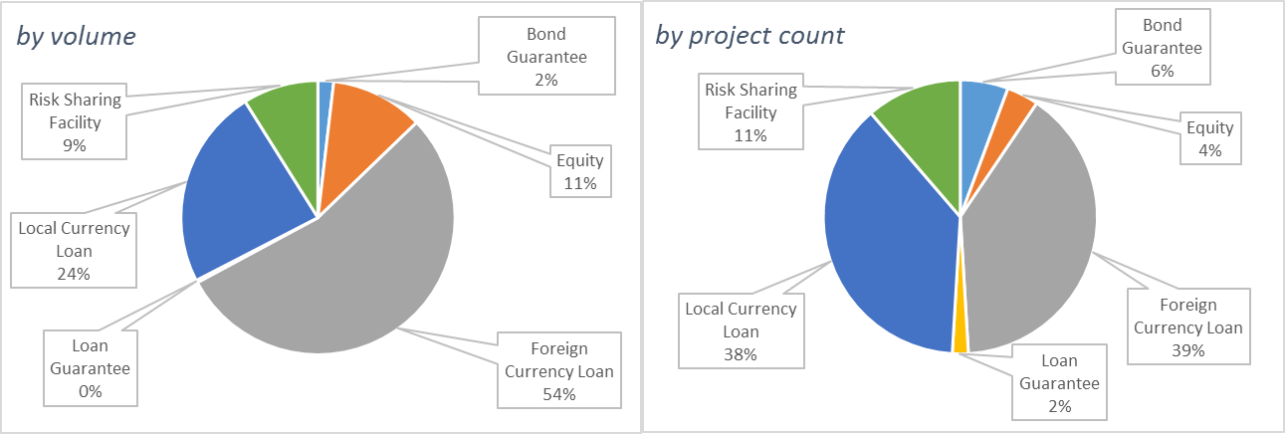

*Source: IFC sub-national finance practice pitch book.*

**Annexure 2: Decentralization**

**Index of Decentralization**



Color of a country corresponds to its percentile in the world’s distribution: red 0-25th, yellow 25-50th, blue 50-75th, green 75-100th .

Source: WPS613, “How close is your government to its people? Worldwide indicators on localization and decentralization”, 2012

**Local Government Borrowing Freedom**



Color of a country corresponds to its percentile in the world’s distribution: red – 0-25th, yellow 25-50th, blue -50-75th, green 75-100th .

Source: WPS613, “How close is your government to its people? Worldwide indicators on localization and decentralization”, 2012

**Annexure 3: Selected Technical Assistance Programs and Initiatives Targeted at Sub-Nationals**

|  |  |
| --- | --- |
| **Multilateral and bilateral Technical Assistance to improve sub-nationals access to finance for infrastructure development** | |
| EBRD | Emphasize long term engagement with clients. Funds and team available to improve capacity (projects and entity). |
| USAID | Bilateral programs to support the delivery of commercially viable infrastructure services and the development of market-based urban infrastructure finance systems. Examples of well recognized programs include: the Financial Institutions Reform and Expansion (FIRE) project in India, launched in 1994; the Municipal Infrastructure Investment Unit (MIIU) in South Africa, launched in 1998. |
| DFID | Bilateral programs focused upon improved urban services for poor. For example, DFID India’s support program for Urban Reforms in Bihar, India; Urban Services for Poor in Madhya Pradesh, India. |
| DFID supported “Infrastructure and Cities for Economic Development” (ICED) (£ 33.5 million; March 2015 till March 2020)  This project targets between eight and 13 new country programs (India, other) and will support DFID and its development partners:   * Improve the enabling environment for sustainable, inclusive growth-enhancing infrastructure service delivery in DFID focus countries; and, * Harness the benefits of cities for sustainable economic growth and poverty reduction in DFID focus countries.   ICED will only support DFID country programs. |
| DFID supported “Cities and Infrastructure for Growth” (CIG)  (£ 100 million; under design)  The project would target six to 10 countries (potentially Zambia, DRC, Burma, Pakistan, Nepal, other) to improve capacity. |
| Inter-American Development Bank | Inter-American Development Bank’s Emerging and Sustainable Cities Initiative The Emerging and Sustainable Cities Initiative provides technical assistance to small and medium cities in LAC identifying, prioritizing and structuring projects to improve their environmental, urban and fiscal sustainability. The Initiative integrates environmental sustainability, comprehensive urban development, fiscal sustainability and good governance, and provides emerging cities with a set of tools to identifies bottlenecks, prioritize investment decisions and monitoring. |
| Development Bank of Latin America (CAF): The program, Ciudades con Futuro (Cities with Future) is focused on technical assistance to define green growth strategies in Latin American cities. |
| ADB | Cities Development Initiative for Asia: Established in 2007, CDIA is an international partnership initiative by the ADB and the Government of Germany (BMZ), with additional core funding support from the governments of Austria, Sweden, Switzerland and the Shanghai Municipal Government. The Initiative provides assistance to medium-sized Asian cities to bridge the gap between their development plans and the implementation of their infrastructure investments. |
| UN Capital Development Fund (UNCDF) | UNCDF, the UN capital investment agency for the 49 least developed countries (LDCs), provides seed capital and technical assistance to test new modalities of public and private financing for local development. In 2015, UNCDF launched a five year Municipal Investment Financing (MIF) Programme (yet unfunded). The aim of MIF is to increase the ability of local governments and other sub-sovereign entities to address key urbanization challenges through access to sustainable sources of capital financing. The program targets LDC cities in Africa and Asia.  In 2015, PPIAF’s SNTA Program provided a grant of $224,500 to MIF for developing a knowledge product, for the activity titled “Promoting Municipal Finance Markets through Strengthening of Knowledge and Capacity Building”. The proposed activity aims to strengthen selected National Investment Funds for Local Authorities (NIFs; in French Institutions de Financement des Collectivités Locales) in LDCs through the RIAFCO network, the Network of African Finance Institutions for Local Authorities, which represents a number of NIFs in Africa. This assignment consists of two components:   * Component 1: Knowledge products that strengthen understanding of municipal finance and the related regulatory/policy context. (The activity will study conditions of sustainability and diversification of financial resources in four selected countries: Cameroon, Mali, Niger, and Madagascar.) * Component 2: Capacity building and curriculum development for national investment funds and the RIAFCO network. |

*Note: The table does not list programs and Initiatives that focus upon climate change and resilience related activities with cities.*

*Sources: Text extracted from Annual Reports, reports available on the web, pitch-books and websites*

**Other Collaborating Partners**

* Cities Alliance
* GPOBA
* ESMAP
* ESMID
* PIDG
* GuarantCo

**Recent Developments (Increasing Interest to Support Cities)**

* In September 2013, the World Bank Group President Jim Yong Kim announced a groundbreaking new initiative to reach 300 cities in developing countries over four years to help them plan for a low-carbon future and get the needed finance flowing

(<http://www.worldbank.org/en/news/feature/2013/09/25/planning-financing-low-carbon-cities>)

* City Climate Finance Leadership Alliance, launched in September 2014 at the United Nations Secretary-General’s Climate Summit (UN-led initiative to help finance cities to become more sustainable and resilient)
* October 2015, the UN-Habitat announced a partnership with the World Bank to implement several Sustainable Development Goals focusing on urban sustainability, safety, inclusiveness, and resilience.
* The United Nations conference on Housing and Sustainable Urban Development (HABITAT III) in October 2016 talks about the New Urban Agenda with a high-level round table discussion on initiatives, partnerships, synergies and mechanisms to ensure adequate resources to finance sustainable urban development.

1. Urbanization is a defining trend of our time. In 1900, 13% of the world population was urban. Today more than half of the estimated population of 7.2 billion lives in cities. This growth has happened within the span of one century. On the upside: Urbanization and economic development are correlated and there are other benefits of density and agglomeration economies. (While correlation does not establish causality, The Commission on Growth and Development finds that, “There is a robust relationship between urbanization and per capita income: nearly all countries become at least 50 percent urbanized before reaching middle-income status, and all high-income countries are 70-80 percent urbanized.”) Production is concentrated in cities, which are also centers of demand and social convergence. No country has achieved high income status without significant urbanization. However, increasing energy use, accelerating CO2 emissions, and increasing environmental pressures, will accompany GDP growth. The Intergovernmental Panel on Climate Change estimates that urban areas account for 71–76% of energy-related CO2 emissions, and the world’s cities produce almost half (37-49%) of all global greenhouse-gas emissions. Mismanaged urbanization will impose social and environmental costs that will be difficult to reverse.
2. It is also important to ensure efficiency in the delivery of an appropriate level of services. Three dimensions of infrastructure services affect the poor: access, quality, and affordability. In developing countries, service providers are often trapped in a “low-level equilibrium”, wherein inadequate cost recovery negatively impacts their ability to invest and maintain infrastructure assets. And such lack of infrastructure and high-levels of system losses, result in an inability to deliver, and therefore, charge for services.
3. For a discussion on the framework for the development of financial markets refer:

   Chami, R., Fullenkamp, C., and Sharma, S. (2009). A Framework for Financial Market Development. IMF Working Paper. (<https://www.imf.org/external/pubs/ft/wp/2009/wp09156.pdf>)
4. The SND created a joint World Bank-IFC department which would work to coordinate their activities. In 2009, as the IFC decentralized, the SND program was incorporated into the IFC’s regional infrastructure finance departments. Today, while IFC continues to provide non-sovereign-guaranteed lending on its balance sheet, the sub-national finance team is dispersed across departments and regions.
5. Following discussions with PPIAF donors, it was agreed that the TA window would be administered by PPIAF. And in May 2007, the PPIAF Program Council endorsed the creation of a new, non-core program fund – the SNTA Program. PPIAF’s SNTA program works in parallel with, but is not be directly connected to IFC’s SN finance practice. The SNTA funding is not tied to the use of any particular transaction advisor, financier, financing arrangement, or guarantee program.
6. ---. (July 31, 2012). “Report on the Municipal Securities Market”, U.S. Securities and Exchange Commission. (<https://www.sec.gov/news/studies/2012/munireport073112.pdf>)
7. Platz, Daniel (2009). “Infrastructure finance in developing countries—the potential of sub-sovereign bonds”, DESA Working Paper No. 76. United Nations Department of Economic and Social Affairs. (<http://www.un.org/esa/desa/papers/2009/wp76_2009.pdf>)
8. Vetter, S. Zipfel, F. and Fritsche, J. (July 2014). “Small is beautiful? Capital market funding for sub-sovereign authorities is on the rise”, EU monitor. DB Research (www.dbreasreach.com)
9. Credit ratings address creditworthiness of the issuer or issues, the likelihood of timely and full payment of principal and interest, and probability of default (Standard & Poor’s).
10. Cities have a number of revenue sources. These include: inter-governmental transfers (these can include components of shared taxes, distributional grants, and specific-purpose grants); own source revenues (taxes such as property tax and user charges that are linked to the delivery of a service such as water supply etc.); and, the potential for monetizing land development (such as through betterment contributions, tax incremental financing, transfer of development rights, etc.).
11. It is worth highlighting that in addition to urban transport and water and sanitation, the functions assigned to cities in South Africa include electricity and gas reticulation, which help diversify their own-budget revenue source.
12. The SNTA program will develop a Theory of Change and results framework based upon the description and illustration of the “why and how” as presented in this working note.
13. The note does not look at implications on resources and capabilities at this stage.