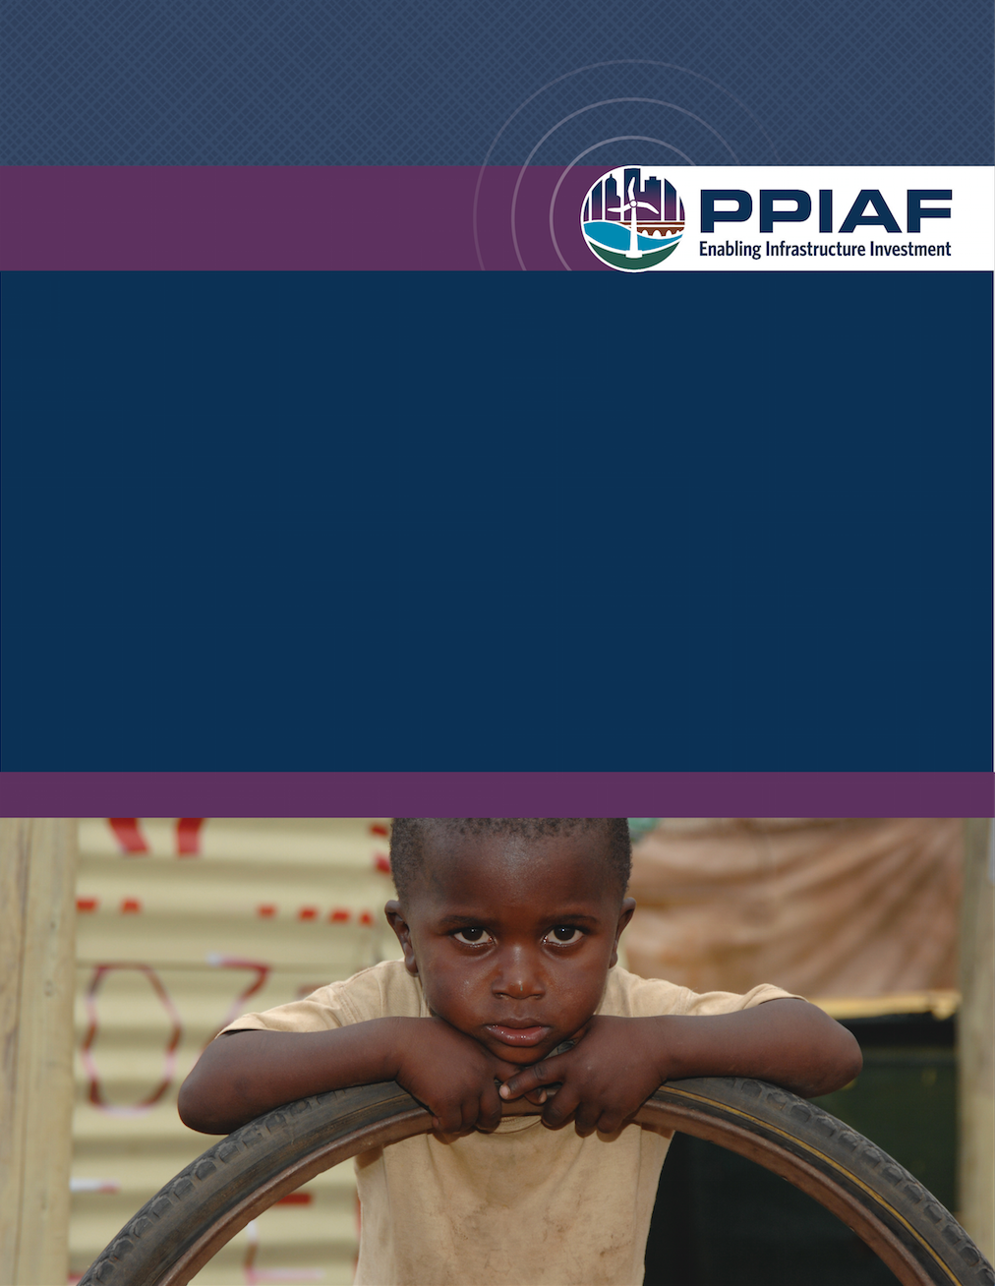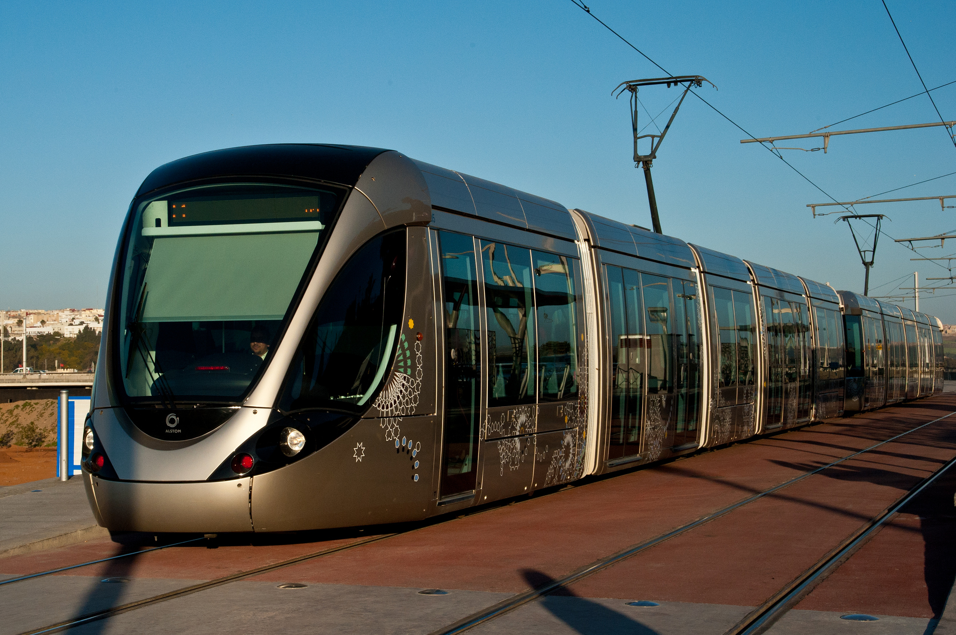g

fh

November 2016

Quarterly Report

Q1FY17

# Table of Contents

Table of Contents 2

LETTER FROM THE PROGRAM MANAGER 3

SECTION 1: TECHNICAL ASSISTANCE FUNDING IN THE FIRST QUARTER OF FY17 4

OVERVIEW 4

HIGHLIGHTS OF TECHNICAL ASSISTANCE ACTIVITIES APPROVED 4

HIGHLIGHTS OF KNOWLEDGE ACTIVITIES 6

DISSEMINATION AND NEW PUBLICATIONS 6

SECTION 2: PROGRAM FINANCES 9

Annex 1: SUMMARY OF ACTIVITY FUNDING 10

OVERVIEW 10

FRAGILE AND CONFLICT-AFFECTED STATES 10

GEOGRAPHIC FOCUS 11

SECTOR BREAKDOWN 12

COUNTRY INCOME STATUS 13

FUNDING SOURCE 14

APPROVED ACTIVITIES FOR THE PERIOD JULY 1, 2016 – SEPTEMBER 30, 2016 14

ANNEX 2: Detailed Program Finances 19

# LETTER FROM THE PROGRAM MANAGER

We are pleased to share with you the first Quarterly Report for fiscal year 2017. PPIAF approved a total of $5.5m in the first quarter for sixteen activities. The average size of approved activities in this first quarter is about $402,000.

Two activities were approved as part of a program: West Bank & Gaza – Non-Revenue Water (NRW) Performance Based Contract from the Developing Good Performance Based Contract (PBC) Practices in the Marketplace to manager Non-Revenue Water (NRW Program and component 1 of the Financing Universal Access to Water Supply and Sanitation Program in Kenya.

Other technical assistance activities approved in this first quarter were also follow-up to activities from previous PPIAF support: Tanzania - PSP Options Analysis for Urban Water Sector Reform; Ghana - Strengthening Private Sector Participation in Community Water Supply; Africa - Green Growth Investment Fund Africa (GGIFA) - Feasibility Study; Timor-Leste - Establishing a Project Management Unit for the management of the Tibar Bay Port Concession; Mongolia - Ulaanbaatar City Capital Investment Plan and Financial Assessment for Urban Transport Service Delivery; Senegal - PPP framework for private sector participation in the road sector in Senegal and development of a strategy for urban transport investment in Dakar

In our Global Knowledge portfolio over the last quarter we approved two new PMU-originated knowledge activities, which are listed in the knowledge activities section below. Regarding dissemination, PPIAF launched its brand new website, as well as several new publications and impact stories that have been produced by the PPIAF team and task managers implementing PPIAF-funded activities. These have been shared with our clients through the PPIAF Newsletter, twitter, and blog channels. Links to these products are found in the in the publication and dissemination sections below. Our team has continued to participate in several events and missions to support the implementation of the activities we are funding, which gives our staff the opportunity to share the knowledge products and resources we produce with our clients.

Our team has also participated in several events and missions to support the implementation of the activities we are funding, which gives our staff the opportunity to share the knowledge products and resources we produce with our clients.

The Program finances section 2 of the report, building on our monthly information reports will provide you with the details and explanations required for a more operational vision of the funding balances available at individual trust fund level.

Yours sincerely

**

Francois Bergere

# SECTION 1: TECHNICAL ASSISTANCE FUNDING IN THE FIRST QUARTER OF FY17

## OVERVIEW

In the first quarter of the fiscal year, PPIAF approved a total of 16 activities which are either a follow-on to previously supported activities or activities that are part of larger programmatic support; 13 country specific, 1 regional and 2 Global (knowledge) Activities. The 14 technical assistance activities worth $4.8 million were approved from the MDTFII, SECO Middle Income, USAID Water for Sub-Saharan Africa and SNTA Trust Funds. The country specific activities were approved in Jordan, Tajikistan, Lao PDR, Tanzania, West Bank & Gaza, Ghana, Peru, Kenya, Timor Leste, Lesotho, Mongolia and Senegal

Annex 1 gives a list of our technical assistance and knowledge management activities approved in the first quarter and how these have been distributed across regions, sector and country income status.

Below, we provide some of the highlights of our approvals in the first quarter illustrating the various regions where we work.

## HIGHLIGHTS OF TECHNICAL ASSISTANCE ACTIVITIES APPROVED

**PERU: Developing a Transit Oriented Development (TOD) Project via Public-Private Partnership (PPP) in Lima - Evaluation of potential for Lima Metro’s Line 2 Project (Funded from SECO MIC)**

This assignment consisted of a study to:

* review and adapt a general framework to use LVC mechanisms to finance TOD, including public infrastructure projects associated with the metro network through PPPs; and
* evaluate the potential to use LVC mechanisms, in the form of TOD pilot projects implemented through PPPs, to help finance complimentary investments to Metro Line 2 and inform future PPP structuring processes of the Lima Metro network.

This study will evaluate the potential viability of developing TOD sites with LVC financing along the Line 2 of the Lima Metro System, through a PPP model. Now that the Line 2 project has been awarded and is underway, the need for complementary investments in urban development was identified. These investments have the potential to be developed through PPPs complementary to the metro concessions and can be structured and promoted by Proinversion. Focusing on the Line 2 project, already awarded, will ensure that the pilot will have a fertile ground for implementation and allow for improvements to be introduced to increase demand and tap into additional sources of funding for this megaproject. The study will also evaluate the potential to use land-based value capture (LVC) mechanisms, in the form of TOD pilot projects implemented through Public-Private Partnerships (PPP) to help finance complementary investments to Metro Line 2 and inform future PPP structuring processes of the Lima Metro network.

**KENYA: Component 1 of the Financing Universal Access to Water Supply and Sanitation-(Funded from SNTA)**

This activity falls under component 1 of the approved Program Concept for the global program, “Financing Universal Access to Water Supply and Sanitation” that seeks to develop opportunities to scale private investments in the sector.  The Program Concept under which this activity is being made was approved on March 18, 2016 for a total PPIAF allocation of $2.5 million.

The objective of Component 1: Outreach, Surveillance and Potential Transaction Structuring: is to complete a minimum of ten country studies that will characterize the broad authorizing environment for private financing of water, identify a potential pipeline of transactions that would attract private capital, and design the financing and technical support structures for the next phase of the Program, where the assessment demonstrates that the outlook for downstream support to such countries is positive.

The Objective of this effort is to support ongoing work in Kenya to make sub-national water service provider’s credit worthy and assist them to access domestic, commercial finance. The work entails technical inputs, policy advice, guidance, knowledge inputs and capacity building to assist these entities to become more credit worthy, market sensitive and able to secure commercial domestic credit either leveraging from their own source resources, ODA, or other financing which may be available.

**TIMOR-LESTE: Establishing a Project Management Unit for the management of the Tibar Bay Port Concession (Funded from MDTF II)**

The objective of this activity is to support GoTL to set up and operationalize the PMU and build its capacity for the management of the first PPP concession contract in Timor Leste. This support is envisaged to encompass capacity building and transfer knowledge from international experts to local staff for long-term contract management, based on the PPIAF recommendation to establish such a Unit provided under the previous PPIAF activity. The proposed assistance is conducted by two consultants; the Project Management Advisor (PMA) and the PPP Specialist.

Given that the proposed project management advisor’s work involves representing the government, responsibilities such as the recruitment of the PMU staff and Independent Engineer and consultation with the Concessionaire on the CA obligations, the proposed assistance is implemented as a recipient-executed grant. The GoTL will be responsible for the procurement and supervision of the consultants to be mobilized under the proposed grant. In order for the WB task team/PPIAF to ensure monitoring and supervision of the activity, the WB task team will take advantage of preparation for the proposed WB $60 million lending operation to partially fund the VGF of the Tibar Bay Port Project such as mission travel to the field. It is likely that the field missions will be scheduled every three months until Board approval (in July or August 2017). The WB task team has hired an individual consultant under their preparation budget, and his ToRs specifically includes the monitoring of the PPIAF grant. In addition, the PPIAF funded Project Management Advisor is expected to  prepare “monthly activity reports and Summary reports on the Monthly Steering Committee Meetings”, which will be very useful for WB/PPIAF to closely assess his performance, relevance, and capacity to meet the GoTL’s needs and expectations. The task team will make sure the consultant selection process is transparent and well managed.

**SENEGAL: PPP framework for private sector participation in the road sector in Senegal and development of a strategy for urban transport investment in Dakar (Funded from MDTF II)**

The objective of this activity is to support the Government of Senegal in defining an appropriate PPP institutional arrangements and regulatory framework in the road sector in Senegal. More specifically, this activity will help the Ministry of transport adopt a coherent urban transport strategy for Dakar that is accepted and understood by different stakeholders and which will clearly set out priorities as well as identify projects that are eligible for PPPs.

This new activity builds on PPIAF’s long-standing engagement with the Government of Senegal on the country’s PPP agenda which has led to series of activities and led to key reforms in a number of infrastructure sectors including the telecommunications and energy sectors. By financing the project, PPIAF will complement not only its early support (under the UMEOA program) but will also be contributing towards the implementation of the priority actions of the Senegal Economic Emergence Plan (PSE). Moreover, this is an important opportunity for PPIAF to contribute to an important project (as the BRT project is the first one in a Francophone country in SSA) and work in partnership with not only the WBG but also external partners that are involved in the project.

## HIGHLIGHTS OF KNOWLEDGE ACTIVITIES

**GLOBAL: Practical Guide on the establishment and operation of investment funds designed to leverage private sector participation in infrastructure development (Funded from MDTF II)**

A growing number of emerging markets and developing economies are establishing sovereign funds to leverage private financing for infrastructure development. The use of Strategic Investment Funds (SIFs) opens up a range of new possibilities for deepening undercapitalized domestic financial markets and crowding in international and domestic private capital to infrastructure projects/funds in priority sectors such as energy, transport, ICT and water. However, the approach also carries significant risks, particularly in country contexts with weak governance and rule-of-law, limited financial market regulation, and high levels of corruption. Governments willing to set-up infrastructure SIFs are facing challenges in terms of defining appropriate investment mandates, governance structures, macroeconomic policy implications, investment policies, and asset allocation, as well as contractual foundations and relations.

The objective of the knowledge product is to provide tools to Governments for the establishment of SIFs for infrastructure development. The Practical Guide provides a set of good practices and guidelines for the establishment and operation of SIFs, with particular focus on infrastructure investment and private sector participation. The Guide pays attention to strategies employed to crowd in external (private or public) investors, and to reconcile commercial objectives with wider economic and social objectives.

The activity is structured as two components: (i) Review of SIFs and (ii) Guidelines for the establishment and operation of SIFs.

**GLOBAL: Selecting and Screening Projects for Implementation as PPPs (Funded from MDTF II)**

This activity examines both the selection of projects and the selection of procurement methods for identified projects. The objective is sought to be achieved through a review and consolidation of methodologies used in countries globally and earlier Bank advice in client countries, especially emerging PPP markets. The activity aims to enhance the understanding of experts working on PPPs and client country practitioners engaged in PPPs in emerging markets about the various methodologies used globally for selecting projects to be undertaken as PPPs as opposed to public procurement. This knowledge product is produced in partnership with the World Bank Group, the Global Infrastructure Hub, and Organization for Economic Cooperation and Development. Both of these partner organizations are reviewing the various PPP selection practices in countries globally with the objective of enhancing the understanding of staff working on PPPs in client country practitioners engaged in PPPs in emerging markets.

The activity also develops a standardized technical guidance that can be applied in future PPIAF technical assistance that includes project selection/screening. PPIAF receives a large number of requests from client governments for this type of technical assistance, and having standardized technical guidance improves the quality of assistance for client governments and builds clients’ capacity to conduct screening and selection on their own. The tool is incorporated into the PPP CCSAs broader work, as well as the World Bank’s engagement with clients on PPPs. This activity will improve the consistency and quality of project screening and selection in a broad range of future WB engagements. The review of methodologies under Component 1 of this activity builds on previous PPIAF activities by including the methodologies of PPIAF-funded pipeline screening and project selection consultancies. This process leverages the use of existing PPIAF materials and identifies best practices to be incorporated into future activities.

More detail on the approved activities can be found in Annex 1, Table 8

## DISSEMINATION AND NEW PUBLICATIONS

We are pleased to announce the launch of our brand new, interactive website (www.ppiaf.org). Our goal is to provide you with a user-friendly way to learn about PPIAF's activities and resources and showcase PPIAF’s breadth of technical assistance and knowledge in easy-to-navigate pages. It features a central repository of resources and documents, tagged with the topics, sectors, activities and programs to which they relate. The site uses technology that enables pages to load quickly, and its design automatically adjusts to fit the size of the client’s browser window, whether it be on an iPhone, iPad, or any other device.

**ppiaf supported publications**

**Regenerating Urban Land: A Practitioner’s Guide to Leveraging Private Investment**

PPIAF has been working with the World Bank on a guide on regenerating urban land, to be used as a guide to leveraging private investment. This study draws on the experience of eight case studies from around the world. The case studies outline various policy and financial instruments to attract private sector investment in urban regeneration of underutilized and unutilized areas and the requisite infrastructure improvements. The study also analyzes rates of return on the investments and long-term financial sustainability.

This Regenerating Urban Land guide helps local governments to systematically identify the sequence of steps and tasks needed to develop a regeneration policy framework, with the participation of the private sector. The manual also formulates specific policies and instruments for expanding private sector participation; structuring effective administrative and legal frameworks; utilizing land readjustment/assembly methods; determining duration of contracts, adequate phasing, and timeline; and balancing the distribution of risk and sustainability measures. [Read More.](https://library.pppknowledgelab.org/PPIAF/documents/3529)

**[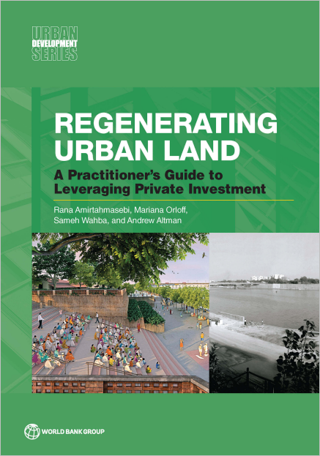](https://library.pppknowledgelab.org/PPIAF/documents/3529)**

**Benchmarking PPP Procurement 2017**

Many economies are yet to adopt broadly recognized good practices to prepare, procure, and manage Public-Private Partnerships. The Benchmarking PPP Procurement 2017 report flags potential improvements that can help governments fill the gap in an effort to provide better PPP procurement and enable better infrastructure service delivery to all. The PPIAF-funded report benchmarks government capabilities in 82 economies across four key areas: PPP preparation, PPP procurement, unsolicited proposals, and PPP contract management. Across the four areas measured, the data finds that most economies fall short of recognized good practices. Project preparation and contract management are the two areas where a significant number of countries perform poorly. When designed well and implemented in a balanced regulatory environment, PPPs can bring greater efficiency and sustainability in providing such public services as water, sanitation, energy, transport, telecommunications, health care, and education. Every country has its own unique challenges, priorities, and financial constraints. [Read More.](https://library.pppknowledgelab.org/documents/3751)

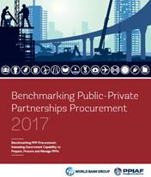

**Three new Impact Stories**

**PPIAF Support Transforms Odisha’s Enabling Environment to Tackle Climate Change through 1,000-MW Solar Park**

PPIAF support was instrumental in transforming the enabling environment in the Indian State of Odisha to scale-up renewable energy and catalyze the development of a 1,000-megawatt (MW) solar park through a public-private partnership. The technical assistance support was critical in removing key barriers for private-sector participation, while helping build the local institutional capacity. READ MORE

**PPIAF Supports the Belize Municipal Development Project and Revenue Enhancement Support Program**

In 2012, PPIAF partnered with the World Bank to engage with the Government of Belize to help it improve and maintain municipal service delivery in selected towns through the Municipal Development Project. PPIAF’s technical assistance support helped to initiate the development of the Revenue Enhancement Support Program, to assist the municipalities in enhancing the capacity of municipal finance management and improving creditworthiness. READ MORE

**PPIAF Supports the Design of PPPs for City-Wide 24/7 Water Service in Karnataka (India)**

PPIAF technical assistance support was used to help the Karnataka Urban Infrastructure Development and Finance Corporation prepare for a PPP by helping on a range of issues, from convening stakeholder workshops to shaping the PPP and providing guidance on procurement and contractual issues to facilitate the new design, supporting city and state-level actors through the bid process. READ MORE

**missions and meetings**

**PPIAF Tanzania Internal Midterm Evaluation Mission**

A mission by PPIAF team members, Serah Njoroge and Sam Baiya, travelled to Dar-es-Salaam Tanzania on July 13-15, 2016. The purpose of the mission was to conduct an outcome realization of the PPIAF-funded program of technical assistance aimed at improving the legislative, institutional, financial and technical framework to enable private investment and accelerate the country PPP program. The team held meetings with Gayle Martin (Acting Country Director IBRD Tanzania) World Bank TTLs in the Water and Transport Sectors, officials from the Ministry of Finance PPP unit, PPP Node, Tanzania Airports Authority, Ilala Municipal Council, Dar es Salaam City Council, Country donor representatives from DFID and GIZ. This is the first program review conducted by PPIAF: a report is under way and the team is working on a short brief to be referenced in the next PPIAF newsletter (incorporating some lessons learned).

**Country Readiness Diagnostic: Dominican Republic**

A mission led by Rui Monteiro (TTL- PPP Senior Specialist) and Luciana Guimaraes Drummond e Silva, and included Nils Jason and Scarlett Piantini (Castalia consultants), travelled to the Dominican Republic on September 11-15, 2016. The purpose of the mission was to initiate the Readiness Diagnostic with the Government of Dominican Republic. During the mission the team held meetings with public and private sector stakeholders in Santo Domingo, Santiago and La Vega.

# SECTION 2: PROGRAM FINANCES

The PPIAF Financial Information System (FIS) provides an integrated approach to monitor performance of PPIAF operations. The FIS tracks activities more granularly at each point in the PPIAF activity cycle from its design to the close-out stage. This information is presented both at monthly/quarterly interval at various levels such as the consolidated PPIAF level, at the core and non-core fund level and at activity level. Annex 2 provides further details on program financial information in terms of available balances per trust fund. Thus, new contributions, disbursement and commitments, pipeline of current activities can be incorporated in our reports enabling us to identify the funds available for future activities at each core and non-core fund levels.

**Table 1: - PPIAF - Overall Fund Level cumulative Sources and Uses in FY16 and FY17 Q1 (US$)**

|  |  |  |  |  |  |
| --- | --- | --- | --- | --- | --- |
|  | **FY16** | | | | **FY17** |
| **Sources** | **Qtr 1** | **Qtr 2** | **Qtr 3** | **Qtr 4** | **Qtr. 1** |
| Contributions (including WB earnings) | **203,721,884** | **207,984,000** | **210,053,343** | **214,512,676** | **219,353,033** |
| **Uses** |  |  |  |  |  |
| Activity disbursements | 115,713,656 | 118,495,000 | 121,501,826 | 123,837,350 | 126,084.684 |
| Activity commitments | 8,305,676 | 7,908,000 | 9,216,794 | 10,155,931 | 11,849.696 |
| Activity grants processing | 18,282,988 | 22,515,000 | 23,960,406 | 24,884,629 | 25,635,636 |
| Admin fee & PMU expenses | 31,823,994 | 32,416,000 | 32,660,252 | 33,053,371 | 33,681,407 |
| Sub total | **174,126,315** | **181,334,000** | **187,339,278** | **191,931,280** | **197,251.423** |
| **Fund balance** | **29,595,570** | **26,650,000** | **22,714,064** | **22,581,395** | **22,100.610** |

The overall opening fund balance at the start of FY17 was approx. $22.5M

# Annex 1: SUMMARY OF ACTIVITY FUNDING

## OVERVIEW

PPIAF approved 16 activities in the first quarter of fiscal 2017, worth a total of $5.5 m as presented in Table 2 below.

| **Table 2** | | |
| --- | --- | --- |
| Source | No. of Activities | Value (US$) |
|
| PPIAF Activities[1] | 12 | 4,290,925 |
| SNTA Activities | 4 | 1,191,750 |
| **Total** | 16 | 5,482,675 |

## FRAGILE AND CONFLICT-AFFECTED STATES[2]

Table 3 below represents all country-specific activities (excluding regional and global activities in the amount of $887,000) broken down regionally between non-fragile and fragile or conflict-affected states. Of the 14 country-specific activities approved, three activities were approved in fragile and conflict-affected states, in West Bank and Gaza, Tajikistan and Timor Leste.

**Regional Breakdown of Country-Specific Activities Approved in Fragile and Conflict-Affected States**

**Table 3**

**Table 2**

**Figure 1**

|  |  |  |  |
| --- | --- | --- | --- |
| **Region** | **Fragile Funding (US$)** | **Non-Fragile Funding**  **(US$)** | **% Fragile by Funding** |
| Sub-Saharan Africa | 0 | 1,971,750 | 0 |
| East Asia and Pacific | 377,025 | 1,040,000 | 27 |
| Europe and Central Asia | 226,900 | 0 | 100 |
| Latin America and Caribbean | 0 | 300,000 | 0 |
| Middle East and North Africa | 660,000 | 220,000 | 75 |
| **Total** | **1,263,925** | **3,531,750** | **26** |

## 

## GEOGRAPHIC FOCUS

A summary of the regional breakdown of all the 14 activities is provided in table 4 and figure 2. Within the country and region specific activities, Sub-Saharan Africa accounted for 41% of the portfolio followed by activities in East Asia Pacific accounting for 30% of the portfolio.

**Regional breakdown of Approved Activities by Funding**

**Table 4**

|  |  |  |  |  |
| --- | --- | --- | --- | --- |
| **Region** | **Total Funding (US$)** | **No. of Projects** | **% of Funding** | **% of Number** |
| Sub-Saharan Africa | 1,971,750 | 7 | 41 | 50 |
| East Asia Pacific | 1,417,025 | 3 | 30 | 22 |
| Europe and Central Asia | 226,900 | 1 | 5 | 7 |
| Latin America and Caribbean | 300,000 | 1 | 6 | 7 |
| Middle East and North Africa | 880,000 | 2 | 18 | 14 |
| **Total** | **4,795,675** | **14** | **100** | **100** |

**Figure 2**

## 

## SECTOR BREAKDOWN

The sector breakdown of the 16 activities is summarized in table 5 and figure 3. The activities were spread across the multi-sector i.e. those activities related to general PPP support or those covering multiple sectors, water, energy and transport. Those activities covering more than one sector were dominant and represented 34% of the total funding provided.

**Sector Breakdown of Approved Activities by Funding (USD)**

**Table 5**

|  |  |  |  |
| --- | --- | --- | --- |
| **Sector** | **Total Funding (US$)** | **% by Funding** | **No. of Projects** |
| Multi-sector | 1,838,900 | 34 | 7 |
| Water | 1,340,000 | 24 | 4 |
| Energy | 1,276,750 | 23 | 2 |
| Transport | 1,027,025 | 19 | 3 |
| **Total** | **5,482,675** | **100** | **16** |

**Figure 3**

## COUNTRY INCOME STATUS [3]

The country income status breakdown of the 14 country-specific activities (excluding regional activities) is summarized in table 6 and figure 4. Activities approved in this first quarter represented countries in DAC I, DAC III, and DAC IV. Low income countries from DAC I category took the largest share of funding, representing 42% while DAC III countries represented 27% of the portfolio.

**Country Income Status of Approved Country-Specific Activities by Funding (USD)**

**Table 6**

|  |  |  |  |  |
| --- | --- | --- | --- | --- |
| **Country Income Status** | **Total Funding (US$)** | **% by Funding** | **No. of Projects** | **% by No. of Projects** |
| DAC I | 1,922,025 | 42 | 5 | 38 |
| DAC II | 898,650 | 20 | 3 | 23 |
| DAC III | 1,255,000 | 27 | 3 | 23 |
| DAC IV | 520,000 | 11 | 2 | 15 |
| **Total** | **4,595,675** | 100 | 13 | 100 |

**Figure 4**

## FUNDING SOURCE

The source of funding for the activities approved in the first quarter of fiscal 2017 is listed in table 7. In the first quarter, activities have been approved from the Multi-Donor Trust Fund II (or “Core fund”), the SECO Middle Income, the Sub-National Technical Assistance Fund and USAID: Water for Sub-Saharan Africa fund.

**Breakdown of Funding Source (July 1, 2016 to September 30, 2016)**

**Table 7**

| Source of funds | Total Funding (**US$**) | % by  Funding | No. of Projects | % by No. of Projects |
| --- | --- | --- | --- | --- |
| Multi-Donor Trust Fund II | 3,445,925 | 63 | 9 | 56 |
| Sub-National Technical Assistance Fund | 1,191,750 | 22 | 4 | 25 |
| SECO Middle Income | 300,000 | 5 | 1 | 6 |
| USAID: Water for Sub-Saharan Africa | 545,000 | 10 | 2 | 13 |
| **Total** | **5,482,675** | **100** | **16** | **100** |

## APPROVED ACTIVITIES FOR THE PERIOD JULY 1, 2016 – SEPTEMBER 30, 2016

Nine of the activities approved in the first quarter of fiscal 2017 are from the MDTF II “Core” fund while one activity was approved from the SECO Middle Income fund, four activities from the Sub-National Technical Assistance Fund and two from the USAID Water for Sub-Saharan Africa fund. All activities are listed in Tables 8 and 9 below.

|  |  |
| --- | --- |
|  | SECO Middle Income |
|  | USAID: Water for Sub-Saharan Africa |
|  | Sub-National Technical Assistance Fund |

**Table 8: PPIAF Activities Approved in FY17 Q1**

| **Country/Title** | **Activity Description** | **Approved Funding (US$)** | **Sector** | **Action Area** |
| --- | --- | --- | --- | --- |
| PPIAF Activities | | | | |
| AFRICA: Green Growth Investment Fund Africa (GGIFA) - Feasibility Study | The overall objective of the activity is to help establish an operational investment fund for leveraging investments in green infrastructure projects in Africa. The specific objective of the PPIAF activity is to assist with the Project Pipeline Preparation and Future Market Trends components of the GGIF Africa feasibility Study. PPIAF support will consist of two components: (i) to analyze a pipeline of public-private-partnership (PPP) projects that could be targets for investment by GGIF Africa; and (ii) to identify and study key market trends that could provide future investment opportunities for GGIF Africa. | 200,000.00 | Multi-sector | Other |
| GHANA: Strengthening Private Sector Participation in Community Water Supply | Improving the enabling environment for private sector engagement in Ghana’s water supply. More specifically, the proposed activity will develop recommendations to improve Ghana’s policy environment; scope a Ghana Water Enterprise Trust which is being formed to attract investment and provide financial stewardship for scaling small water enterprises; and adapt the guidelines and operating principles for private sector engagement from Benin and potentially other countries for Ghana. Lessons from the project will be documented and disseminated nationally. | 295,000.00 | Water | Infrastructure Development Strategies |
| GLOBAL: Practical Guide on the establishment and operation of investment funds designed to leverage private sector participation in infrastructure development | The activity will help develop a Practical Guide of good practices and guidelines for the establishment and operation of SIFs, with particular focus on infrastructure investment with private sector participation. The activity will be structured as two components: 1.Review of SIFs; 2. Guidelines for the establishment and operation of SIFs | 537,000 | Multi-sector | Infrastructure Development Strategies |
| GLOBAL: Selecting and Screening Projects for Implementation as PPPs | Examines both the selection of projects and the selection of procurement methods for identified projects. | 150,000 | Multi-sector | Infrastructure Development Strategies |
| LAOS: Sustainable Hydropower Development and Integrated Water Resource Management | The main thrust of this activity will be to strengthen institutional and human capacity of GoL to oversee sustainable development of the hydropower sector with focus on four components: i) Concession Agreement Management and Monitoring; ii) Implementation of Hydropower Fiscal Regime; iii) Hydropower and Integrated Water Resources Management (IWRM); and iv) Support to Power Sector Reform. | 740,000 | Energy | Capacity Building |
| LESOTHO: PPP Policy and Framework Support | This activity will support updating and finalizing the previously drafted PPP policy, PPP regulations, guidance note on unsolicited proposals as well as assessment of the existing laws and regulations to ensure consistency. This support activity is expected to result in a harmonized PPP draft policy which clearly outlines Lesotho’s approach to PPPs, PPP legislation, and PPP regulations to be endorsed by the Government before the end of FY17. | 205,000 | Multi-sector | Policy, regulatory and institutional reforms |
| PERU: Developing a Transit Oriented Development (TOD) Project via Public-Private Partnership (PPP) in Lima, Peru: Evaluation of potential for Lima Metro’s Line 2 Project | This activity complement a World Bank lending operation (Lima Metro’s Line 2 Project) to support the National Government’s contribution to the Lima Metro Line 2 project, a 35-km greenfield subway to be designed, built, operated and transferred through a 35-year concession contract. The Metro L2 project will serve a critical East-West corridor from Ate-Vitarte to Callao, including the maritime port and international airport. | 300,000 | Transport | Infrastructure Development Strategies |
| SENEGAL: PPP framework for private sector participation in the road sector in Senegal and development of a strategy for urban transport investment in Dakar | Supporting the Government of Senegal to define the appropriate PPP institutional arrangements and regulatory framework in the road sector in Senegal. More specifically, this activity will include: review of the economic and financial analysis of road investment; review of the institutional and regulatory framework for PPP in the Road sector; assessment of PPP in the road sector and development of a strategy for urban transport in Dakar | 350,000 | Transport | Infrastructure Development Strategies |
| TAJIKISTAN: Support to the Government of Tajikistan’s PPP Program | The goal of this technical assistance (TA) is to enhance GoT’s capacity to develop PPPs by helping them to develop the tools to screen and evaluate projects within their priority project list; prioritize those projects and determine which are suitable for the PPP structure. Following this exercise the team will work with the PPP unit and relevant line ministries to further develop two priority and potentially feasible projects. In doing so this technical assistance will provide on the job learning for the Government officials. | 226,900 | Multi-sector | Capacity Building |
| TANZANIA: PSP Options Analysis for Urban Water Sector Reform | Assisting the Ministry of Water and Irrigation and local utilities in determining what if any role(s) PPP can play in improving water and sanitation service provision and investment efficiency and sustainability in Tanzania and in selecting the most suitable shortlist of possible PPP projects to meet current financing and capacity augmentation requirements. | 250,000 | Water | Infrastructure Development Strategies |

**Table 9: SNTA Activities Approved in FY17 Q1**

| **Country/Title** | | **Activity Description** | **Approved Funding (US$)** | **Sector** | **Action Area** | |
| --- | --- | --- | --- | --- | --- | --- |
| SNTA Activities | | | | | | |
| JORDAN: Greater Amman Municipality: PEFA Assessment and Design of Technical Assistance for Strengthening Municipal Finance | | The capital city of Jordan, GAM has the responsibility to meet the increasing demands for municipal services from its citizens and stakeholders. Strengthening the institutional and financial management systems of the city government will enable it to ensure sustainability in the financing and delivery of services as well as to enhance its accountability to citizens. | 220,000 | Multi-sector | Financing | |
| KENYA: Component 1 of the Financing Universal Access to Water Supply and Sanitation-Kenya Country Assessment | | The goal of the global program - Financing Universal Access to Water Supply and Sanitation is to develop opportunities to scale up private sector investment in water and sanitation. This activity implements Component 1 (Outreach, Surveillance and Potential Transaction Structuring) sub-component 2: Assessment Study. | 135,000 | Water | Financing | |
| KENYA: Financial Advisory Services for Kenya Energy Utilities (KENGEN & KPLC) | | Supporting KPLC in developing an investment and financing strategy that allows the company reaching the access targets without compromising its financial sustainability. | 536,750 | Energy | Financing | |
| MONGOLIA: Ulaanbaatar City Capital Investment Plan and Financial Assessment for Urban Transport Service Delivery | | Improving Ulaanbaatar City’s creditworthiness is key for the private sector to participate in investment operations in Ulaanbaatar. Specifically, the financial sustainability of public transport sector also encourages private sector participation in financing public transport infrastructure and service provision in Ulaanbaatar. | 300,000 | Multi-sector | Financing | |
|  | | | | |

# ANNEX 2: Detailed Program Finances

**Table 10: PPIAF Fund Balance per Parent Trust Fund as of 09/30/2016 (in US$ ‘000)**

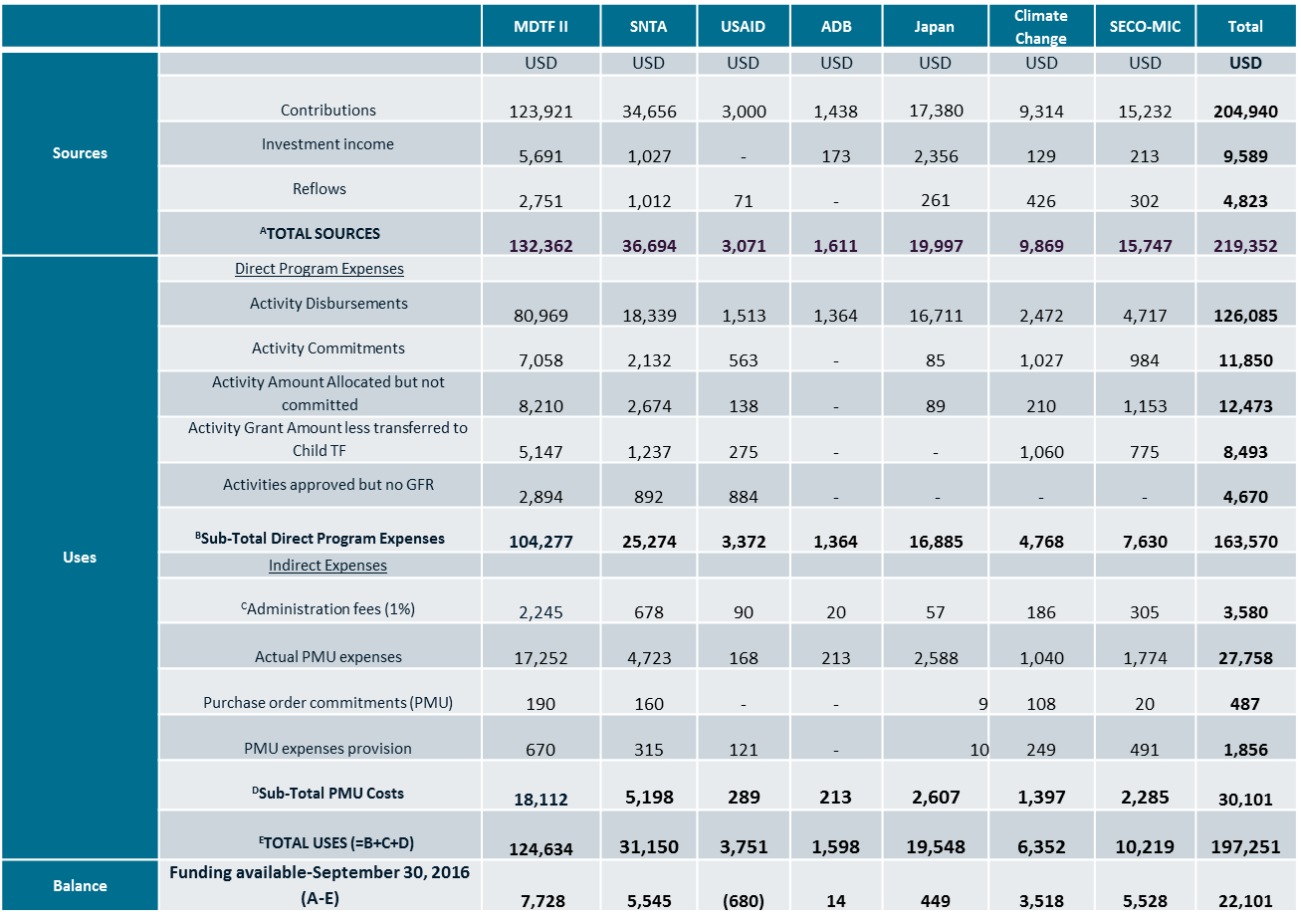

1. PPIAF Activities excludes those approved from the SNTA fund
2. Fragile and conflict-affected status is defined according to the World Bank’s Harmonized List of Fragile Situations FY16, which is available [here](http://pubdocs.worldbank.org/en/700521437416355449/FCSlist-FY16-Final-712015.pdf).
3. Country income status is defined according to the Organization for Economic Co-operation and Development’s Development Assistance Committee (DAC) List of Official Development Assistance (ODA) Recipients. The DAC List was most recently updated in October 2011, effective 1 January 2012, for reporting on 2011, 2012 and 2013 flows, and is available [here](http://www.oecd.org/dac/stats/daclistofodarecipients.htm).